Learning About The Lever

Simple machines are used to make our work easier. They reduce the force needed to do a job. A lever reduces the force needed to lift heavy objects. There are three terms associated with levers that you should know. The effort/force is the push or pull that moves the lever. The load is what the lever is trying to lift. The fulcrum is the part where the lever is supported.
When using a lever the placement of the fulcrum is the most important decision. Where you place the fulcrum in relation to the load determines how hard you will have to work. The most efficient placement of the fulcrum is closest to the load. You will have to use less effort/force to move the load when the fulcrum

Look at the picture below and label the effort, load and fulcrum.

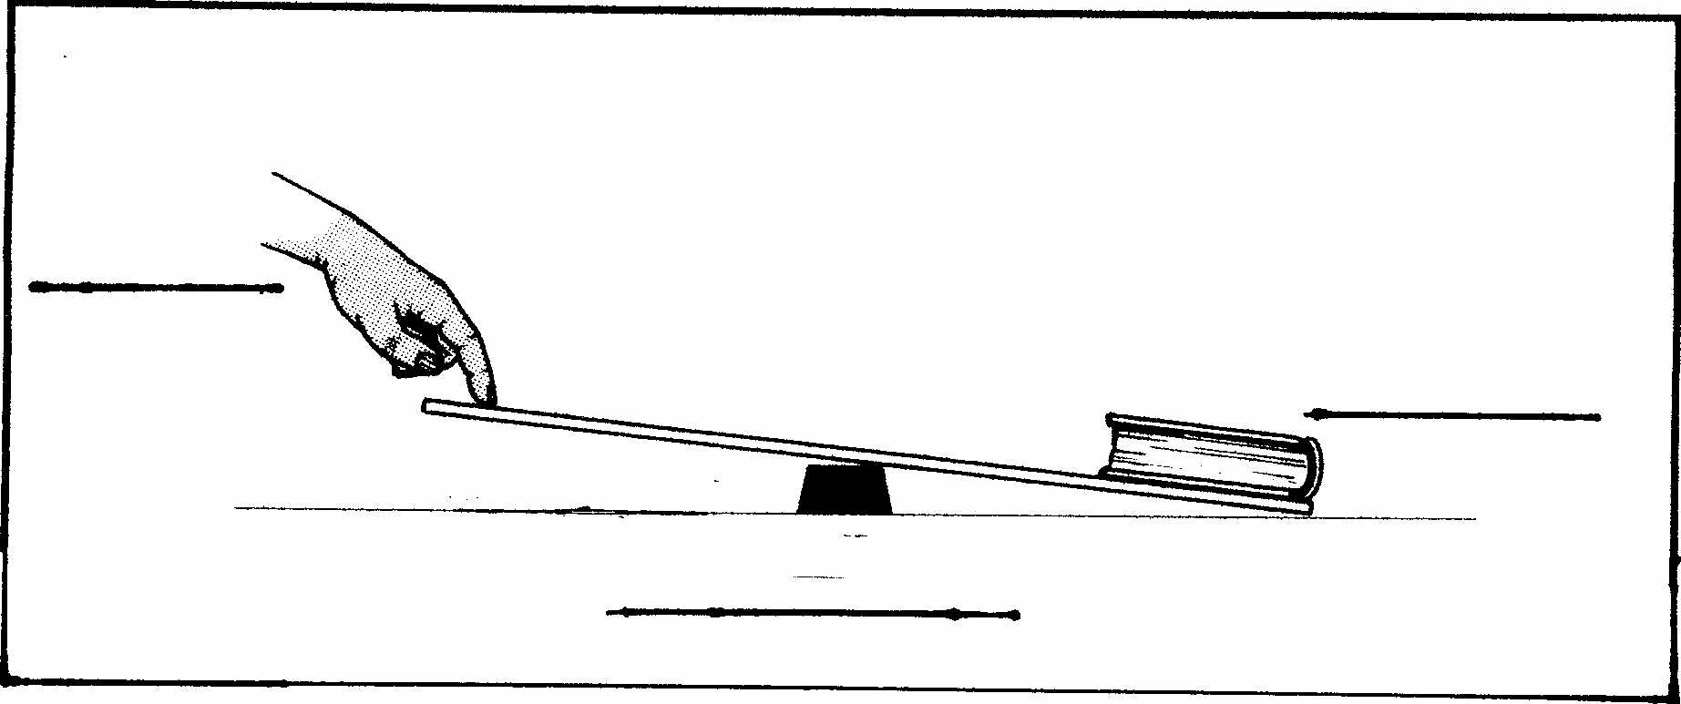

Materials: dowel, ruler with 5 washers taped to the 30 cm position, tape, 35 free washers per set up

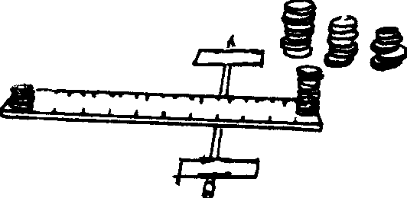
What To Do:
1. Label the effort and load on the picture.
2. Tape the dowel to the table as shown in the picture.
3. Place the 10 cm mark of the ruler on top of the dowel.
4. Place one washer at a time on the 1 cm side of the
ruler until the other washers are lifted.
5. Count and record the number of washers it took to
lift the stack of 5 washers.
6. Record it in the chart below.
7. Move the ruler to the 15 cm mark and repeat the experiment.
8. Count and record the number of washers it took to
lift the stack of 5 washers.
9. Move the ruler to the 20 cm mark and repeat the experiment.

Position of the dowel (fulcrum) | Load  (number of washers you are lifting) | Effort/Force  (number of washers needed to lift the load)
10 cm
15 cm
20 cm

Questions:
1. Which position of the dowel (fulcrum) required the least effort to lift the washers? __________________

2. Which position of the dowel (fulcrum) required the most effort to lift the washers? _________________

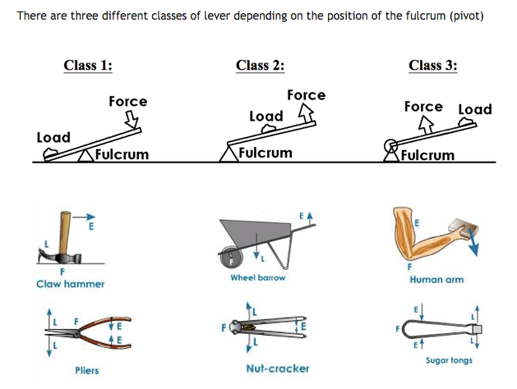
We have been using a lever in which we can move the fulcrum closer to the load. What if we couldn’t move the fulcrum? Is there a way we could still make our work easier? If you can’t move the fulcrum to make your work easier, you must move the load. When moving the load the rule of thumb is: To use ½ the force, move the load ½ the distance closer to the fulcrum.

Materials: Same as before except a different ruler with no load taped on it
What To Do:
1. Place the 15cm mark of the ruler on the dowel.
2. Place 10 washers on the 30 cm mark of the ruler. This
is your load.
3. Find the location on the ruler where only 5 washers
will pick up the load of 10 washers.
4. Draw and label what you discover below.

Question: If you are on a seesaw and a little kid you’re (less than your weight) wants to play where would you have him sit on the seesaw so he could lift you up?

______________________________________________

______________________________________________

There are three types or classes of levers, according to where the load and effort are located with respect to the fulcrum.

Look at the pictures below and describe where each is located.
Cross out Force and write Effort on each picture.

In Class 1 the _________ is placed between the _______ and __________. An example is a __________________.

In Class 2 the ________ is in between the ________ and the ___________. An example is a _____________________.

In Class 3 the _________ is between the ________ and the ___________. An example is a ____________________.

Name ___________________ period _____
EXIT TICKET
Learning About the Lever
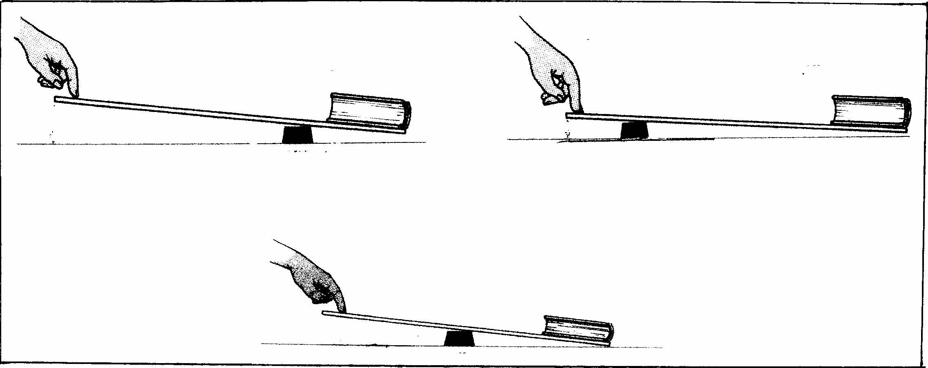
A
B
C

1. In the picture above, which of the levers will require the least effort to lift the book? __________

2. Which of the levers will require the most effort to lift
the book? _____

Conclusion: (close, simple machines, lever, half, load, reduces, placement)

_________ ___________ make our work easier. The ________ is a simple machine that _________ the effort needed to lift heavy objects. When using a lever, the most important decision is the ___________ of the fulcrum. To make lifting a heavy object easier I should place the fulcrum _________ to the object I want to pick up. If I could not move the fulcrum I would use the rule that says: To use ______ the force, move the _____ half the distance from the fulcrum.

Name ___________________ period _____
EXIT TICKET
Learning About the Lever

Conclusion: (close, simple machines, lever, half, load, reduces, placement)

_________ ___________ make our work easier. The ________ is a simple machine that _________ the effort needed to lift heavy objects. When using a lever, the most important decision is the ___________ of the fulcrum. To make lifting a heavy object easier I should place the fulcrum _________ to the object I want to pick up. If I could not move the fulcrum I would use the rule that says: To use ______ the force, move the _____ half the distance from the fulcrum.
A
B
C

1. In the picture above, which of the levers will require the least effort to lift the book? __________

2. Which of the levers will require the most effort to lift
the book? _____

