Identifying Tectonic Plates
For many years it was believed by geologists that the location of the continents was fixed. These scientists believed that the locations of the continents were determined many billions of years ago. It was believed that the continents were simply areas where the crust was too high for the oceans to cover them over.
Modern scientific discoveries have helped us understand that this view of the Earth is inaccurate. We have learned that the lithosphere (the crust and upper layer of the mantle) float on top of the asthenosphere and can move around. How does this happen?
At the bottom of the ocean, located almost exactly halfway between the continents are under-water mountain ranges. This is where hot magma escapes from the Earth’s core, and spreads outward. As the seafloor spreads outward, the continents are carried across the sea, riding on top of the crust.
As new crust is created it forms what resemble giant plates. One side of the plate is where new crust is being made, while the other side is where older crust is being destroyed. These plates are called tectonic plates and move from 5-10 cm a year.

Watch the Plate Tectonics video from www.missdoctorbailer.com

Questions:
1. What was Pangaea? _____________________
2. What two continents fit together like a puzzle? ________________________________________
3. What theory do scientists use to explain the moving continents? _________________________________

The Earth’s tectonic plates are generally named
for the continents or oceans that are located on that piece of crust.
Materials: Tectonic Plate map
What to Do:
1. Use the clues and the coordinates below to locate and label each of the following tectonic plates on your map.

Pacific Plate – While I am mostly crust under the ocean, I have a small piece of continental crust and can cause a lot of moving and shaking in California. I am found between 150°E longitude and 120°w longitude.
North American Plate - I rattle people’s nerves when I collide with my pal the Pacific plate. I am home to the United States and Mexico. About half of me is under the Atlantic Ocean.
Indo-Australian Plate – I am located underneath the Indian Ocean and stretch from the land of the koalas to Iraq in the Middle East. I can be found between 40°N latitudes and 60°S latitude.
African Plate – I can be found with my “mummy” where 0°latitude meets 0° longitude.
South American Plate – I extend from 60°S latitude to 15°N latitude and am home to the Amazon rainforest.
Eurasian Plate – Russia, China and Europe all call me home, which makes me rather large. I collide with the Indo Australian Plate quite often
Nazca Plate- I am sliding towards and under my neighbor, the South American plate. I am a smaller plate covered by the Eastern Pacific Ocean.

Do Not Glue into your notebook until finished with the next two lessons. Then fold in half and glue to only one page

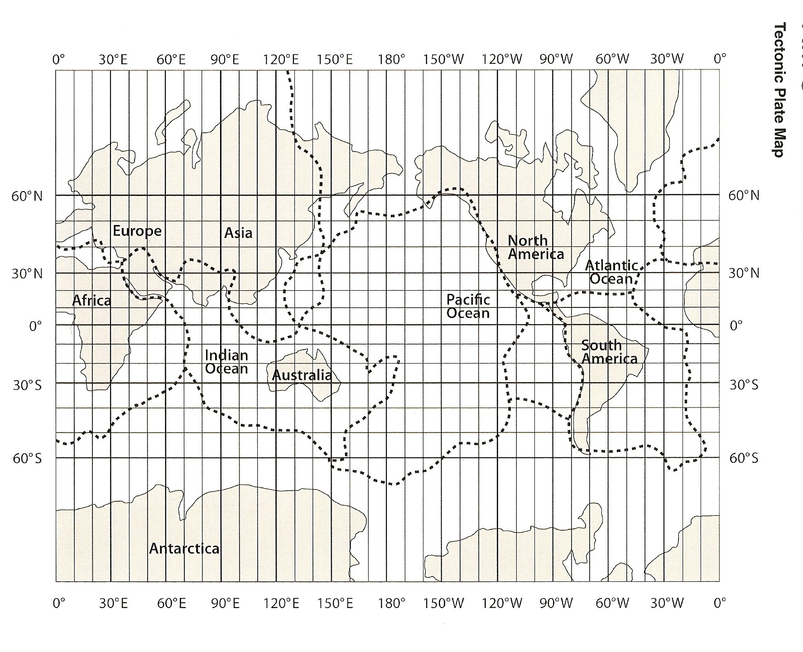

Name ________________ period _____

EXIT TICKET
Identifying Tectonic Plates
1. Label any two of the tectonic plates in the map above.

2. Which continent is found where 0°latitude meets 0°
longitude? _____________________________

3. Which continent extends from 60°S latitude to 15°N
latitude? _________________________________

4. Which tectonic plate has very little landmass on it?
___________________________________________

Name ________________ period _____

EXIT TICKET
Identifying Tectonic Plates
1. Which continent extends from 60°S latitude to 15°N latitude? _________________________________

2. Which tectonic plate has very little landmass on it?
______________________________________________
3. Label any two of the tectonic plates in the map above.

4. Which continent is found where 0°latitude meets 0° longitude? _____________________________

