Comparing the Sun and the Planets

Our Sun is the largest body in the Solar System but
it is still considered an average-sized star. It is the only star in our solar system. The Sun is over 93 million miles away from the earth. It’s light takes about 8 minutes to reach the earth. Without its heat and light there would be no life on our planet.
A planet is a large body that shines by reflected light and travels in a stable path around a star. The Sun is the star of our Solar System and controls the motion of all the planets that travel around it. The planets are illuminated, or lit up by sunlight. Some planets may be mistaken as bright stars on a clear night. However, where carefully observed, planets shine with a steady glow of reflected light, whereas, stars appear to flicker or twinkle.

Size of Sun and Size of Planets

Materials: Bulletin board display

What To Do:

Observe the bulletin board your teacher has prepared showing the planet sizes.
Questions:
1. Which planet is the largest? ___________________
2. Which planet is the smallest? __________________
3. Which two pairs of planets are about the same size?
________ and ________ AND ________ and ________

Your teacher will fold the earth model in half

so you can see the diameter.
4. Predict how many earths do you think would fit across
the diameter of Jupiter? ________
Your teacher will have a volunteer measure it.
5. How many earths fit across Jupiter? ______
6. How many earths fit across of Saturn? _________
7. How many earths fit across Neptune? __________
Your teacher will show you how much bigger the sun
is than the planets with a piece of string.
8. The sun’s diameter on the same scale as these planets
will be 11 meters across. The earth’s diameter is 5 cm.
How many earths can fit across the sun? Do the math
in the box below.

How Close are the Planets?
Materials: calculator, toothpick (one per planet) modeling clay, tape, scissors, ruler, 25 cm Sun

What To Do:
1. Using the diameters of the planets in kilometers,
calculate the scale sizes of the planets in centimeters
using the chart on the next page.
2. Your teacher will assign your group a planet.
3. Get enough clay to form a sphere the size of your planet.
4. On a small strip of paper, write the name of your planet and attach it to your planet to label it.
5. Take your planet where your teacher has set up the sun
and the scale for the solar system.

6. One person in your group should stand with the
planet where indicated and everyone else should stand
back and observe how the planets are arranged.

Planet | Diameter (km) |  | Scale ratio | Scale Diameter (mm)
Mercury | 4,878 | ÷ | 5568
Venus | 12,104 | ÷ | 5568
Earth | 12,756 | ÷ | 5568
Mars | 6,787 | ÷ | 5568
Jupiter | 142,800 | ÷ | 5568
Saturn | 120,00 | ÷ | 5568
Uranus | 51,200 | ÷ | 5568
Neptune | 48,600 | ÷ | 5568

Questions:
1. Which planets are close together? _____________________________________
2. Which planets are far apart? _________________________________________
3. Which planets are large? __________________________________________
4. Which planets are small? __________________________________________

OUR SOLAR SYSTEM
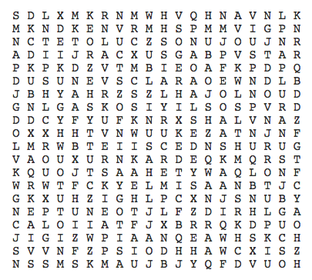

Dwarf Planet Earth
Eris Jupiter
Mercury Neptune
Planet Pluto
Saturn Star
Sun Uranus
Venus

Name ___________________ period _____

EXIT TICKET
Comparing the Sun and Planets

1. How is a star different from a planet?
A. A planet shines by its own light
B. A star shines by its own light
C. A star is smaller than a planet

2. How many stars are in our Solar System?

A. one
B. two
C. thousands
D. millions

3. Which planet is farthest from the Sun?

A Mercury
B. Earth
C. Neptune
D. Mars

Conclusion: (Uranus, Sun, star, Saturn, Mars)
The ______ is the largest body in our Solar System. It is the only ______ in this Solar System. Venus is about the same size as _________. Earth and __________ are close together while Jupiter and _________ are far apart.

Name ___________________ period _____

EXIT TICKET
Comparing the Sun and Planets

1. Which planet is farthest from the Sun?

A Mercury
B. Earth
C. Neptune
D. Mars

2. How is a star different from a planet?
A. A planet shines by its own light
B. A star shines by its own light
C. A star is smaller than a planet

3. How many stars are in our Solar System?

A. one
B. two
C. thousands
D. millions

Conclusion: (Uranus, Sun, star, Saturn, Mars)
The ______ is the largest body in our Solar System. It is the only ______ in this Solar System. Venus is about the same size as _________. Earth and __________ are close together while Jupiter and _________ are far apart.

