Famous Comets

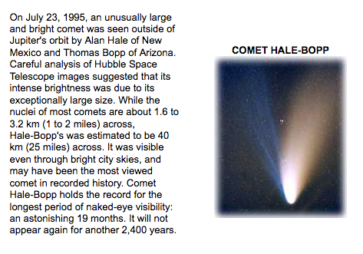

Comet Hale-Bopp

Anchor Tab
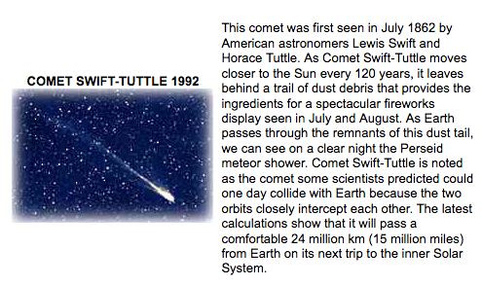

Comet Swift-Tuttle

Anchor Tab

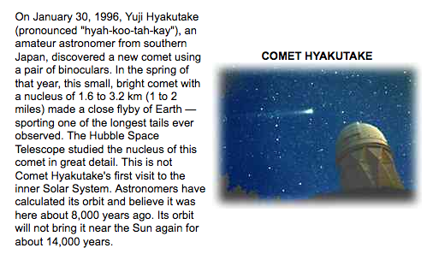

Comet Hyakutake

Anchor Tab

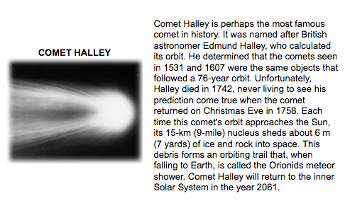

Comet Halley

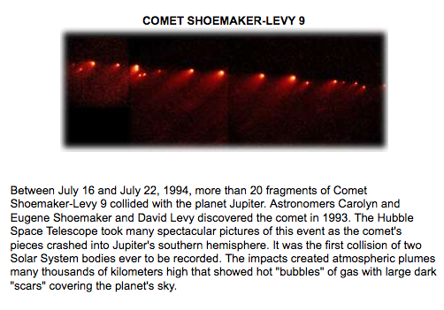

Comet Shoemaker-Levy 9

