8th grade Unit 1 Introduction to Chemistry
Teacher Instructions

TEKS
SCI.8.1A Demonstrate safe practices during laboratory and field investigations as outlined in the Texas Safety Standards.
SCI.8.5A Describe the structure of atoms including the masses, electrical charges and locations of protons and neutrons in the nucleus and electrons in the electron cloud.
SCI.8.5B Identify that protons determine an element’s identity, and valence electrons determine its chemical properties including reactivity.
SCI.8.5C Interpret the arrangement of the Periodic Table including groups and periods, to explain how properties are used to classify elements.

Activity 1 Reviewing Lab Safety

Materials:
- Safety equipment labels - Print out and place around the room on your safety equipment.

Focus: I can demonstrate safe practices during laboratory and field investigations as outlined in the Texas Safety Standards.

Language Objective: I can listen to my teacher and recognize safe and unsafe laboratory practices.

Activity 2 Inside the Atom

Materials:
- Strip of colored paper ½” x 11”, scissors, glue
- Penny and dime – 2 per group, yellow, green and red strips of paper ½” x8 ½”, hole punch, scissors, glue

Focus: I can describe the structure of atoms including the masses, electrical charges and locations of protons and neutrons in the nucleus and electrons in the electron cloud.

Language Objective: I can work with my partners to make a model of an atom.

Activity 3 A Deeper Look at Atoms

Materials: none

Focus: I can describe the structure of atoms including the masses, electrical charges and locations of protons and neutrons in the nucleus and electrons in the electron cloud.

Language Objective: I can use a graphic organizer to summarize information about the atom.

Activity 4 Reviewing the Periodic Table

Materials:
- Copy of the Periodic Table, colored pencils
- Pictures of elements (last page of file) printed in color for each pair. There are 2 sets on the page.

Focus: I can interpret the arrangement of the Periodic Table including groups and periods, to explain how properties are used to classify elements.

Language Objective: I can use a graphic organizer to arrange elements into families.

Activity 5 What are Valance Elections?

Materials:
- SEPUP tray, small piece of aluminum foil, iron washer, zinc shot, stirring stick, dropping bottle of copper chloride solution, paper towels
- Download Braniac video from www.missdoctorbailer.com. It will play better if you don't stream it.

SEPUP trays look like the pictures below. If these are not available small portion cups or bathroom drinking cups can be used.

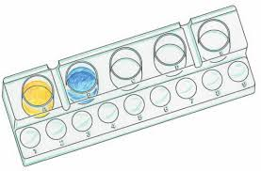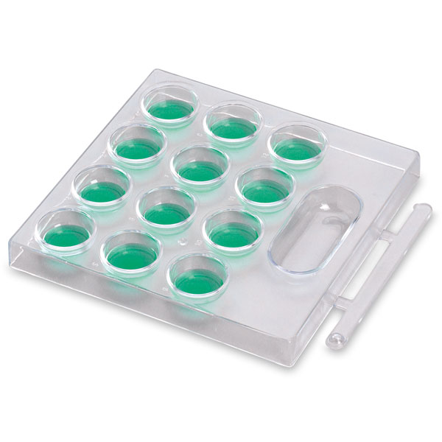

Focus: I can interpret the arrangement of the Periodic Table including groups and periods, to explain how properties are used to classify elements.

Language Objective: I can watch and listen to a video to place information in a graphic organizer
Activity 6 More About the Periodic Table

Materials:
- Bag of dark beans, light colored beans and popcorn kernels, 5 ziplock sandwich baggies per group, clear packing tape, labels

Make 5 bags that for each group. Seal the bags with tape so the students do not open them. Don’t tell them which bean is which. Have them figure it out by knowing that the number of electrons equals the number of protons.

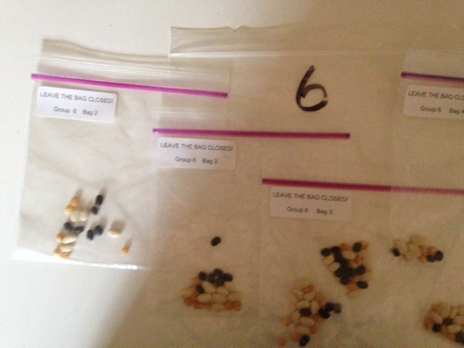

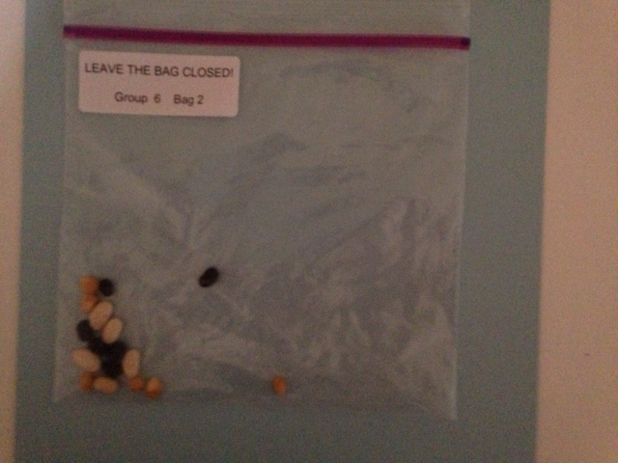

Focus: I can interpret the arrangement of the Periodic Table including groups and periods, to explain how properties are used to classify elements.

Language Objective: I can work with my partners to use a model of the inside of the atom.

