Inside An Atom
Clothes, rain, DVD’s food, air, gasoline and paper are all examples of matter – the “stuff” that makes up everything in the universe. Every kind of matter is made up of one or more elements. An element is a substance that cannot be broken down into other substances by chemical or physical means. Carbon is an element, oxygen is an element and helium is an element. These and all other elements are made of atoms. An atom is the smallest particle of an element.
If you could look inside an element, what would you see? Theories about the shapes and structures of atoms have changed over the last 200 years and continue to change even now. But some properties of atoms are well understood.
Although atoms are extremely small, they are made up of even smaller parts. An atom consists of a nucleus surrounded by one or more electrons. The nucleus is the tiny, central core of an atom. Nuclei contain particles called protons and neutrons. Protons have a positive electrical charge, which is indicated by a plus symbol (+). Neutrons have no electrical charge. They are neutral which is indicated by a zero symbol (0). A third type of particle moves in the space around the outside of the nucleus. This space is called the electron cloud. The particles are called electrons and they have a negative charge indicated by a negative symbol (-).
Directions: Fill in the chart below from the reading.

Particle | Charge | Location
Proton
Electron
Neutron

How big is the atom?
Materials: Strip of colored paper ½” x 11”, scissors, glue
What to do:
1. Fold the strip of paper in half and then cut it so you have 2 equal pieces.
2. Fold one of the half pieces in half and cut in half.
3. Continue to cut one of the half sheets in half until you cannot cut any more.
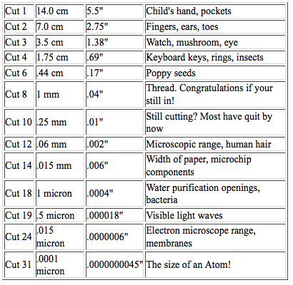
4. Look at the chart below to compare how many cuts you were able to make with the size of an atom.
Questions:
1. How many cuts were you able to make? __________
2. What is the closest item to your cut? ____________
3. What does this tell us about the size on an atom?
____________________________________________
Making a model of an atom

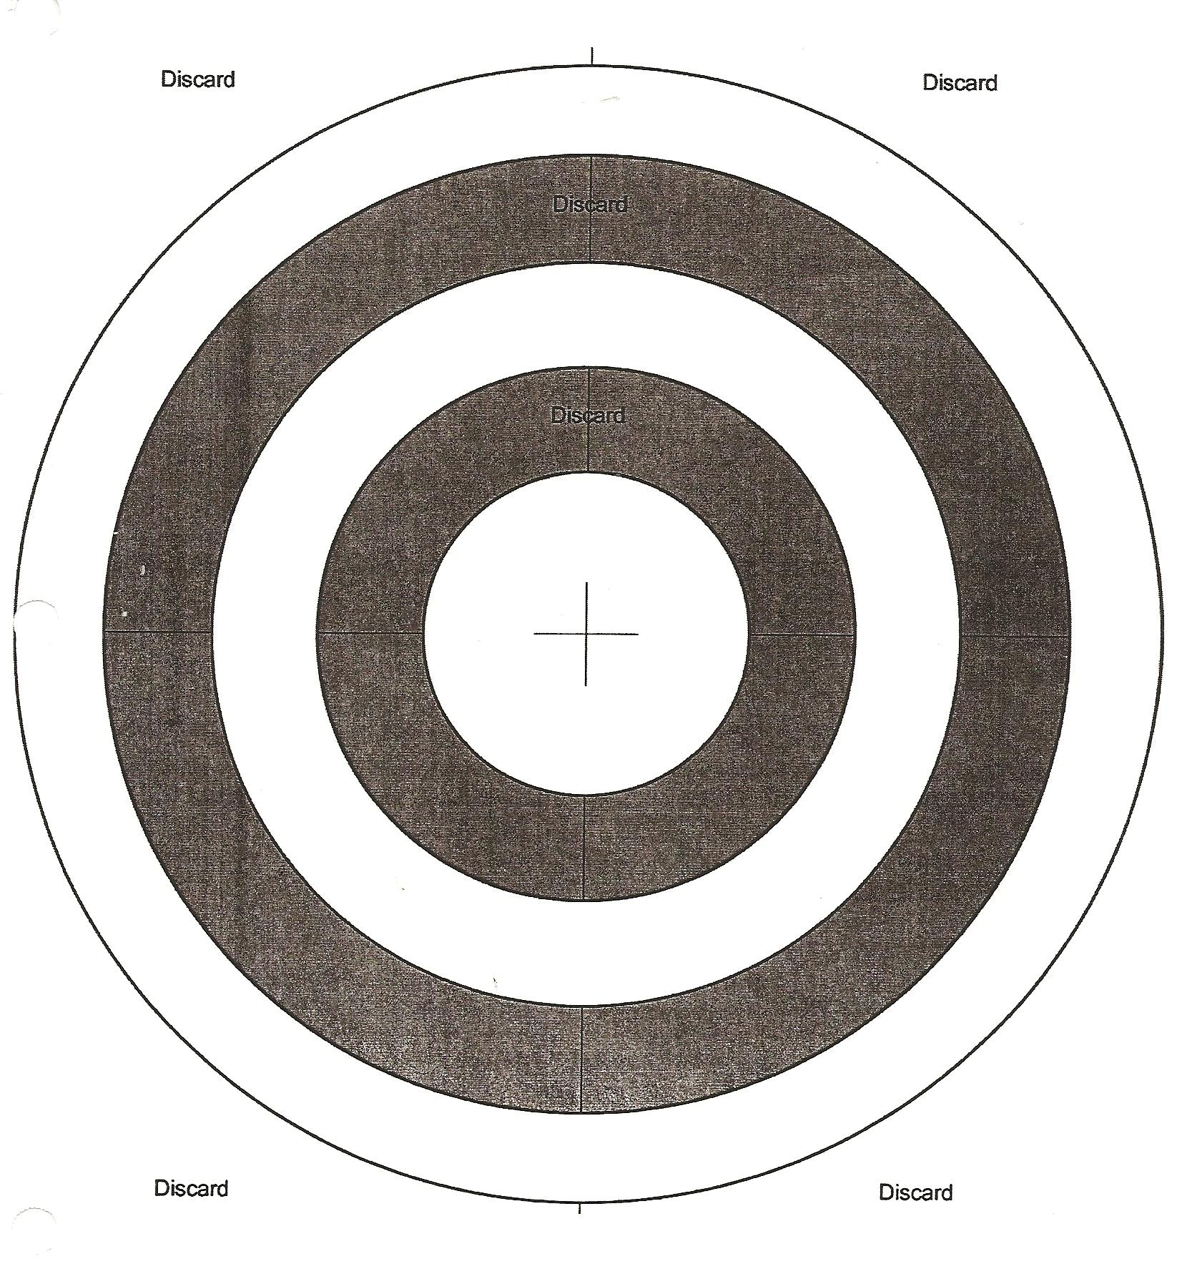
Materials: Penny and dime – 2 per group, yellow, green and red strips of paper ½” x8 ½”, hole punch, scissors, glue
What To Do:
1. Cut out pattern – Discard black circles and keep white circles and middle.
2. Make neutrons – fold yellow strip of paper in half 2 times. Use penny to draw a pattern and make 2 circles. Cut through all layers. Give each a 0 sign.
3. Make protons – fold a green strip of paper in half 2 times. Use a dime to draw a pattern and make 2 circles. Cut through all layers. Give each a + sign.
4. Make electrons – use hole punch on red paper. Make 10 circles. Give each a – sign
5. Fill the nucleus with 5 protons and 6 neutrons. Arrange the 5 protons and 6 neutrons close together and slightly overlapping to represent an area of high density. Cut away any pattern that is visible.
6. Glue to the center on the next page.
7. Glue the small ring around the nucleus. This is the energy level that is closest to the nucleus. There are never more than 2 electrons in this ring. Glue 2 electrons on it opposite each other.
8. Go to the outer ring and glue it down. This is the next energy level. Glue 3 electrons in this level.
9. Cut out and glue in the labels in the correct space.

Questions:
1. How many protons and what are their charges? _______
2. How many neutrons and what are their charges? ______
3. How many electrons and what are their charges? ______
4. What is the smallest particle? _____________________
5. What is the largest particle? ______________________
6. How many energy levels are in this atom? __________

DO NOT GLUE IN THIS PAGE!!!

Nucleus | Electron Cloud | Protons
Electron | Neutron | Energy Level

Name __________________ period _____
EXIT TICKET
Inside An Atom

1. Where are the protons located in the atom?

A. Inside the neutrons
B. Inside the nucleus
C. Inside the electron cloud

2. Where are the neutrons located in the atom?

A. Inside the protons
B. Inside the nucleus
C. Inside the electron cloud

3. Where are the electrons located in the atom?

A. Inside the neutrons
B. Inside the nucleus
C. Inside the electron cloud

4. Which particle inside the atom has a positive charge?

A. protons
B. electrons
C. neutrons

5. Which particle inside the atoms has a negative charge?

A. protons
B. electrons
C. neutrons

Name __________________ period _____
EXIT TICKET
Inside An Atom

1. Where are the electrons located in the atom?

A. Inside the neutrons
B. Inside the nucleus
C. Inside the electron cloud

2. Which particle inside the atom has a positive
charge?

A. protons
B. electrons
C. neutrons

3. Which particle inside the atoms has a negative
charge?

A. protons
B. electrons
C. neutrons
4. Where are the protons located in the atom?

A. Inside the neutrons
B. Inside the nucleus
C. Inside the electron cloud

5. Where are the neutrons located in the atom?

A. Inside the protons
B. Inside the nucleus
C. Inside the electron cloud

