A Deeper Look at Atoms

We have learned that the structure of the atom contains a nucleus and an electron cloud. We also learned that the nucleus contains the protons and neutrons while the electron cloud contains the electrons.
Protons determine the identity of the element. If an element has 2 protons it is the element Helium. If the element has 10 protons it is the element Neon. Protons have a mass of approximately 1 amu (atomic mass unit) and have a positive electrical charge.
Neutrons are also in the nucleus with the protons. They also have a mass of approximately 1 amu. So, they are about the same size as a proton. They have no electrical charge and are considered neutral.
Electrons move around the nucleus so fast that it is impossible to know exactly where any electron is at any particular time. The space around the nucleus is a spherical cloud of negatively charged electrons. This is the electron cloud. They have a mass of 1/2000 amu. That’s really small!

Fill in the chart below with the information about the structure of the atom.

Part of Atom | Location within Atom | Atomic Mass | Electrical Charge

Over the years scientists have had many theories about
the structure of the atom. The current theory is called
the electron cloud theory. This theory does not allow
us to study the parts of the atom very easily. An early theory of the structure of the atom came from a
Danish scientist named Neil Bohr. His model
showed electrons moving in specific layers or
orbitals. We use a modified Bohr model to
study the atom. Instead of orbitals we call them
energy levels.

Label each part of the atoms shown below. Use the following words: (nucleus, electron cloud, proton, neutron, electron)
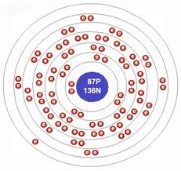
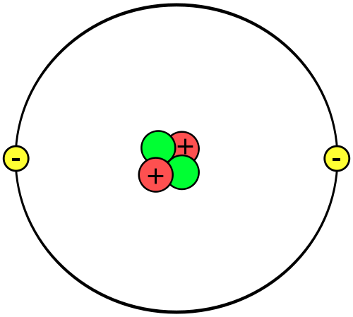
Helium
Francium

Questions:
1. How many protons does Helium have? ______
2. How many protons does Francium have? _____
3. How many energy levels does Helium have? ___
4. How many energy levels does Francium
have? ______

Scientists have rules about the number of electrons that can go into an energy level. The first level can have up to 2 electrons, the second can have up to 8 electrons and the third energy level can have up to 18 electrons.

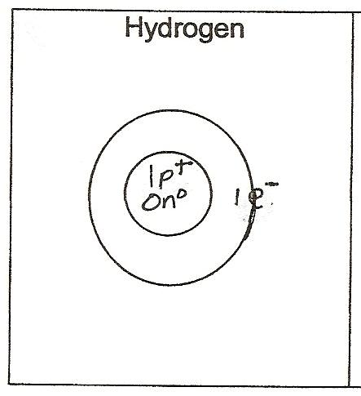
Look at the drawing of the Hydrogen atom. The innermost circle represents the nucleus where the protons and neutrons are located. It has 1 proton represented by a 1p+ and 1 electron represented by a 1e-. It is the only atom that does not have a neutron.

What to do:
1. Place the number of protons in the nucleus.
2. Place the electrons in the energy levels using the rules above.
3. Place the number of neutrons in the nucleus. Remember neutrons have no charge.

Lithium  3 Protons  3 Electrons  4 Neutrons | 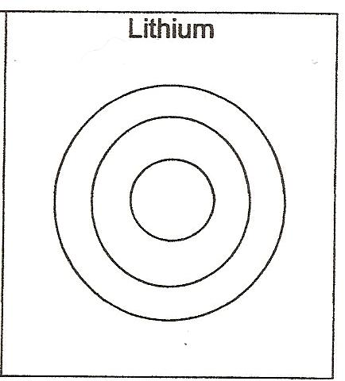

Beryllium  4 Protons  5 Electrons  5 Neutrons | 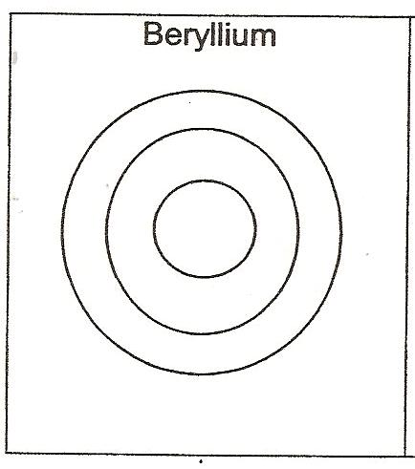
Boron  5 Protons  5 Electrons  6 Neutrons | 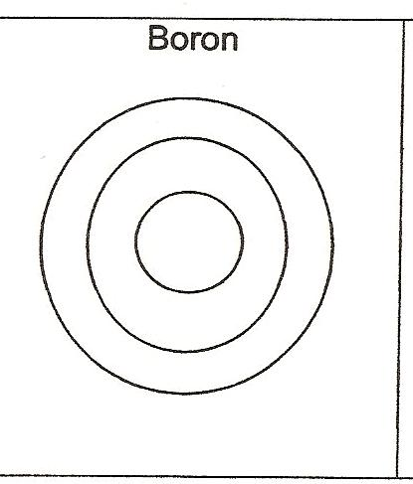
Oxygen  8 Protons  8 Electrons  8 Neutrons | 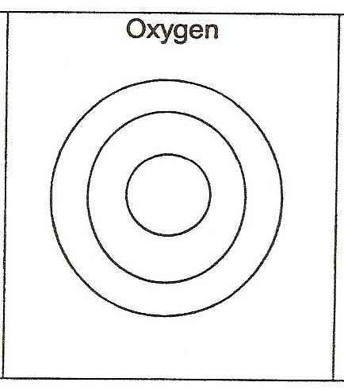

An easy way to remember the particles that make up the atom is to remember the letters PEN! P for protons, E for electrons and N for neutrons.

What to Do:
1. Determine the PEN numbers for the following atoms.
Aluminum  P =  E =  N= | 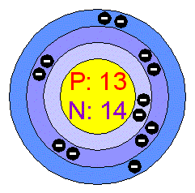
Boron  P =  E =  N= | 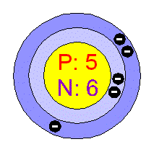
Krypton  P =  E =  N= | 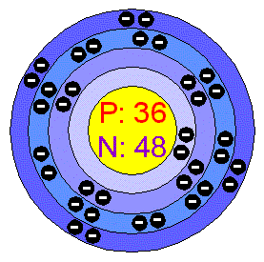

Questions:
1. What is the electrical charge of a proton? _____
2. What is the electrical charge of an electron? ____
3. What is the electrical charge of a neutron? _______
4. Compare the number of protons and electrons in each atom. What pattern to do see? ______________

Watch the BrainPop video on the Atom.

Summarize using a 3-2-1 Strategy.

3 things I learned.

___________________________________________

___________________________________________

___________________________________________

2 things I already knew.

___________________________________________

___________________________________________

1 question I still have.

___________________________________________

Name _______________ period ___
EXIT TICKET
A Deeper Look at Atoms
1. Which particle determines the identity of an element?

A. Proton
B. Electron
C. Neutron
2. Where are protons located in the atom?

A. In the electron cloud
B. Just outside the nucleus
C. Inside the nucleus
3. What is the electrical charge of an electron?

A. Positive
B. Negative
C. Neutral
4. Where are neutrons located in the atom?
A. In the electron cloud
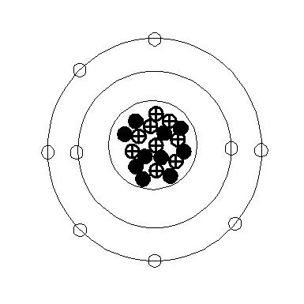
B. Just outside the
nucleus
C. Inside the nucleus

5. What are the PEN numbers for the atom shown?

P =
E =
N =

Name ______________ period ___
EXIT TICKET
A Deeper Look at Atoms
1. What is the electrical charge of an electron?
A. Positive
B. Negative
C. Neutral
2. Where are neutrons located in the atom?
A. In the electron cloud
B. Just outside the nucleus
C. Inside the nucleus
3. What are the PEN
numbers
for the atom shown?

P =
E =
N =

4. Which particle determines the identity
of an element?

A. Proton
B. Electron
C. Neutron
5. Where are protons located in the atom?

A. In the electron cloud
B. Just outside the nucleus
C. Inside the nucleus

