Reviewing the Periodic Table

The Periodic Table organizes information about elements and their properties. Each box on the Periodic Table represents one element. The number at the top of the box is the atomic number. The number at the bottom of the box is the atomic mass. The first letter of the chemical symbol for each element is a capital letter. If there is a second letter it will always be in lower case. Elements are classified as metals, metalloids and nonmetals. On the left side of the Periodic Table we find the metals. On the right side of the Periodic Table we find the nonmetals. The elements along the zigzag line are called metalloids. The vertical columns on the Periodic Table are called groups or families. The horizontal rows on the Periodic Table are called periods.

Use the large square with Si in it to label the following boxes from the periodic table.
6

C

Carbon

12.011

29

Cu

Copper

63.546

What’s on the table?

Materials: Copy of the Periodic Table, colored pencils
Directions: Find the information below on your Periodic Table.

1. How many groups are on the periodic table? ________

2. How many periods are on the periodic table? _______

4. Find the zigzag line that starts in the group 13. Outline them purple.

5. On the right side of the zigzag line are the nonmetals. Outline them yellow.

6. Metals are located on the left side of the periodic table. The only element on the left side of the periodic table that is NOT a metal is hydrogen. Outline hydrogen in yellow.

7. The rest of the elements are metals. Outline them in green.

8. What is element found in group 1 and period 4?___
9. In what group will you find copper? __________
10. In what period will you find silver? _________
11. What element has the symbol He? _________
12. What element has the symbol Cl? __________
13. What element has the symbol C? ___________
14. How is chlorine classified? __________________
15. How is silicon classified? ___________________
16. How is calcium classified? ___________________

Family match
We have learned the Periodic Table organizes elements based on similar properties. Elements in the same period are arranged in order of increasing atomic number. Elements in the same group or family have similar physical and chemical properties.

Materials: Color set of elements 1 per 2 students
What To Do:
1. Put away your Periodic Table.
2. The cards you have been given belong in family/group 1 and 2.
3. Using their physical properties classify them into two families. Some may not match the others exactly. DO NOT USE YOUR PERIODIC TABLE until told to do so.
4. Group 1, called the alkali metals, are all shiny, soft and slivery. Group 2, called alkaline earth metals are shiny, solid and slivery-white.
5. When you think you have the groups separated correctly, place their atomic number and chemical symbol in the boxes on the next page.
6. Be sure to place the numbers in descending order.
7. Now take out your Periodic Table and change any answers you got wrong.

Questions:
1. Which elements are missing from Group 1? ________
2. Why do you think they are missing? ________________
3. Did all the elements in Group 2 fit the pattern? ____
4. Which one(s) didn’t fit? ______________________

Group 1 Group 2

Alkali Metals Alkaline Earth Metals

Name __________________ period ______
EXIT TICKET
Reviewing the Periodic Table
How should these element symbols be written?
1. CA _________________
2. mg _________________

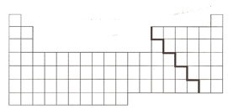

3. In the periodic table above use a blue colored pencil to color in an entire group.

4. In the periodic table above use a yellow colored pencil to color in an entire period.

5. Why are groups sometimes referred to as families?

__________________________________________
_________________________________________

Name __________________ period ______
EXIT TICKET
Reviewing the Periodic Table
How should these element symbols be written?
1. RA _________________
2. ag _________________

3. In the periodic table above use a green colored pencil to color in an entire group.

4. In the periodic table above use a pink colored pencil to color in an entire period.

5. Why are groups sometimes referred to as families?

__________________________________________
__________________________________________

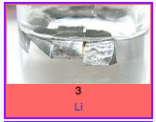 |  | 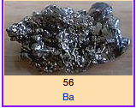
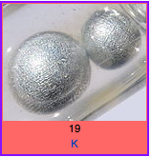 |  | 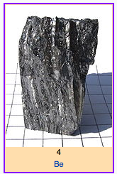
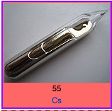 |  | 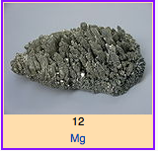
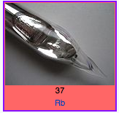 |  | 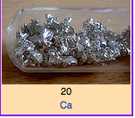
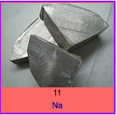 |  | 