What are Valence Electrons?

The number of electrons in the last energy level in an element is known as the valence electrons. Valence electrons are very important when trying to determine if an element will react with other elements to form compounds. To determine the number of valence electrons you must count the number of electrons in the last energy level.
Remember that the 1st energy level can have up to 2 electrons, the 2nd energy level can have up to 8 electrons and the 3rd can have up to 18 electrons.
Why are Valence Electrons Important? When the outermost energy level of an atom contains the maximum number of electrons, the level is full or complete. Atoms that have complete (filled) outermost energy levels are very stable. They usually do not combine with other atoms to form compounds. They do not form chemical bonds.
Elements that do not have filled energy levels will react with other elements. The fewer the number of valence electrons the more reactive the element will be.

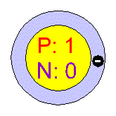
Look at this model of Hydrogen.
1. How many energy levels does it have? _____
2. How many electrons are in the level? _______
3. How many more electrons could go in this level? _____
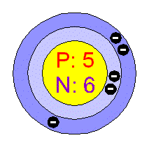
4. How many energy levels does Boron have? _____
5. How many electrons are in the last level? _______
6. How many more electrons could go in this level? _____

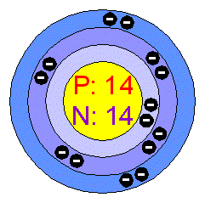
7. How many energy levels does Silicon have? _____
8. How many electrons are in the last level? _______
9. How many more electrons could go in this level? _____
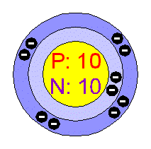
10. How many energy levels does Neon have? _____
11. How many electrons are in the last level? _______
12. How many more electrons could go in this level? _____

So Neon is a stable element. It does not combine with any other element to form a compound. Its family is known as the Noble gases and none of them react with other elements to form compounds.

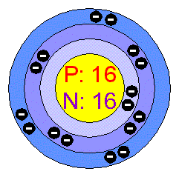
Look at this the model of Sulfur.
13. How many energy levels does Sulfur have? _____
14. How many electrons are in the last level? _______
15. How many more electrons could go in this level? _____

This means that Sulfur can combine with up to 2 other elements. So, Sulfur is more reactive than Neon.
Question:
1. What determines the reactivity of an element?

________________________________________

What is reactivity?

Materials: SEPUP tray, small piece of aluminum foil, iron washer, zinc shot, stirring stick, dropping bottle of copper chloride solution, paper towels

What To Do:
1. Observe each item and write your observations in the BEFORE column below.
2. Crumple up the aluminum foil and place it in cup 1 of the SEPUP tray.
3. Place the iron washer in cup 2 of the SEPUP tray.
4. Place the zinc shot in cup 3.
5. Place 10 drops of the copper chloride solution in
each cup and observe.
6. Use the stirring stick to take each object out of the cups and place them on a piece of paper towel.
7. Observe each of the objects and write your observations in the AFTER column.
8. Observe the color of the copper chloride solution and record your observations before and after in the chart below.

Observations:
 |  |  |  | Copper Chloride Solution
Cup | Object | Before | After | Before | After
1 | Aluminum Foil
2 | Iron washer
3 | Zinc Shot

Questions:

1. What happened when you placed the copper chloride solution on the aluminum? ____________
2. What happened when you placed the copper chloride solution on the iron washer? ___________
3. What happened when you placed the copper chloride solution on the zinc? ________________
4. Why do you think these things happened?
___________________________________________

Watch the video “Brainiac Alkali metals.

Fill in the chart with the names and reaction to water for each element shown.

Element | Reaction to water

What do you predict would happen if they had placed Francium in water?

Name ________________ period _____
EXIT TICKET
Valence Electrons

1. Valence electrons are found -

A. in the first energy level
B. in the second energy level
C. in the last energy level

2. How many valence electrons are shown in the picture below?

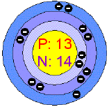

A. 3
B. 13
C. 14

3. Valence electrons are important because –

A. They tell us how reactive an element is.
B. They tell us if an element is a metal or nonmetal
C. They tell the element’s color

4. How many electrons does it take to fill the 3rd energy level?

A. 18
B. 8
C. 2

Name ________________ period _____
EXIT TICKET
Valence Electrons

1. Valence electrons are important because –

A. They tell us how reactive an element is.
B. They tell us if an element is a metal or nonmetal
C. They tell the element’s color

2. How many electrons does it take to fill the 3rd energy level?
A. 18
B. 8
C. 2

3. Valence electrons are found -

A. in the first energy level
B. in the second energy level
C. in the last energy level

4. How many valence electrons are shown in the picture below?

A. 3
B. 13
C. 14

