Moves up | Moves down | Moves left
Moves right | Stays still | 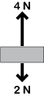  A
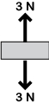  B | C | 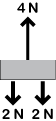  D
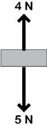  E | F | 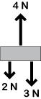  G
H | 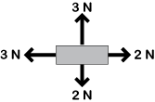  I | 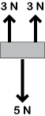  J
K | L | M

