Measuring and Calculating Speed

When objects are in motion you can calculate their speed. Speed is always written as a unit rate - either miles per hour or meters per second. The speed of an object is determined by the amount of time it takes that object to move over a distance. When you travel in a bus or car you can say you are traveling 35 miles per hour (mph). That is your speed. So to measure your speed you must have a distance (miles, meters, kilometers) and a time (seconds, minutes, hours).

Materials: masking tape, marker, motorized car,
meter stick, timer, calculator

What To Do:
1. Make a 1-meter track for your car with a large sheet of paper. Tape it to the table with the masking tape.
2. Use the marker to mark START and FINISH like
shown on the diagram below.

1 meter
START
FINISH

3. Check your timer to make sure it is set at 00:00.
4. Put your notebooks at the end of the table to keep
the car from falling off the table.
5. Put the car on the START LINE.
6. Start the timer and start the car.
7. Stop the timer when it reaches the FINISH line.
8. Record the time in the data table below.
9. Repeat the time trials for a total of 3 times.

Observations:

 | Trial 1 | Trial 2 | Trial 3 | Total | Average Time
Number of seconds

10. Use the calculator to determine the total and the average time.

Questions:
1. What was the distance the car traveled on each trial?___
2. What was the average time for the 3 trials? __________
The relationship between speed and distance is written
like this:
Speed = distance moved
time

3. Speed is equal to the distance moved divided by average time. In our lab we found that

Speed = __________ ÷ _________ = ____________
distanced moved average time

4. When writing speed you must use the distance and time units. A car goes 65 mph, which means miles per hour.

What is the unit for speed in this lab?

______________ per ______________.

Speed Problems:

1. A train traveled 100 kilometers in 2 hours. What was its speed? ____________
2. A bullet traveled 60 kilometers in 60 seconds. What was its speed? ____________
3. A runner traveled 5 kilometers in 25 minutes. What was her speed? _________
4. A car traveled 60 kilometers in 1 hour. What was its speed? ____________
5. A bus traveled 35 kilometers in 60 minutes. What was
its speed? ____________

Write a speed problem to share with a classmate.

Speed can be placed on a line graph. The shape of the line will tell you about the motion of the object. Time is always plotted on the X-axis. Distance is always plotted on the y-axis.

Look at the graph below about the speed of a train.

Questions:
1. What is missing that would make this an excellent graph? ________________________
2. What is the speed of the train after 1 hour? __________
3. What is the speed of the train after 3 hours? _________
4. When the speed of an object stays the same, scientists call it having “constant” speed. Does the train have constant speed? _________________

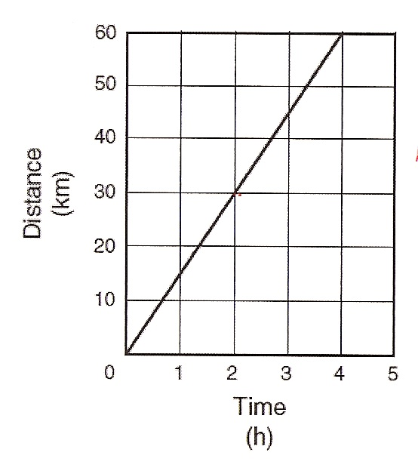

The shape of the line on a distance-time graph

can tell you about the motion of the object.
Questions:
1. From the graph below calculate the speed of the car at
2 seconds. ___________________

2. From the graph below calculate the speed of the car at
4 seconds. ____________________

3. From the graph below calculate the speed of the car at
10 seconds. ________________

When an object stays at the same speed scientists call it constant speed. When you see a graph like this it tells you the object is moving at a constant speed.

4. What is the shape of the line?
____________________________________________

5. What would you have to do to your car to get this type
of graph? ___________________________________

6. Let a student volunteer use the motorized car again to make
the car do what the graph shows.
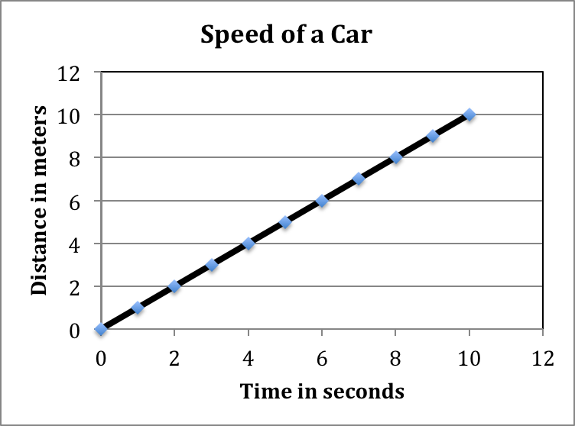
Look at the graph below and calculate the

speed indicated.

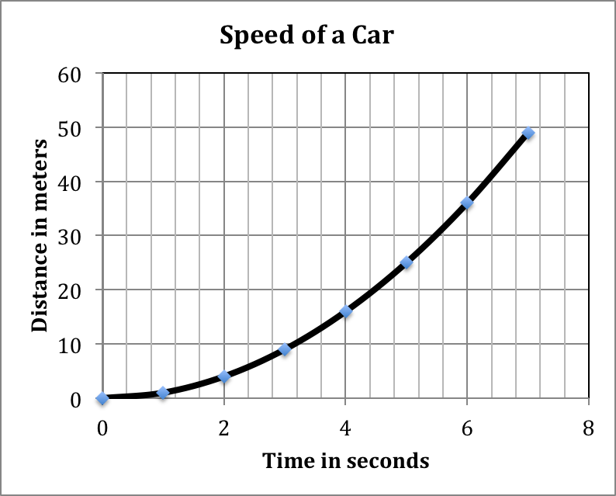

1. Calculate the speed of the car at 2 seconds. _________

2. Calculate the speed of the car at 4 seconds. ________

3. Calculate the speed of the car at 6 seconds. ________

4. What is happening to the speed of the car? ____________

5. How is the shape of the graph different from the previous graph? _____________________________________

6. What would you have to do to your car to get this type of graph? ______________________________________

When an object speeds up at a steady rate scientists call this increasing speed. When you see a line such as this it tells you the object is increasing its speed.

Name _______________ period _____
EXIT TICKET
Measuring and Calculating Speed
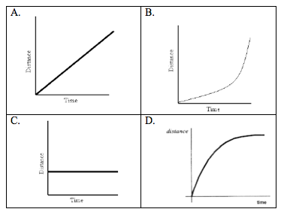

1. Which of the graphs above shows an object traveling at constant speed?

A. B. C. D.

2. Which of the graphs above shows an object traveling at increasing speed?

A. B. C. D.

3. What is the speed of an object that travels 50 m in 25 sec.?

Name _______________ period _____
EXIT TICKET
Measuring and Calculating Speed

1. What is the speed of an object that travels 60 m in 5 sec?

2. Which of the graphs below shows an object traveling at increasing speed?

A. B. C. D.

3. Which of the graphs below shows an object traveling at constant speed?

A. B. C. D.

