Acceleration

When you first get into a car, hopefully it is at rest. Remember, when an object is not moving, it is at rest. After the car is started and in placed in gear it starts to move. This movement is called acceleration. Usually we think that only if a car is going faster and faster it is accelerating. But a car accelerates when it speeds up, slows down or changes direction. So the next time you come to a traffic signal and the car slows down – you are accelerating. When you turn the corner, you are accelerating and when you speed up after the traffic signal, you are accelerating! You can tell the difference between speed and acceleration by looking at the units. Speed is m/s while acceleration is m/s².

Part 1

Materials: balloon, student volunteer, green, yellow, orange and blue colored pencils
What To Do:
1. Observe the student volunteer blow up the balloon.
2. Observe the balloon while the student volunteer holds
it closed.
3. Answer the questions (1 & 2)
4. Observe what happens to the balloon when it is let go.
5. Draw the path of the balloon in the box.

Questions:
Speeding Up-Acceleration
1. What is the motion of the balloon at this time? __________________________________________
2. What will happen when the student lets the balloon
go? _______________________________________

Path of the balloon

6. Use the yellow colored pencil to show when the balloon was at rest.
7. Use the green colored pencil to show when the balloon was speeding up.
8. Use the blue colored pencil to show when the balloon was changing direction.
9. Use the orange to show when the balloon was slowing down.

Part 2
Materials: 2 books, ramp, toy car, sheet of paper
What To Do:
1. As we learned in the last activity, acceleration is an object speeding up, slowing down or changing direction.
2. Use the objects listed in the materials to demonstrate each type of acceleration.
3. Draw your three set-ups in the space below and on the next page.
4. Show your teacher each type of acceleration.

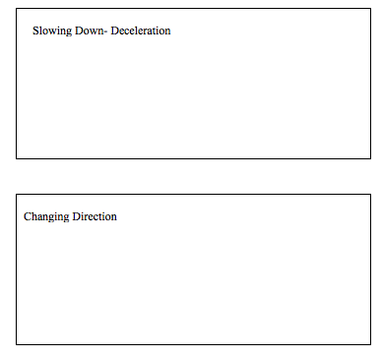
Questions:

1. What did you have to do to the car to make it speed up? _______________________________________

2. What did you have to do to the car to make it slow down? ____________________________________
3. What did you have to do to the car to make it change directions? __________________________________

Speed-time graphs look a lot like distance time graphs so be sure to look at the y-axis label. As with the distance-time graph, time goes on the X-axis. Speed – in m/s- goes on the Y-axis. Graph the following data.

Time  sec |   Speed  m/s
0 | 5
1 | 5
2 | 5
3 | 5
4 | 5
5 | 5

Questions:
1. Describe the motion of this object. ________________
2. What is the shape of the line? ____________________
3. How is it different from constant speed on a distance-time graph? ____________________________________

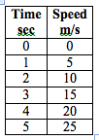

Questions:
1. Describe the motion of this object. ________________
2. What is the shape of the line? ____________________
3. How is it different from a distance-time graph? ______________________________________________
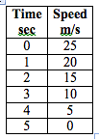

Questions:

1. Describe the motion of this object. ________________
2. What is the shape of the line? ____________________
3. How is it different from a distance-time graph? ______________________________________________
The graph below shows how the speed of a bus changes during part of a journey.
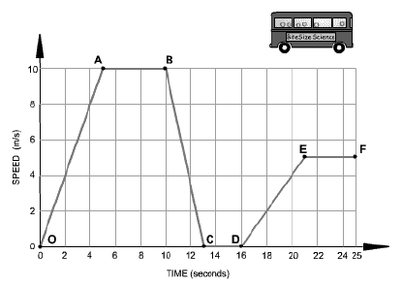
Label the lines of the graph with the following words.
- Speeding Up
- Slowing Down
- Constant speed
- At rest

Speed, Velocity, or Acceleration?

Materials: scissors, glue
What To Do:
1. Cut the squares below apart.
2. Determine if they are describing speed, velocity or acceleration.
3. Glue them in the correct column on the next page.
An airplane slows down at a rate of 3 m/s²   | Geese fly about 64 kilometers per hour when they migrate South.   | A storm moves East toward Houston at 30 km/hr  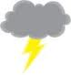
Ms. Baez ran a marathon 26.2 miles in 3 hours.   | A downhill skier leans down as she makes a turn down the slope.   | Jason rode his skateboard 10 meters in 1 second.  
A car drives North at 400 kilometers per hour.  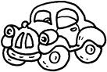 | A snail moves 0.013 meters in 1 second.  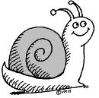 | A soccer ball rolls to a stop  
The runners increase their speed as they near the finish line   | A bamboo plant grows 3.75 cm Up taller in one hour.   | The cheetah moved at a rate of 3 m/s  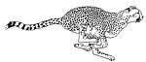

Speed | Velocity | Acceleration
Name ___________________ period _____

EXIT TICKET
Acceleration
1. Which of the following is written as acceleration?
A. 4
B. 4 m
C. 4 m/s
D. 4 m/s²

2. Which of the follow is NOT considered acceleration?
A. Speeding up
B. Slowing down
C. Being at rest
D. Changing direction

3. Which line segments in the graph below show constant speed?
_______________________________________________

Name ___________________ period _____

EXIT TICKET
Acceleration
1. Which of the follow is NOT considered acceleration?
A. Speeding up
B. Being at rest
C. Slowing down
D. Changing direction

2. Which of the following is written as acceleration?
A. 4 m/s²
B. 4 m
C. 4 m/s
D. 4

3. Which line segments below show speeding up?
_____________________________________________

