Newton’s First

Isaac Newton was an English physicist and mathematician who helped develop calculus, built the first practical reflecting telescope and developed a theory of color using a prism. He also formulated his laws of motion all in the late 1600s.
His first law of motion is called the Law of Inertia. It states that objects in motion tend to stay in motion unless acted on by an unbalanced force. It also states that an object at rest will stay at rest unless act on by an unbalanced force.
Inertia is the tendency of an object to resist change. If it is moving it will continue to move until acted upon by an unbalanced force. If it is at rest it will continue to be at rest until acted upon by an unbalanced force.

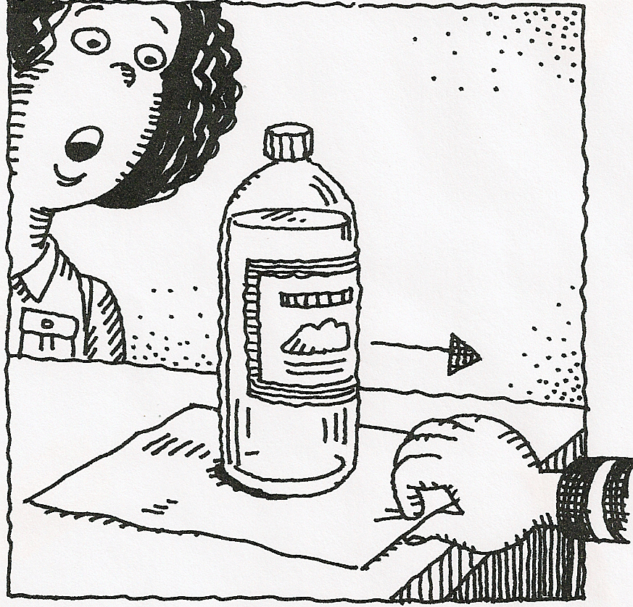
Materials: 2-liter soda bottle filled with water, piece of paper
What To Do:
1. Take a look at the picture to the right.
2. Predict what will happen when your teacher pulls the paper from under the bottle.

3. Watch your teacher perform the demonstration. Describe what happened.
_______________________________________________

4. How does this illustrate the idea of inertia?
_______________________________________________
_______________________________________________

Materials: Toy car, penny, 3 books same height,
small book, ramp, meter stick or ruler
What To Do:
1. Set up your ramp to look like the picture except use only one book for the height of the ramp.
2. Place the small book at the end of the ramp to stop the car.
3. Place the penny on top of the car and let it roll down the ramp.
4. Use the ruler or meter stick to measure how far the penny goes from the end of the ramp.
5. Add another book and repeat.
6. Add a third book and repeat.
7. Record your measurements in the data table.
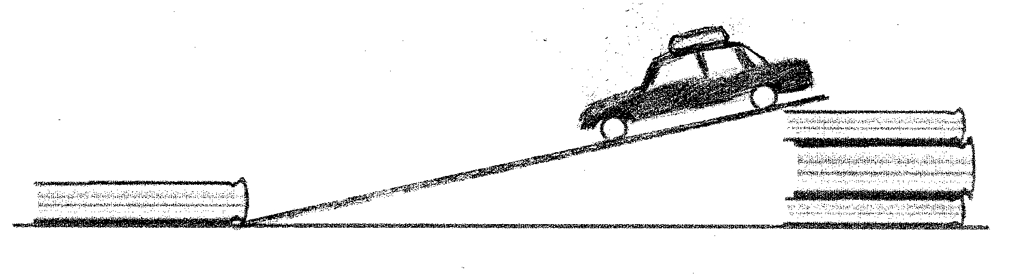
Number of Books | Distance Penny Traveled in cm
1
2
3
Questions:
1. In this activity we changed the number of books that were under the ramp. How did this change the motion
of the car? ________________________________
2. What happened to the penny? ________________
3. Why did the penny continue to move?
____________________________________________
4. How does the action of the car and the penny illustrate Newton’s first law of motion?
____________________________________________
____________________________________________

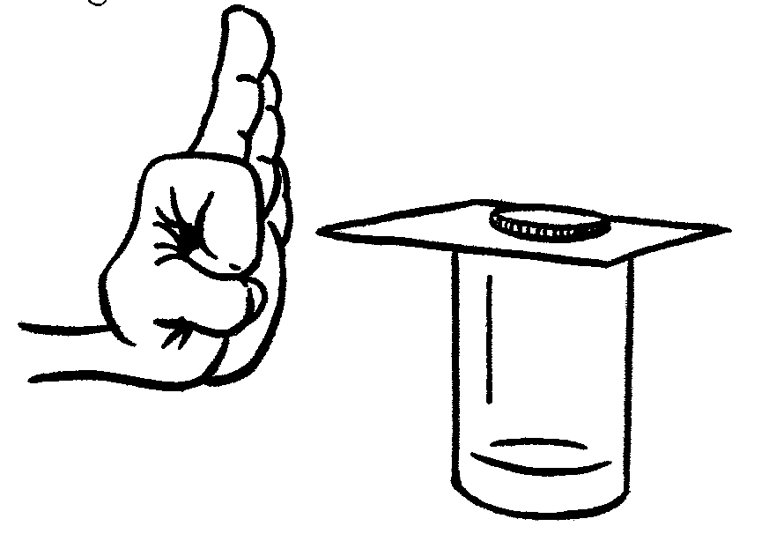
Materials: Beaker, penny and index card
What to Do:
1. Lay an index card on the top
of the beaker.
2. Place a penny on the card, centered over the beaker.
3. With a flick of your finger, give the card a quick thump.

1. What force acted on the card to make it move?
_____________________________________________
2. What force acted on the penny to make it move?
______________________________________________

3. How does this activity illustrate Newton’s First Law?
_______________________________________________

_______________________________________________

Watch the animation called Car and the Wall
from the website http://www.physicsclassroom.com/mmedia/newtlaws/cci.cfm
Describe what happens to the guy in the car after it hits the wall.
_______________________________________________

According to Newton’s first law of motion why does this happen?
_____________________________________________

Watch the Inertia video from www.missdoctorbailer.com.

How does the video describe Newton’s First Law?

________________________________________

________________________________________

On the lines below write 3 sentences telling why Newton’s Law of Inertia means we need to wear seatbelts in a car.

_____________________________________________

_____________________________________________

_____________________________________________

_____________________________________________

Name __________________ period ____
Exit Ticket
Newton’s First

1. Imagine a place in the cosmos far from all gravity and friction. Suppose you visit that place and throw a rock. Which of the following will the rock do?

A. Continue in motion in a straight line
B. Continue in motion until gravity pulls it down.
C. Not move out of your hand
D. Drop straight to the ground.

2. The tendency of an object to resist change is called -

A. Friction
B. Motion
C. Inertia
D. Force

3. What type of force will make an object move or change its motion?

A. Balanced force
B. Unbalanced force

4. Who was the scientist that developed the Laws of Motion?

A. Galileo
B. Newton
C. Armstrong

Name __________________ period ____
Exit Ticket
Newton’s First

1. What type of force will make an object move or change its motion?

A. Balanced force
B. Unbalanced force

2. Who was the scientist that developed the Laws of Motion?

A. Galileo
B. Newton
C. Armstrong

3. Imagine a place in the cosmos far from all gravity and friction. Suppose you visit that place and throw a rock. Which of the following will the rock do?

A. Continue in motion in a straight line
B. Continue in motion until gravity pulls it down.
C. Not move out of your hand
D. Drop straight to the ground.

4. The tendency of an object to resist change is called -

A. Friction
B. Motion
C. Inertia
D. Force

