Newton’s Third

The third law of motion states that for every action there is an equal and opposite reaction. It is called the Law of Action-Reaction. When you sit in a chair you push down on the chair and the chair pushes back on you. This is action-reaction. If you were at the Galleria, with your friends at the ice skating rink and you pushed your friend’s shoulder, your friend’s shoulder will push back on you.
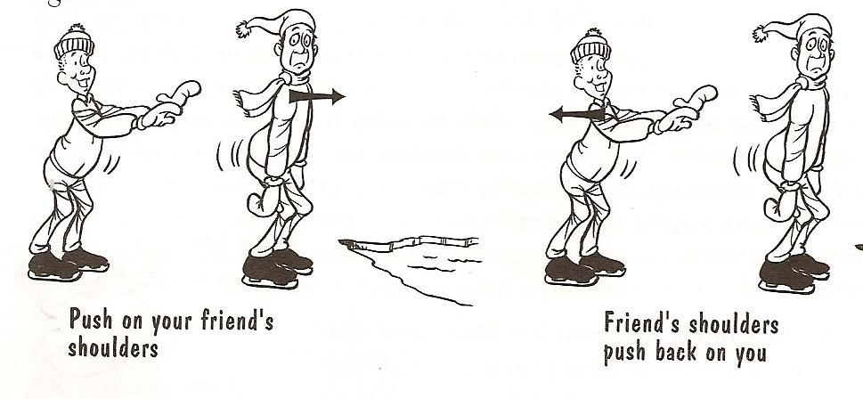

Label each action and reaction in the picture above.
Let’s try it with 2 skateboards.

Materials: 2 skateboards, 2 student volunteers
What To Do:
1. Two student volunteers will each stand on a skateboard both facing the same direction.
2. The student in back with GENTLY push the other student.
3. Observe what happens to both students.
4. Draw it below. Label the action and the reaction.

Materials: Newton’s Cradle or video from www.missdoctorbailer.com
What To Do:
1. Observe the Newton’s Cradle your teacher shows you.

Predict what will happen when one ball is lifted and allowed to swing and hit the other balls.

___________________________________________

Predict what will happen when two balls are lifted and allowed to swing and hit the other balls.

___________________________________________

Predict what will happen when three balls are lifted and allowed to sing and hit the other balls.

_____________________________________________

What happened in each instance? ____________________

_______________________________________________

How does this illustrate Newton’s third law of Motion?
_____________________________________________
_____________________________________________
_____________________________________________

Watch the Action-Reaction video from www.missdoctorbailer.com.

Rockets are able to blast off because of Newton’s
third law. The rocket carries “propellants” which
are basically things that explode when you mix
them together and ignite them. The gasses from the controlled explosions are forced out of the rear of the rocket. The rocket pushes the gases out at a really high speed. The gases push back and the rocket accelerates. Because rockets push on these gases instead of pushing on air they don’t need air molecules and can cruise along just fine in outer space.

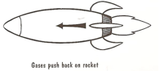
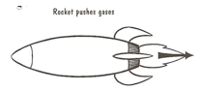

Materials: vinegar, baking soda, water bottle, beaker with measurements, medicine cup with measurements, tissue, spoon, rocket pattern, index card, cork, paper clip, tape
What To Do:
1. Use the medicine cup to measure 2 ounces of baking soda.
2. Place it in the tissue and roll it up to a size that will fit into the water bottle opening. But don’t put it in the bottle yet.
3. Place 100 mL of vinegar in the water bottle.
4. Use the rocket pattern to trace a rocket on the index card.
5. Unbend the paper clip one time and push it into the cork. Tape the rocket pattern to the paper clip.(See picture on next page.)

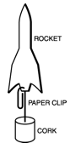
6. Go outside with your teacher.
7. One group at a time will launch
their rocket by putting the baking
soda packet into
the bottle and putting
the cork firmly into the bottle.
8. For safety everyone will
stand back from the launch pad and
watch.
9. After each group has launched their rocket gather up all materials and return to the classroom.
Questions:
1. What happened inside the water bottle? __________
____________________________________________
2. What did the mixing of baking soda and vinegar produce? ____________________________________
3. How did this help the rocket launch? ___________
___________________________________________
4. The gas from the baking soda and vinegar pushed on the rocket and the rocket pushed back. Which had the stronger force? ______________________________________
5. What was the action? __________________________
6. What was the reaction? _______________________

Name __________________ period ____
Exit Ticket
Newton’s Third

1. Which of the following is Newton’s third law?

A. Objects in motion will remain in motion.
B. Force equals mass times acceleration.
C. For every action there is an equal and opposite reaction.

2. When a rocket ship blasts off what is the action?

A. The lift off of the rocket.
B. The pushing out of propellants against the earth.
C. The landing of the rock on the moon.

3. Which of the following is an illustration of Newton’s third law of motion?

A. A person flying through a windshield after a crash.
B. Two people on ice skates pushing each other and
both going backward.
C. A car speeding down a hill.

4. According to Newton’s Third Law, if someone jumps off a skateboard, the skateboard will roll backwards because-

A. the mass of the skateboard is the same as the mass of the person jumping off.
B. the pull of gravity on the person is the same as on the skateboard
C. for the force that sent the person forward, there is an equal force pushing back on the skateboard.

Name __________________ period ____
Exit Ticket
Newton’s Third
1. Which of the following is an illustration of Newton’s third law of motion?

A. A person flying through a windshield after a crash.
B. Two people on ice skates pushing each other and both going backward.
C. A car speeding down a hill.

2. According to Newton’s Third Law, if someone jumps off a skateboard, the skateboard will roll backwards because-

A. the mass of the skateboard is the same as the mass of the person jumping off.
B. the pull of gravity on the person is the same as on the skateboard
C. for the force that sent the person forward, there is an equal force pushing back on the skateboard.

3. Which of the following is Newton’s third law?

A. Objects in motion will remain in motion.
B. Force equals mass times acceleration.
C. For every action there is an equal and opposite
reaction.

4. When a rocket ship blasts off what is the action?

A. The lift off of the rocket.
B. The pushing out of propellants against the earth.
C. The landing of the rock on the moon.

