Reviewing Mass and Volume

Balances and scales are used in science to find the mass of an object. Mass measures the amount of matter in an object. Mass is different from weight because weight depends on gravity and mass does not. So if you could fly in the Space Shuttle there is little gravity and you are almost weightless. You may have lost your weight but you did not lose your mass. Weight is measured in pounds and ounces, while mass is measured in grams. Grams are abbreviated with a small g.
In the science laboratory we use a triple beam
balance to measure mass. It has a pan to place the
object to be massed and three beams to calculate the mass. On the beams are movable objects called riders. On the right side is a pointer that tells you when the riders are balanced.

Use the words in the word bank to label the parts of the balance below.
Word Bank
Beams Riders Pan Pointer

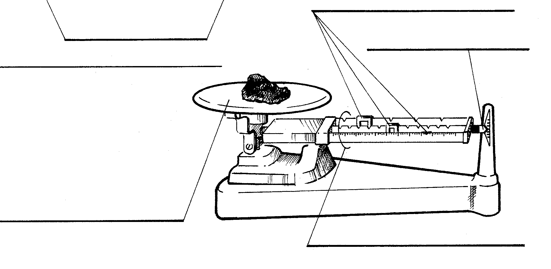

Reading the Triple Beam Balance
Look at the beams below. The middle beam shows the 100’s and the back beam shows the 10’s. The front beam shows the ones and the tenths. So, you add up each of the amounts starting with the middle beam.

Find the mass indicated by each balance below. Don’t forget your units!

1. ____________

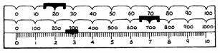

2. ____________
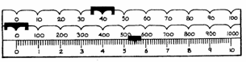

Questions:

1. Which beam on the triple beam balance shows
the 100’s? _________________
2. How are the tenths written? ____________
3. What is the unit for mass? _____________
4. How is it abbreviated? ___________________

Using the Triple Beam Balance

1. Before you start to measure anything with a balance you must ZERO the balance.
2. To zero the balance you must do the following steps:
a. Make sure all riders are set on zero
b. Make sure nothing is on the pan
c. Make sure the pointer is pointing at the zero line.
3. If you have tried to zero your balance and it will not zero, get the teacher to help you.
4. Find the mass of an object by doing the following steps:
a. Place the object on the pan
b. Move the largest rider across the beam until the pointer drops.
***Make sure the rider is pointing at a number - it can’t be between numbers.
c. Then move this rider back one.
d. Move the next rider until the pointer goes down – then move it back one space.
e. Move the smallest rider until the pointer is as the zero line.
f. Add up all the riders to calculate the mass of the object.
Materials: triple beam balance, pair of scissors, block of wood, pencil or pen, Science notebook
What To Do:
1. Find the mass of the objects listed below. Don’t forget
to write the unit for mass!

Object | Mass
1. Pair of scissors
2. Pencil or pen
3. Block of wood
4. Science Notebook

Measuring Liquid Volume
The volume of an object is the amount of space it takes up. Volume is measured using metric units such as milliliters (mL). Liquid volumes are measured in the science laboratory with a graduated cylinder.
Graduated cylinders are made of two different types of material - plastic and glass. Measuring with a glass graduated cylinder is complicated somewhat by a meniscus. A meniscus is the curvature of the surface of the water.
Water “sticks” to the walls of the glass graduated cylinder. When you look at the surface, the water level is not straight. You should always read the measurement at the lowest point of the curve.
You need to read the graduated cylinder at eye level in order to get an accurate reading. You should place the graduated cylinder on the table and then lower your head to be able to read the amount at eye level. A plastic graduated cylinder does not have a meniscus.
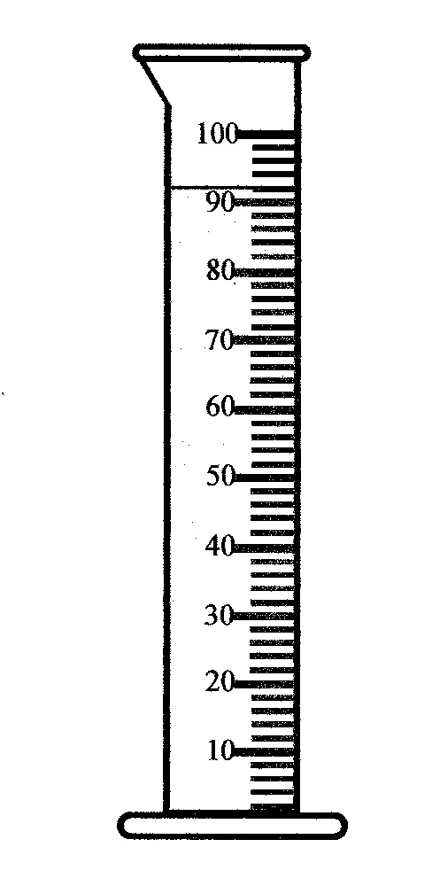
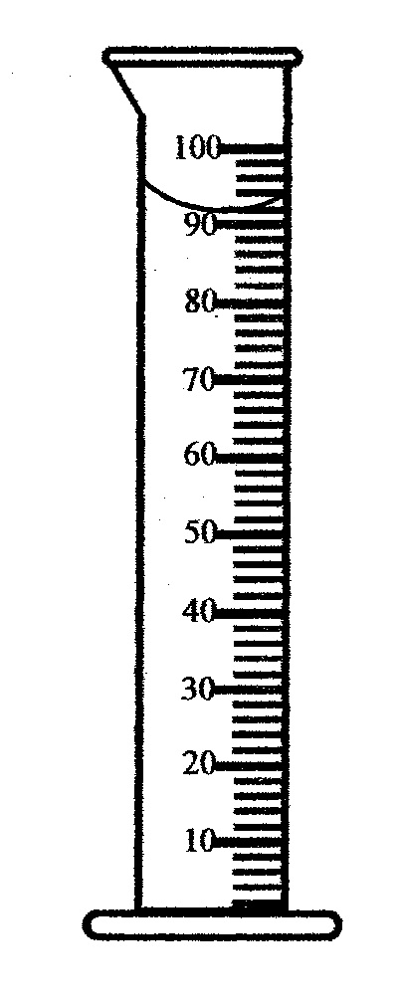
Label the graduated cylinders as glass or plastic.

__________ __________

Using the Graduated Cylinder
On most graduated cylinders each line represents 1mL. Read the following volumes at the bottom curve of the meniscus. Don’t forget your units.
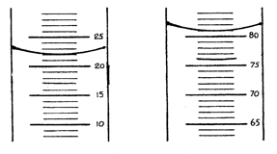

_______________ ______________

When measuring liquids with a graduated cylinder it is important to be accurate. If you want to pour 15 mL of water into a graduated cylinder, put about 12-14 mL in first and then use a medicine dropper to reach the 15mL line. NEVER use the dropper to take liquid out of the graduated cylinder. You will contaminate your sample!

Materials: 1 glass and 1 plastic graduated cylinder for each table, bottle of water, 2 medicine droppers, 2 beakers
What To Do:
1. Fill the beakers about half full with water from the bottle.
2. One student from each side of the table should fill one of the graduated cylinders to a point of their choosing.
3. Have each member of the group read and record the amount you poured then let the other members of the group fill the cylinder and you read it.
4. Record your measurements on the next page.

Name of pourer
Amount of
Liquid in glass cylinder
Amount of liquid in plastic cylinder

Questions:
1. How do you know if a picture of a graduated cylinder is
glass or plastic? _______________________________
2. Where do you read the volume on a glass graduated cylinder?
___________________________________________
3. Explain how can you get an accurate amount of liquid in
a graduated cylinder. ___________________________

________________________________________________
4. What is the unit for volume? ____________________
5. How is it abbreviated? _________________________
6. On the cylinders below mark the amount shown. These
are plastic graduated cylinders.
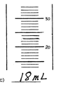
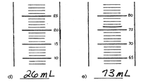

Name ______________ period ______
EXIT TICKET
Reviewing Mass and Volume
1. Read the measurements of each graduated cylinder below. Don’t forget your units!
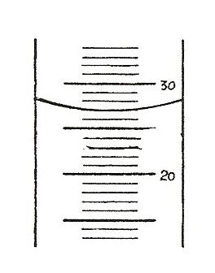
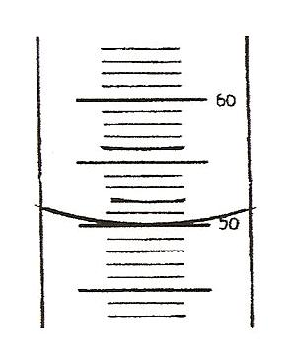

2. Are these plastic or glass graduated cylinders? _______
3. How do you know? _____________________________
4. What is the mass shown on the balance below? _______
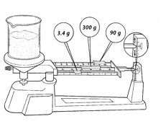

5. What are the movable objects on the beams called?
___________________

Name ______________ period ______
EXIT TICKET
Reviewing Mass and Volume

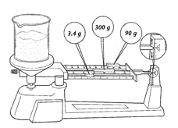
1. What is the mass shown on the balance below? _______

2. What are the movable objects on the beams called?

__________________________________

3. Read the measurements of each graduated cylinder below. Don’t forget your units!

_____

4. Are these plastic or glass graduated cylinders? _______
5. How do you know? ____________________________

