Reviewing Density
Mass and volume are physical properties of matter. Mass and volume have a special relationship. Density is a physical property that describes how much matter is packed into a given space. In other words, density is how much mass is in a given unit of volume.
Which weighs more -a ton of feathers or a ton of bricks? Many students would immediately say, a ton of bricks. But the feathers and the bricks weigh the same and contain the same mass, but the space each ton of matter requires is quite different, so the volume is different. The ton of bricks is packed into a much smaller space than the ton of feathers; this makes the bricks denser than the feathers.

Finding the volume of irregular solids
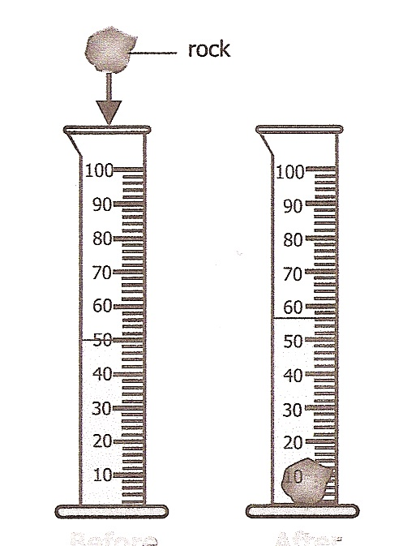
Typically to find the volume of an object you multiply length X width X height but if the object is irregular you must use another method. The easiest is to determine how many mL it displaces when it is put into water. Look at the picture.
1. What is the volume before the rock is placed in the cylinder? __________
2. What is the volume after?
____________
3. What is the difference? __________

The difference or displacement of water tells you the volume in (mL) of the rock.

Materials: Triple beam balance, graduated cylinder, 2 beakers of water, 2 medicine droppers, rock, large hex nut, key, pink eraser
What To Do:
1. Determine the mass of each item using the triple beam balance.
2. Place 40 mL of water in the graduated cylinder.
3. Tilt the graduated cylinder to the side and gently roll one of the items into the water.
- Don’t splash the water or your measurements won’t be exact!
4. Determine the new volume in the graduated cylinder.
5. Record in data table below.
6. Determine the volume of the metal cylinder by subtracting the final volume from the initial volume (40 mL)
7. Empty the graduated cylinder and measure a
different item.

Metal Cylinder | Mass  g | Final Volume  mL | Initial  Volume mL | Volume of object  mL
Rock |  |  | 40
Hex nut |  |  | 40
Key |  |  | 40
Pink eraser |  |  | 40
Questions:
1. Why was important to have items that would sink in the water? ___________________________________
2. What could you do to find the volume if the item did not sink completely?
_____________________________________________

Calculating Density

To calculate the density of an object you must know two things – its mass (g) and its volume (mL). We calculate density by dividing the mass by the volume. That makes the unit for density g/mL.
Materials: calculator
What To Do:
1. Place the information from the previous table in the table below.
2. Calculate the density of each item by dividing the mass by the volume.
3. Record that information below.
Metal Cylinder | Mass  g | Volume  mL | Density g/mL
Rock
Hex nut
Key
Pink eraser

Finding the volume of regular solids
You may remember from math class that to find the volume of a regular solid you multiply length X width X height. When we work with density and the volumes of regular solids we work with the unit of cm³ (cubed). Did you know that 1 mL equals 1 cm³? See if you can calculate the following volumes.

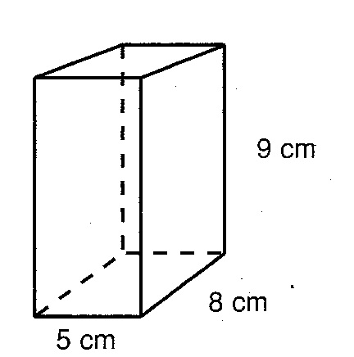
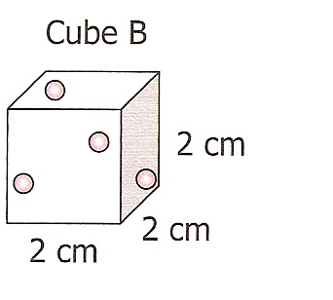

Materials: triple beam balance, ruler, brass, aluminum, steel, copper, plastic and wood cubes, and calculator (Large beaker of water for teacher demo)
What To Do:
1. Determine the mass of each cube using the triple beam balance.
2. Determine the volume of each cube by multiplying the length X width X height.
3. Determine the density of each cube.

Cube | Mass  g | Volume  cm³ | Density  g/cm³
Copper
Aluminum
Steel (gray)
Brass (gold)
Plastic
Wood

Predicting Floating or Sinking
The density of water is 1 g/mL. Any substance that has a density less than 1 g/mL will float on water. Any substance that has a density greater than 1 g/mL will sink in water.
Questions:
1. Which of the cubes do you predict will sink in water?

____________________________________________

2. Which of the cubes do you predict will float in water?
____________________________________________

Watch while your teacher shows you which cube with float in a beaker of water.

Name ________________ period _____
EXIT TICKET
Reviewing Density

1. What is the density of a 50 g object that displaces 10 mL of water?

_____________________

2. What is the density of a 24 g object that displaces 100 mL of water?

____________________

3. What is the density of a 200 g object that has a volume of 50 cm³?

____________________

4. Which of the objects below will float in water? ________

Object | Mass g | Volume cm³
A | 10 | 2
B | 20 | 40
C | 30 | 15

5. Why will the object you picked in question #4 float in water?
______________________________________________

______________________________________________

Name ________________ period _____
EXIT TICKET
Reviewing Density

1. Which of the objects below will float in water? ________________

Object | Mass g | Volume cm³
A | 10 | 20
B | 20 | 4
C | 30 | 15

2. Why will the object you picked in question #1 float in water?
_____________________________________________

_____________________________________________

3. What is the density of a 50 g object that displaces 5 mL of water?

_____________________

4. What is the density of a 26 g object that displaces 100 mL of water?

____________________

5. What is the density of a 200 g object that has a volume of 20 cm³?

____________________

