Revolving and Rotating

Our Solar System is made up of one star, planets, moons, asteroids and comets. We used to have nine planets but now we only have eight. Most diagrams still show Pluto. Pluto doesn't fit with the definition of a planet – it is too small.
One part of the definition of a planet is that is revolves around a sun. One complete revolution around the sun is called a year. A year on Earth is 365 days long. That’s the number of days it takes our planet to orbit the Sun. Some planets have short years while other planets have long years.
Whenever we make diagrams of the solar system there is a major problem. The problem is that the solar system is too big to be shown to the right size on our papers. Problems with diagrams and models like these are called limitations.
Label the Sun and Planets below.
Draw a red circle to trace one revolution of the Earth and one revolution of Neptune.

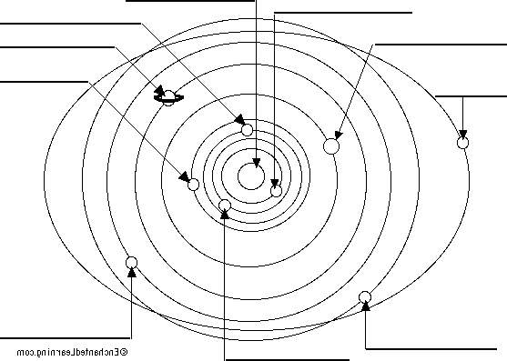

Each planet takes a different amount of time to revolve around the sun. The amount of time a planet takes to revolve around the Sun is called a year.
Materials: calculator
What To Do: Use the chart below to answer the questions.
How Long is the Year?
Planet | Revolution  In Earth Days |  | Planet | Revolution  In Earth Days/Years
Mercury | 88 days |  | Jupiter | 4380 days or  12 years
Venus | 225 days |  | Saturn | 10,950 days or  30 years
Earth | 365 days |  | Uranus | 30,660 days or  84 years
Mars | 687 days |  | Neptune | 60,225 days or  165 years

Questions:
1. Which planet has the shortest year? ______________
2. Why do you think this is true?
____________________________________________
3. Which planet has the longest year? ______________
4. Why do you think this is true? ___________________
5. About how old would you be if you lived on Mercury? __________________________
(Hint: Divide 365 by 88 and then multiply your age by that number.)
6. How many Earth years would you need to live in order to be two years old on Neptune? _______________

7. The diagram of the solar system can be thought of as a model. What limitation does it have? ______________

Watch the video called The Earth’s Perfect Orbit. Write down two facts from the video on the lines below.
__________________________________________
_________________________________________
The imaginary line that passes through Earth’s center and the North and South poles is called Earth’s axis. The north end of the axis currently points toward a point in space near Polaris, the North Star. Earth’s spinning on its axis is called its rotation. Earth’s rotation on its axis causes day and night. It takes the Earth about 24 hours to rotate once on its axis. As you know, each 24-hour cycle of day and night is called a day. The equator is the imaginary line that goes around the middle of the earth
Materials: colored pencils
What To Do:
1. Label the North and South poles.
2. Draw a red line from the North to the South Pole to show
the Earth’s axis. Label it.
3. Trace over the equator with a green colored pencil
4. Label the Sun and color it yellow.
5. Label the portion of the Earth facing toward the Sun “Daytime.”
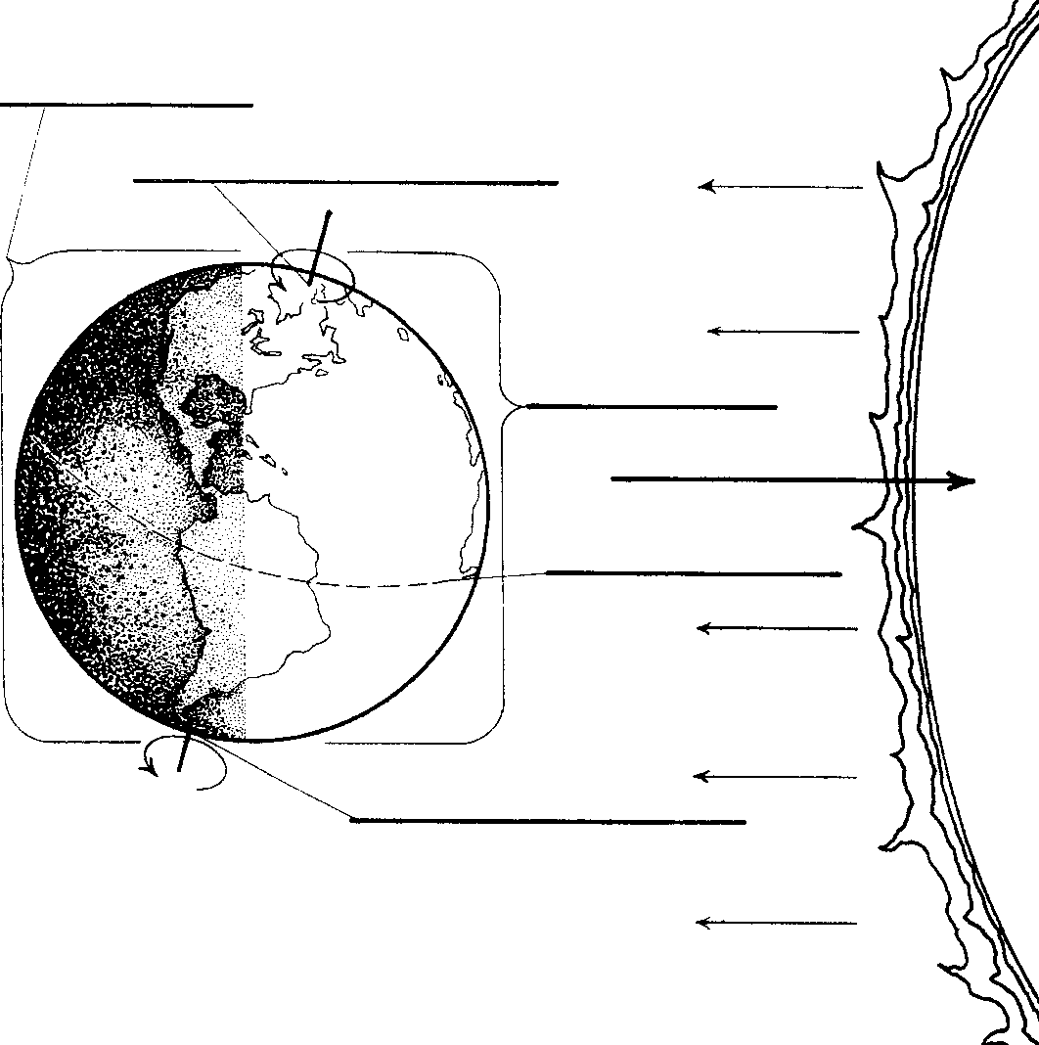
6. Label the portion of the Earth facing away from the Sun “Nighttime.”

Did you know that other planets also rotate on their axis and so have daytime and nighttime? All of the planets in our solar system rotate at different speeds and so their days have a different length. Some planets have short days while other planets have very long days. Use the chart to answer the questions.
How long is the Day?
Planet | Day |  | Planet | Day
Mercury | 59 days |  | Jupiter | 10 hours
Venus | 243 days |  | Saturn | 10.5 hours
Earth | 24 hours |  | Uranus | 17 hours
Mars | 25.5 hours |  | Neptune | 16 hours

Questions:
1. Which planet has the shortest day? ____________
2. Which planet has the longest day? _____________
3. Which planet has a day nearest the length to Earth’s day? ________________________________________
4. Is a day on Venus longer or shorter than a day on Earth? ______________________________________
5. Is a day on Mercury longer or shorter than a day on
Jupiter? ____________________________________
Watch the video Day and Night and write down three facts on the lines below.

Name ________________________ period _____
EXIT TICKET
Revolving and Rotating
1. The time required for the earth to revolve around the Sun is - - -

A. 24 hours
B. 7 days
C. 29.5 days
D. 365 days
2. The time required for the earth to rotate on its axis is - - -

A. 24 hours

B. 7 days

C. 29.5 days

D. 365 days
3. Mercury has the shortest year of any planet in the solar
system because --

A. It is the smallest planet
B. It is the largest planet
C. It is closest to the Sun
D. It is farthest from the sun

4. The spinning of the earth on its axis causes - -

A. day and night
B. the seasons
C. a year to by
D. the moon to change shape

5. We cannot fit the solar system on a sheet of paper because
of its size. Problems with models like this are called ---

A. model problems
B. limitations
C. size adjustments
D. solar flares

Name ________________________ period _____
EXIT TICKET
Revolving and Rotating
1. Mercury has the shortest year of any planet in the solar system
because --

A. It is the smallest planet
B. It is the largest planet
C. It is closest to the Sun
D. It is farthest from the sun

2. The spinning of the earth on its axis causes - -

A. day and night
B. the seasons
C. a year to by
D. the moon to change shape

3. We cannot fit the solar system on a sheet of paper because
of its size. Problems with models like this are called ---

A. model problems
B. limitations
C. size adjustments
D. solar flares

4. The time required for the earth to revolve around the Sun is - - -

A 24 hours
B 7 days
C 29.5 days
D 365 days
5. The time required for the earth to rotate on its axis is - - -

A 24 hours

B 7 days

C 29.5 days
D 365 days

