Changes in Seasons

You’ve probably noticed that when the Sun is “low in the sky” its “warming” power is diminished. During winter when the Sun barely creeps above the horizon, the Sun provides us with less heat than it does when it “beats down on us” from almost directly overhead at noon on a summer day.
When the Sun is directly overhead, its rays strike Earth perpendicular to the ground and so deliver the maximum amount of energy. When the Sun is lower in the sky, a sunbeam strikes the ground at an angle and so its energy is “spread out” over a larger area, thus “diluting” its energy.
The perpendicular rays of the Sun are called direct rays and the slanted rays are called indirect rays.

Watch The Earth’s Tilt video. Write down three facts
from the video on the lines below.
____________________________________________
____________________________________________
____________________________________________

Materials: Flashlight, calculator

What To Do:
1. Observe as your teacher demonstrates perpendicular rays of light using a flashlight and the large piece of graph paper on the wall.
2. In the diagram on the next page label the shape that shows perpendicular rays of light hitting the Earth.
3. Observe as your teacher demonstrates slanted rays of light using a flashlight and the large piece of graph paper on the wall.

4. In the diagram below label the shape that shows slanted rays of light hitting the Earth.
5. Now label which are direct rays and which are indirect rays of light.

The Sun provides the Earth 45,000 Joules of energy every hour. That amount is spread out over the area in which the rays of the sun hit.
Questions:
1. Approximately, how many squares are in the Direct Rays circle? _________
2. Divide 45,000 Joules by the number of squares. How much energy is each square in the Direct rays receiving? _______________
3. Approximately, how many squares are in the Indirect Rays oval? __________

4. Divide 45,000 Joules by the number of squares. How much energy is each square in the Indirect rays receiving? _________________
5. In which circle is each square getting the most
energy? ________________
6. In which circle would you get the worst sunburn? ___________________
7. Which circle is getting the most concentrated heat
energy?_________________________

We have just learned about the direct and indirect rays of the Sun. Why are the rays of the sun different when they hit the Earth? Aren’t all rays of the Sun the same? Yes, all rays of the Sun are the same but where they strike the Earth’s surface is different. First, the Earth is not a flat piece of paper. It is round, so the rays spread out when they hit the round surface. Second, the Earth’s axis is tilted. Let’s see what difference that makes.
Most places outside the tropics have four distinct seasons: winter, spring, summer and autumn. Take a look
at the diagram of the Earth. Notice that the axis is not straight up and down. It is actually 23.5º tilted from the vertical. This is called the tilt of the axis. The Earth has seasons because of this tilt of the axis. When the direct rays of the sun fall in a hemisphere, then that hemisphere has summer. When the north end of the Earth’s axis is tilted toward the sun, the Northern Hemisphere has summer because it is getting the direct rays of the sun. At
the same time, the south end of the Earth’s axis is tilted
away from the Sun. As a result, the Southern Hemisphere has winter because it is not getting the direct rays of the sun.
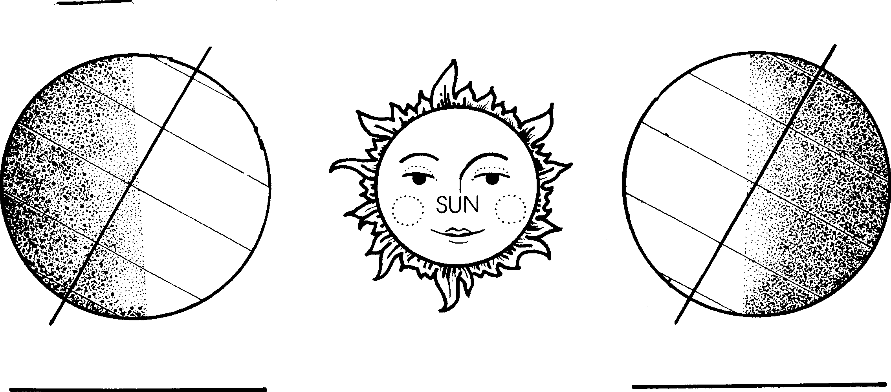

Materials: colored pencils

What To Do:
1. Trace over the axis on each earth with a red colored pencil. Label it axis.
2. Trace over the equator on each earth with a blue colored pencil. Label it equator. Label the northern and southern hemispheres.
3. Trace over the line of latitude above the equator with a green pencil. Label it Tropic of Cancer.
4. Trace over the line of latitude below the equator with a purple pencil. Label it Tropic of Capricorn.
5. Color the Sun yellow.
6. From the middle of the Sun draw a straight line to each earth. Label these Direct Rays.
7. If the direct rays are hitting the earth above the equator it
is summer in the northern hemisphere. Label that earth summer on the line below it.
8. If the direct rays are hitting the earth below the equator it is winter in the northern hemisphere. Label that earth winter on the line below it.

On two days of the year, the noon sun is overhead at either the Tropic of Cancer or the Tropic of Capricorn. Each of these days is known as a solstice. The winter solstice occurs around December 21 each year and is the shortest day of the year. The summer solstice occurs around June 21 each year and is the longest day of the year. Halfway between the solstices the noon sun is directly overhead at the equator. Each of these days is known as an equinox. The spring equinox occurs around March 21 and the autumn equinox occurs around September 23.
86

What To Do:
1. Draw the direct rays of the sun for figures A and B.
2. Determine which is winter and which is summer in the northern hemisphere.
3. On the solid lines next to the Earth place the date of the winter and summer solstice.
4. Follow the arrows and determine which of the drawings is spring and autumn.
5. On the dotted lines place the name of the season for each Earth.

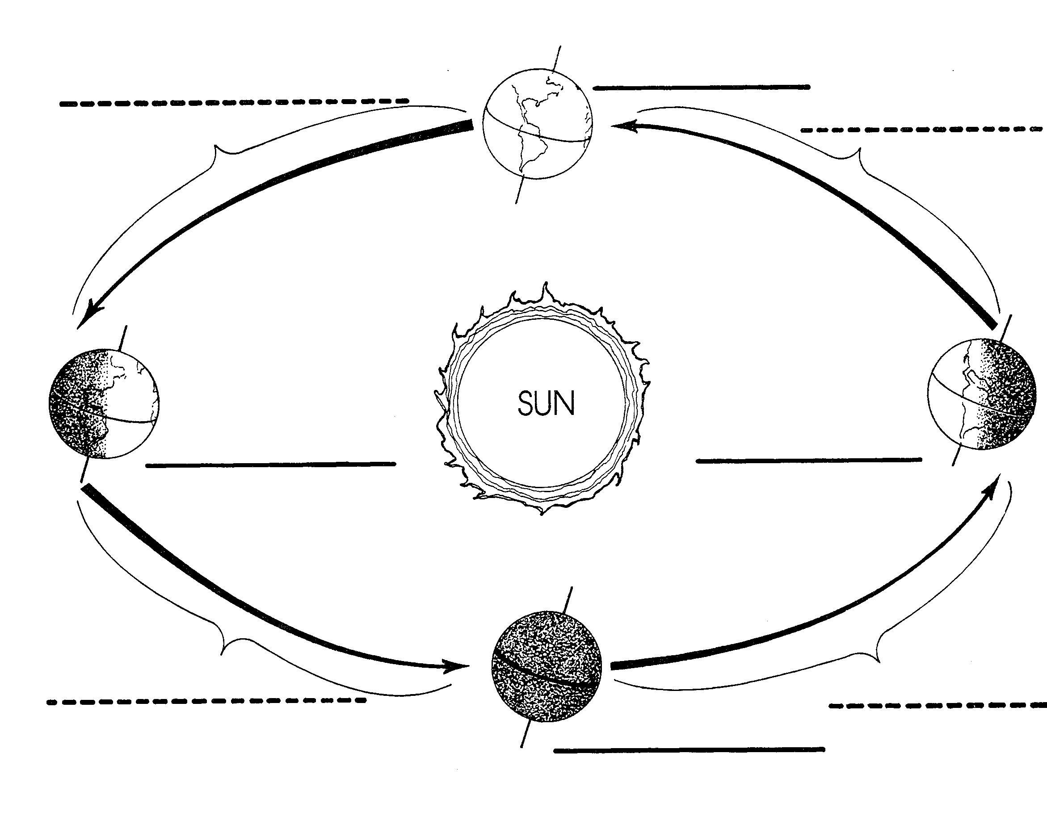
A
B

Name _______________ period _____
EXIT TICKET
Changes in Seasons
1. Rays from the sun –
A. are all the same
B. are different because they are hotter in the summer
C. are different because they are cooler in the winter

2. What season happens in the Northern Hemisphere when it has direct rays shining on it?
A. Winter
B. Summer
C. Fall

3. What season happens in the Southern Hemisphere when it has direct rays shining on it?
A. Winter
B. Summer
C. Fall

4. The main cause of the change of the seasons is –
A. The rotation of the Earth on its axis
B. The tilt of the Earth’s axis
C. The amount of energy the Sun releases

5. What is the imaginary line that divides the Earth into Northern and Southern Hemispheres called?
A. axis
B. Tropic of Cancer
C. Equator

Name _______________ period _____
EXIT TICKET
Changes in Seasons
1. The main cause of the change of the seasons is –
A. The rotation of the Earth on its axis
B. The tilt of the Earth’s axis
C. The amount of energy the Sun releases

2. What season happens in the Northern Hemisphere when it has direct rays shining on it?
A. Winter
B. Summer
C. Fall

3. What is the imaginary line that divides the Earth into Northern and Southern Hemispheres called?
A. axis
B. Tropic of Cancer
C. Equator

4. Rays from the sun –
A. are all the same
B. are different because they are hotter in the summer
C. are different because they are cooler in the winter

5. What season happens in the Southern Hemisphere when it has direct rays shining on it?
A. Winter
B. Summer
C. Fall

