Phases of the Moon

You may have noticed that the moon does not always look the same. Some times it is round and at other times only a small portion is visible. Sometimes we can’t see the moon at all. The different shapes of the moon you see from Earth are called phases. The moon goes through its whole set of phases each time it revolves around the Earth, that is about once a month.
Phases are caused by changes in the positions of the moon, Earth and the sun. The moon does not give off any light by itself. We are able to see the moon because the sunlight reflects off of it. Because the sun lights the moon, half of the moon is always in sunlight and half is always in darkness. The phase of the moon you see depends on how much of the sunlit side of the moon faces earth.
There are four words that you need to know when learning the phases of the moon. The first word is waxing. The word waxing means getting bigger. The second word is waning. The word waning means getting smaller. The next word is gibbous. The word gibbous means swollen or bulging. The last word is crescent. Crescent means curved with points at the end.

Part 1
Materials: Phases of the moon sheet, Moon phase pictures, scissors, glue
What To Do:
1. Cut out the #1 moon and glue it to Phases of the Moon Sheet. Label it New Moon.
2. Cut out the #2 moon and glue it to the Phases of the Moon Sheet. Label it Waxing Crescent.
3. Cut out the #3 moon and glue it to Phases of the Moon Sheet. Label it First Quarter.
4. Cut out the #4 moon and glue it to Phases of the Moon Sheet. Label it Waxing Gibbous.

5. Cut out the #5 moon and glue it to Phases of the Moon Sheet. Label it Full Moon.
6. Cut out the #6 moon and glue it to Phases of the Moon Sheet. Label it Waning Gibbous.
7. Cut out the #7 moon and glue it to Phases of the Moon Sheet. Label it Third Quarter or Last Quarter.
8. Cut out the #8 moon and glue it to Phases of the Moon Sheet. Label it Waning Crescent
Questions:
1. Where does the moon get its light? ______________
2. What are the changes in the shape of the moon called? _______________
3. How long does it take the moon to go through these phases? _______________
4. What does waxing mean?_____________________
5. What does waning mean? ____________________
6. Is the lighted side of a gibbous moon large or small? ______________________
7. Is the lighted side of a crescent moon large or small? ______________________
8. Glue the diagram on to the next page.
Watch the following animation about the phases of the moon.
http://www.harcourtschool.com/activity/moon_phases/
In the space below draw and label the positions of the Sun, Moon and Earth when the moon is at a new moon phase.

Moon Phase Calendar

It takes about a month for the moon to go through its
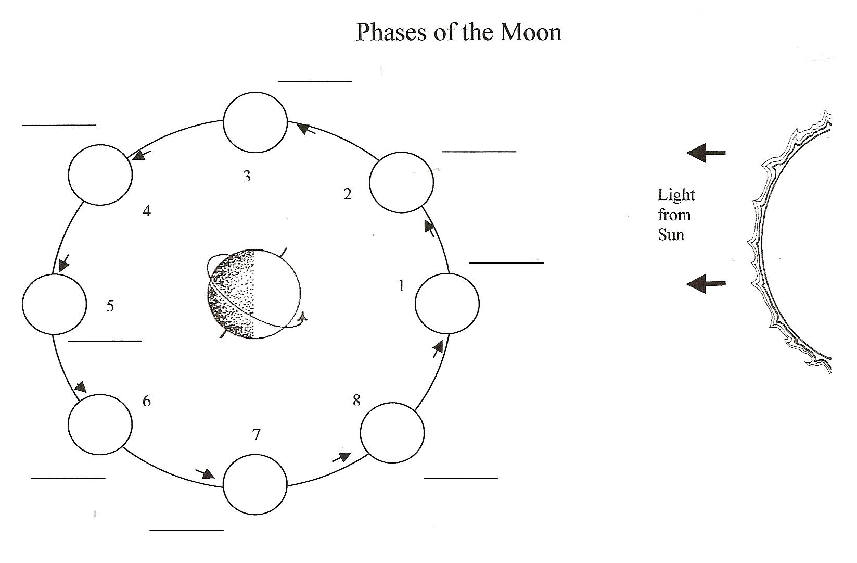
phases. Remember nothing is covering up the part of the moon we can’t see. We are just looking at the part of the moon that is facing the earth and lighted by the sun. As it goes through its phases, it starts with the new moon and gets bigger and bigger. You can tell if the moon is getting bigger by using the saying, “If the light is on the right, the moon is getting bright!” After the full moon the moon begins to get smaller and the light is now on the left.
Materials: Moon Phases Calendar
What To Do:
1. Look at the Moon Phases Calendar.
2. Look for daily patterns by coloring the lighted side with a yellow highlighter.
3. There are 5 blank circles on the calendar.
4. Use your highlighter to draw the appropriate lighted side and your pencil to color in the dark side.
5. Predict the phase that will occur in the last box and color it in.
6. Your teacher will show you the following website and change it for July 2001 in the northern hemisphere:
http://www.moonconnection.com/moon_phases_calendar.phtml
7. Compare it to your moon phase calendar.
Questions:
1. How is the computer calendar different from your calendar? ___________________________________
2. How is it the same? _______________________
3. Where is the lighted side after the new moon? _______
4.Where is the lighted side after the full moon? _______
3. What happens to the lighted side after the new moon? _____________________
4. What happens to the lighted side after the full moon? _____________________

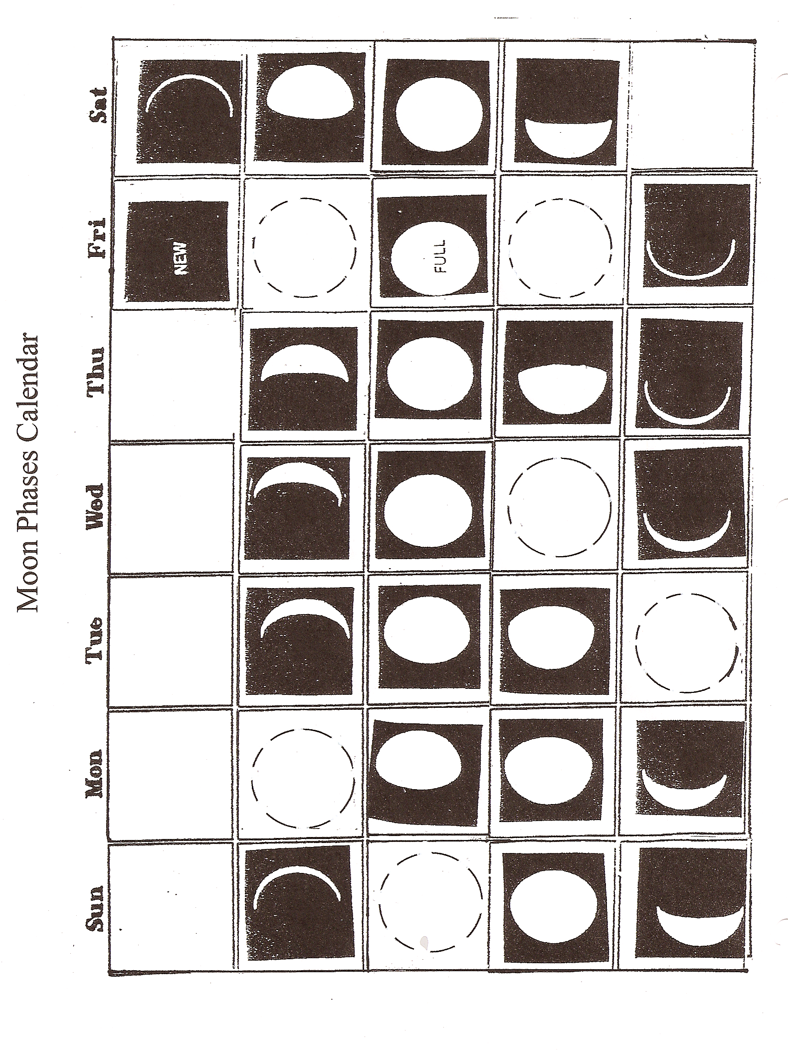
Birthday Moon
1. Your teacher will show the following website:
https://stardate.org/nightsky/moon

2. Your teacher will find your birth year and your birth
month on the website.

3. Determine the phases of the moon for you and your lab
partners.

4. Write the information in the chart below.

Names | Birth Date | Phase of the Moon

Name _______________ period _____

EXIT TICKET
Phases of the Moon
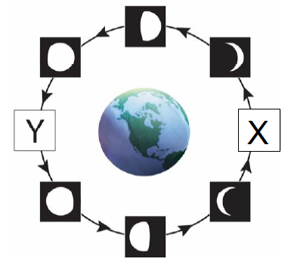

1. The phase of the moon that could replace letter Y in the diagram is –
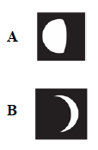
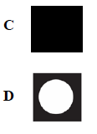

Conclusion: (waxing, reflected, waning, left, right, phases, position, sun)
The moon’s light is _________ from the sun. The changes we see in the shape of the moon are called ___________. Phases are caused by the changes in the ___________ of the Earth, moon and _________. When the moon is getting bigger it is called ___________. When the moon is getting smaller it is called ______________. When the moon is waxing the lighted side is on the _________. When the moon is waning, the lighted side is on the ____________.

Name _______________ period _____

EXIT TICKET
Phases of the Moon

1. The phase of the moon that could replace letter X in the diagram is –

Conclusion: (waxing, reflected, waning, left, right, phases, position, sun)
The moon’s light is _________ from the sun. The changes we see in the shape of the moon are called ___________. Phases are caused by the changes in the ___________ of the Earth, moon and _________. When the moon is getting bigger it is called ___________. When the moon is getting smaller it is called ______________. When the moon is waxing the lighted side is on the _________. When the moon is waning, the lighted side is on the ____________.

