Eclipses

When the sun, Earth and moon are in a direct line, we have an eclipse. There are two general types of eclipses. The first is the lunar eclipse. The word eclipse means to cover up and the word lunar refers to the moon. So, a lunar eclipse means to cover up the moon. The second type of eclipse is the solar eclipse. The word solar refers to the sun. So a solar eclipse means to cover up the sun.

Watch the video Spacefiles – Solar Eclipse

1. What happens to cause the “diamond ring” effect during a solar eclipse? ___________________________________________
____________________________________________
2. What is the ring that can be seen around the moon during a total solar eclipse called? ______________

Why do people have to wear special glasses or watch the solar eclipse through darkened glass? The Sun emits light from the entire spectrum from radio waves to X-rays and Gamma Rays all the time. If you look at X-rays or Gamma Rays directly it will burn your retina. Most of the time when we try to look at the Sun it is so bright, we have to look away. During a solar eclipse we can look directly at the sun letting in the harmful rays.

Watch the video Super-sized Lunar Eclipse

3. Why does the moon turn red during a Lunar Eclipse?
____________________________________________
4. What is the moon illusion? ___________________
____________________________________________

What To Do:

Below we have diagrams of both types of eclipses. Label each of the objects and then determine which diagram shows a solar eclipse and which diagram shows a lunar eclipse. Remember to place yourself on the earth not in space.
128
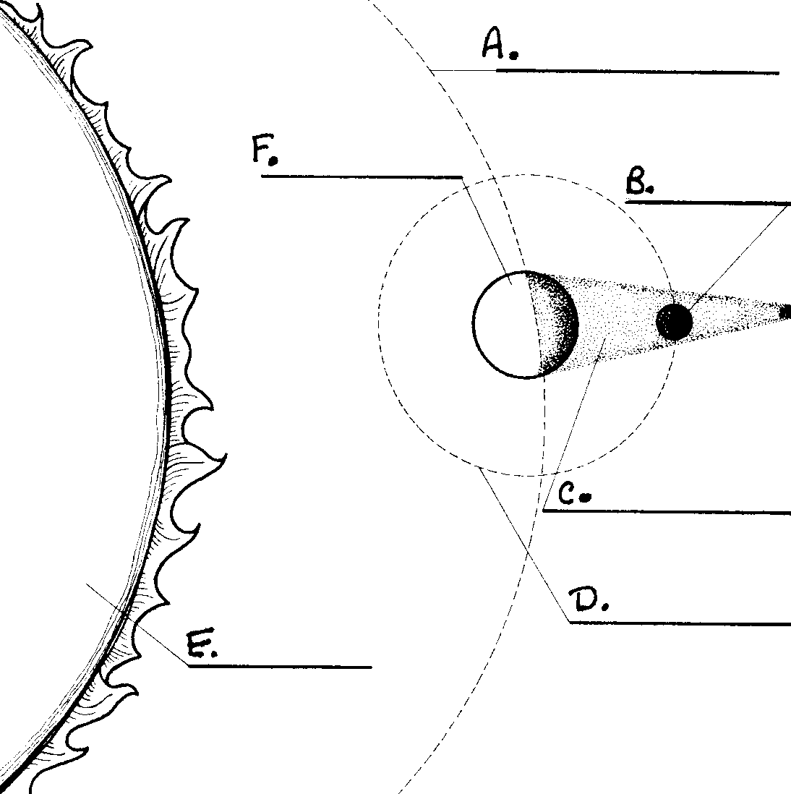
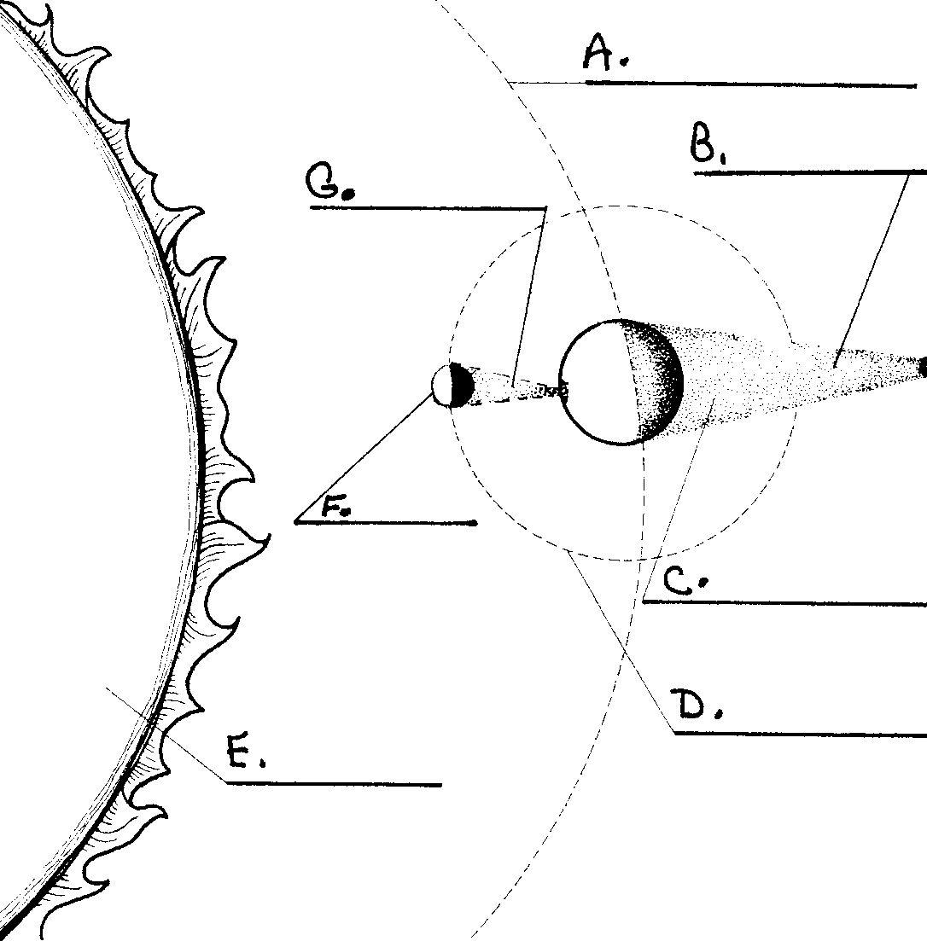

1. _________ Eclipse

Word Bank

Earth’s orbit moon’s orbit

moon Earth sun

Earth’s shadow moon’s shadow

2. _________ Eclipse

Questions:
1. At which phase of the moon does a lunar eclipse occur? ___________________
2. At which phase of the moon does a solar eclipse occur? _____________________

Materials: Flashlight taped to a plastic cup, Earth ball, stand, Moon ball
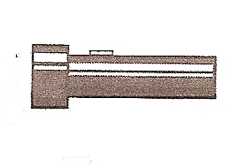
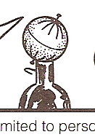

What to Do:
1. Set the Earth ball in the stand making sure the North Pole
is pointed up AND the axis is tilted. See picture.
2. Place the flashlight about 18 “ in front of the Earth Ball.
3. Turn on the flashlight and turn off the classroom lights.
4. Use the Moon ball to orbit the Earth passing in and out of
the Earth’s shadow. This is a lunar eclipse.
5. Use the Moon ball to orbit the Earth causing a shadow to
fall on the Earth ball from the Moon ball. This is a solar
eclipse.
6. Show your teacher the two eclipses.

After using the model shown above, draw the moon and the shadow that makes the labeled eclipse.

LUNAR ECLIPSE SOLAR ECLIPSE
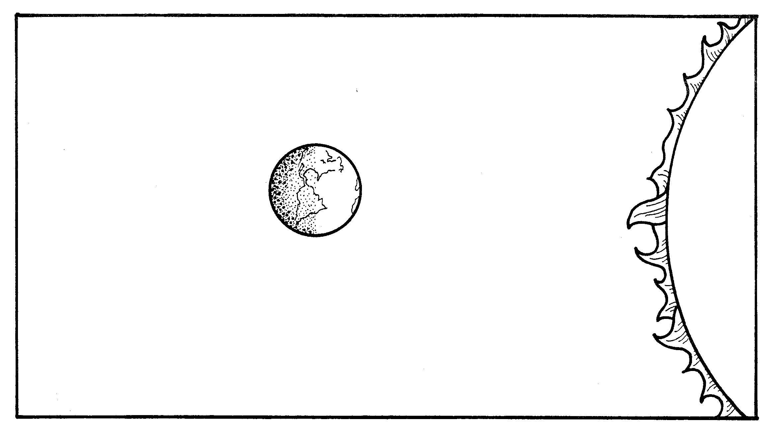

Questions:
1. In which type of eclipse is the moon in the earth’s shadow? ________________________________
2. In which type of eclipse does the moon cause the shadow? ____________________________

3. How are the two eclipses alike? _______________
_____________________________________________
4. How are the two eclipses different? ______________
_____________________________________________

Conclusion: (eclipse, direct, cover-up, moon, shadow, lunar, sun, solar)
When the Earth, moon and sun are in a _______ line there will be an _________. The word eclipse means to ______-_____. Lunar refers to the __________ and solar refers to the __________. When the ________ of the moon falls on the Earth it is a ___________ eclipse. When the shadow of the Earth falls on the moon it is a _________ eclipse.

Name ________________ period ______
EXIT TICKET
Eclipses
1. What type of eclipse is occurring when the moon is in front of the sun?

A. Solar eclipse
B. Lunar eclipse

2. What type of eclipse is occurring when the earth is in front of the sun?

A. Solar eclipse
B. Lunar eclipse

3. Which type of eclipse covers up the moon?

A. Solar eclipse
B. Lunar eclipse

4. Which type of eclipse covers up the sun?

A. Solar eclipse
B. Lunar eclipse

5. Which type of eclipse is dangerous to look at without special glasses?

A. Solar eclipse
B. Lunar eclipse

Name ________________ period ______
EXIT TICKET
Eclipses
1. Which type of eclipse is dangerous to look at without special glasses?

A. Solar eclipse
B. Lunar eclipse

2. What type of eclipse is occurring when the earth is in front of the sun?

A. Solar eclipse
B. Lunar eclipse

3. Which type of eclipse covers up the sun?

A. Solar eclipse
B. Lunar eclipse

4. Which type of eclipse covers up the moon?

A. Solar eclipse
B. Lunar eclipse

5. What type of eclipse is occurring when the moon is in front of the sun?

A. Solar eclipse
B. Lunar eclipse

