What Causes the Tides?

Gravitational forces of the Moon and Sun on the Earth cause tides. Tides are periodic rises and fall of large bodies of water. As the tide flows in, water level rises and rises. When the water reaches its highest level, it is considered high tide. After the point of high tide, the waters ebb (go out slowly) away. When the water reaches it lowest point, it is considered low tide. The water level difference between high and low tides varies from a few centimeters to 13 meters depending on the location.
The gravitational attraction of the moon causes the oceans to bulge out in the direction of the moon. Another bulge occurs on the opposite side, since the Earth is also being pulled toward the moon. Isaac Newton was the first person to explain the tides scientifically.
Spring tides are especially strong tides. They occur when the Earth, the Sun and the Moon are in a straight line. Spring tides occur during the full and the new moon. Neap tides are especially weak tides. They occur when the gravitation forces of the Moon and Sun are at right angles to each other. Neap tides occur during quarter moons.

Your teacher will show you two videos on tides. In the space below write three things you learned about tides.

What To Do:

1. In the diagrams below label the Earth and the Moon
2. The ring around the Earth shows the tidal bulge. In diagram A color the bulge green.
3. In diagram B color the bulge blue.
4. Label the correct diagram with Spring Tides and Neap Tides.

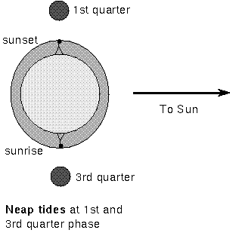
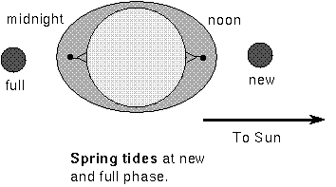
A

B

Questions:
1.Why does diagram A show the largest tidal bulge? _________________________
2.Why does diagram B show the smallest tidal bulge? ________________________
3.What phases of the moon are shown in diagram A? __________________________
4.What phases of the moon are shown in diagram B? __________________________
5.What causes the ocean’s tides? _______________

Graphing Tidal Readings

Graph the following Tidal Readings from Galveston Bay, Texas.

Day | High Tide Reading
1 | 3.0
2 | 1.5
3 | 1.9
4 | 4.0
5 | 2.5
6 | 1.5
7 | 2.0
8 | 3.5

Questions:
1. Which day was probably a full moon? _____________
2. Why do you think so? __________________________
3. Which day was probably the 1st quarter? ___________
4. Why do you think so? _________________________

Conclusion: (Neap, gravitational, greatest, moon, high, Spring, low, Sun)

Ocean tides are caused by the ______________ pull of the _______ and the _______. The moon has the __________ effect on the tides. When the Sun, moon and earth are in a straight line, we have __________ tides. When the Sun, moon and earth are at right angles we have _________ tides.
Spring tides are especially _________ tides while neap tides are especially _________ tides.

Name _______________ period _____
EXIT TICKET
What Causes tides?
1. What is true during a spring tide?

A. The moon is in a straight line with the earth and
the Sun.
B. The moon is waning toward a new moon.
C. The moon is waxing toward a full moon.
D. The moon is at a right angle to the line between Earth and
the Sun.

2. Which of these is never true during a neap tide?

A. The moon is in a straight line with the earth and
the Sun.
B. The moon is waning toward a new moon.
C. The moon is waxing toward a full moon.
D. The moon is at a right angle to the line between Earth and
the Sun.

3. Circle the diagram that shows a spring tide.
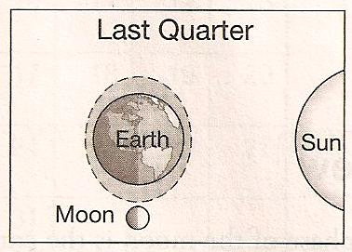
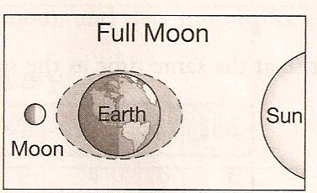

4. Circle the diagram that shows a neap tide.
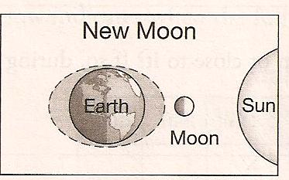
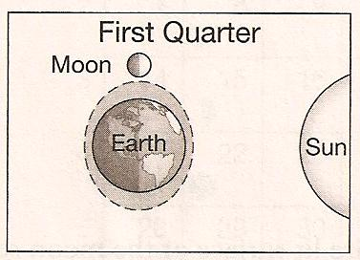

Name _______________ period _____
EXIT TICKET
What Causes tides?
1. Circle the diagram that shows a spring tide.

2. Circle the diagram that shows a neap tide.

3. What is true during a spring tide?

A. The moon is in a straight line with the earth and
the Sun.
B. The moon is waning toward a new moon.
C. The moon is waxing toward a full moon.
D. The moon is at a right angle to the line between
Earth and the Sun.

4. Which of these is never true during a neap tide?

A. The moon is in a straight line with the earth and
the Sun.
B. The moon is waning toward a new moon.
C. The moon is waxing toward a full moon.
D. The moon is at a right angle to the line between
Earth and the Sun.

