Life Cycle of Star Pictures

Nebula  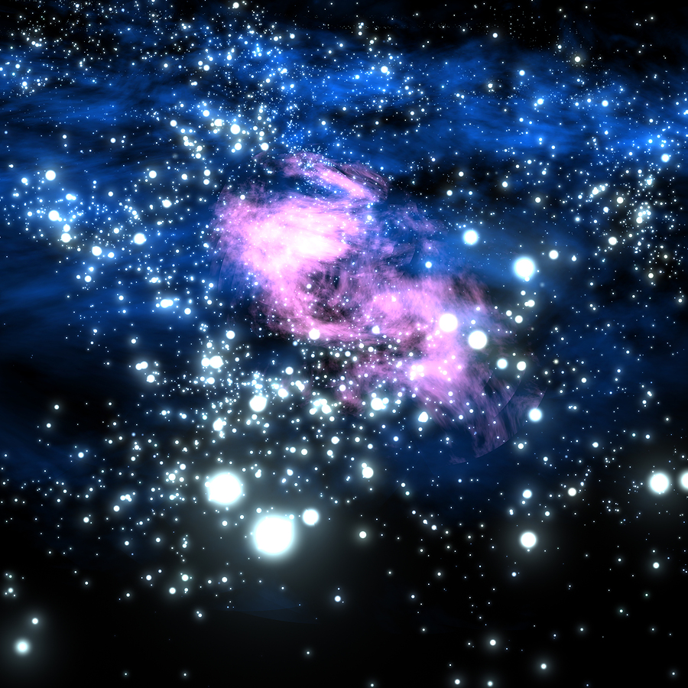 |  | Average Star  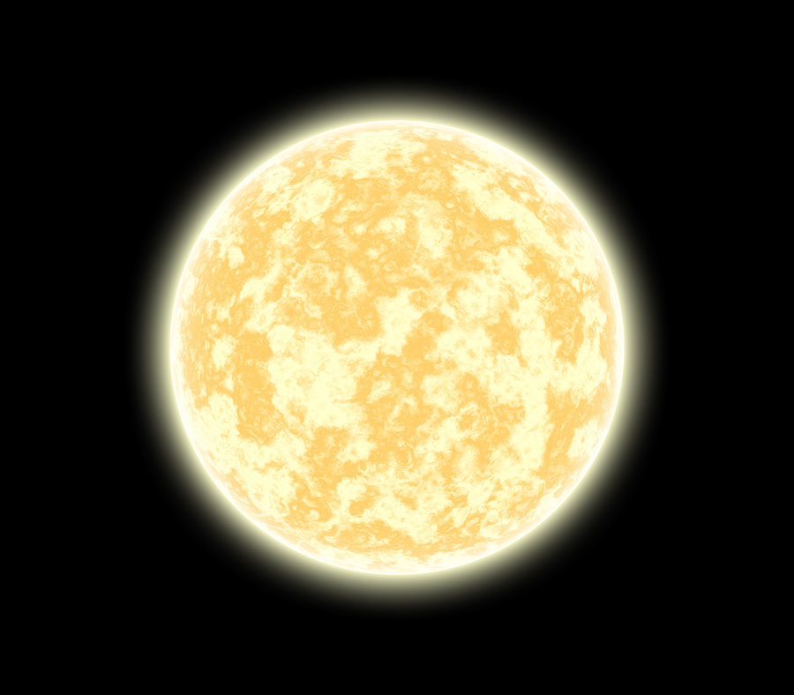 |  | Red Giant  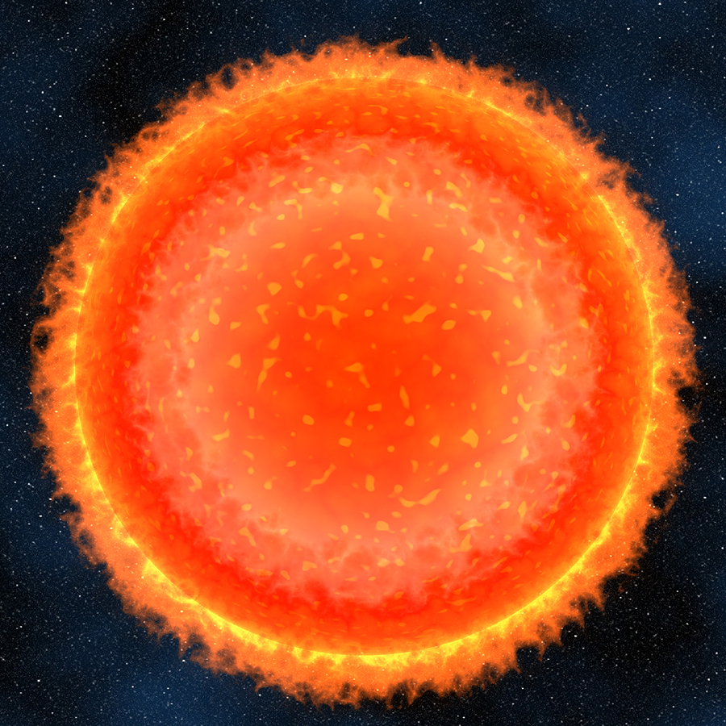 |  | Planetary Nebula  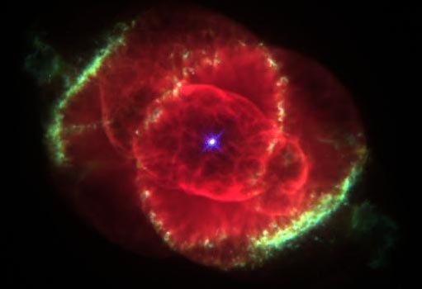  Credit: Nasa |  | White Dwarf  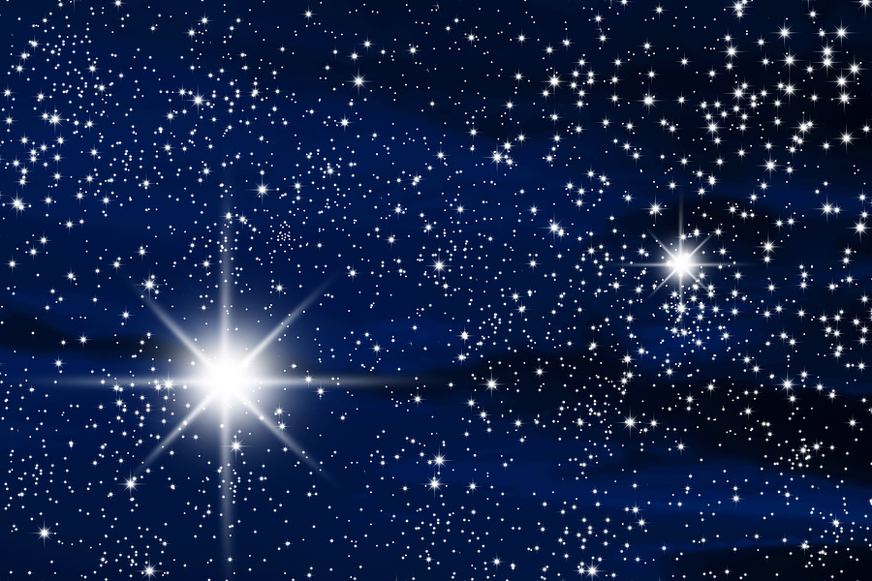
Massive Star  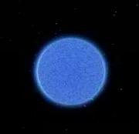  Credit: Nasa |  | Red Supergiant  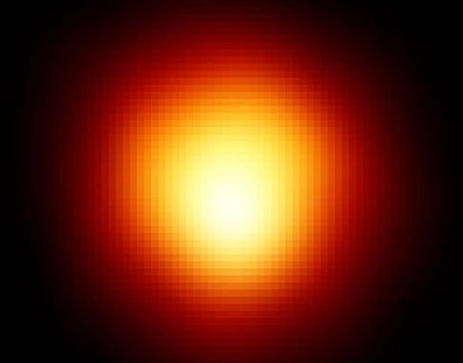  Credit: nasa |  | Supernova  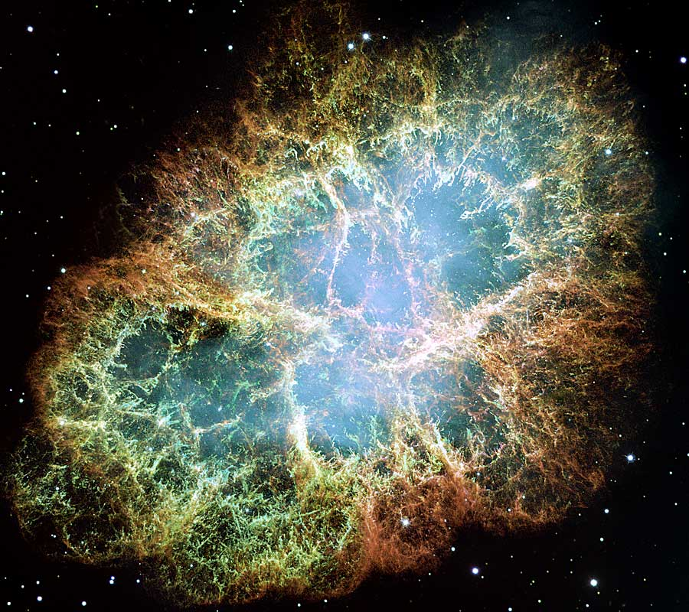 |  | Neutron Star  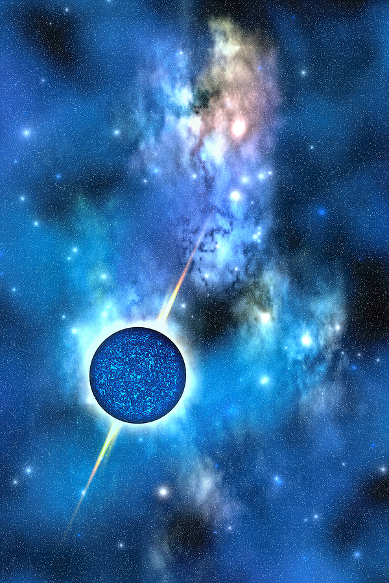 |  | Black Hole  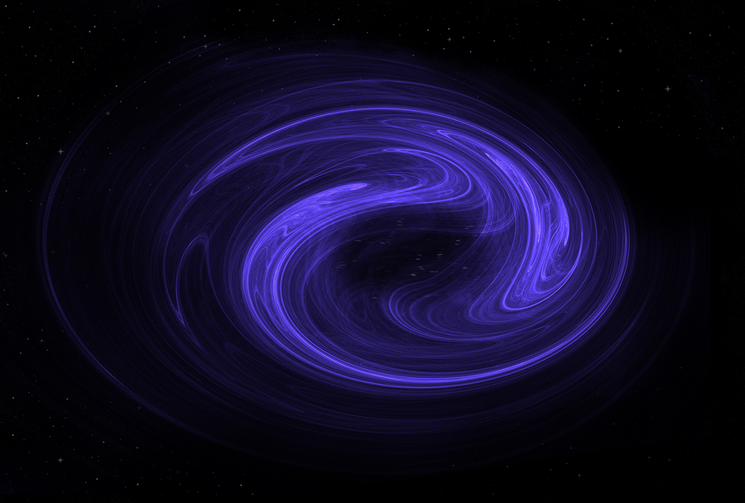

Life Cycle of a Star Description Cards

Nebula  A huge cloud of gas and dust that begins to shrink under the pull of its own gravity. This stellar nebula is the beginning of all star’s lives. |  | Average Star  Our Sun is an average star that formed from a nebula. It produces its own heat and light by nuclear reactions. They live for billions of years before becoming a red giant. |  | Red Giant  Toward the end of life of an average star, it swells up into a red giant before losing its outer layers in an explosion that creates a planetary nebula. |  | Planetary Nebula  Don’t confuse a planetary nebula with a stellar nebula. A planetary nebula is near the end of an average star’s life before it turns into a white dwarf. |  | White Dwarf  These are small and hot and are the shrunken remains of  an average size star. Their nuclear energy supplies have been used up and this is the last stage in the life cycle.
Massive Star  These are the brightest stars that form from a nebula. They are white or blue in color. They have masses 100 times that of the Sun but they live for less than a million years. |  | Red Supergiant  When a massive star has used up all its nuclear energy it swells up to 1000 times the diameter of the Sun. |  | Supernova  When gravity overcomes the nuclear energy in a red supergiant, the star begins to collapse leading to a massive explosion that can remain visible for months. |  | Neutron Star  These may be produced after a supernova explosion. They are small and have faint light, so they can’t be seen with visible light. |  | Black Hole  If an object 4 times the size of the sun is left after a supernova, it will become a black hole. The gravitational pull is so great, not even light can escape.

