What are Galaxies?

Our Sun is a medium-size star in terms of both mass and diameter and so at the end of its life cycle it will become a black dwarf. Very massive stars become supergiants – huge, cool, red stars. The most massive stars will end their life cycle by collapsing into a black hole. A black hole is an object so dense and with so much gravity that no light can escape from it.

Materials: Large red balloon, large sheets of aluminum foil – enough to cover the blown up balloon, sharp pin, electronic balance, calculator
What To Do:
1. Observe as your teacher blows up the balloon to about 15 cm.
2. Observe as your teacher covers the balloon with aluminum foil.
3. Observe as the star goes supernova and your teacher uses the pin to pop the balloon, but keeps the foil as round as possible.
4. Your teacher will use the balance to measure the mass. Record it in the table below.
5. Your teacher will cause the star to collapse to about half of its original size and measure the mass. Record it below.
6. Again the star will collapse to half of its size and the mass measured.
7. One last collapse and measurement of the mass.

Mass
Star after supernova explosion
1st collapse
2nd collapse
3rd collapse

As the supergiant collapses it does not lose any mass but its volume changes. This means that its gravitational pull stays the same as the supergiant but it gets smaller and smaller. Remember there is a relationship between mass and volume called density.

Density = mass/volume

Calculate the following densities using your calculator. Don’t forget your units.
 | MASS | VOLUME | DENSITY
Star after supernova explosion | 400 g | 100 cm³
1st collapse | 400g | 50 cm³
2nd collapse | 400 g | 25 cm³
3rd collapse | 400 g | 12.5 cm³

Questions:
1. What happened to the mass as the star collapsed? _______________________
2. What happened to the volume as the star collapsed?
______________________
3. What happened to the mass as the star collapsed?
_______________________

Watch the video titled: The Life Cycle of a Star. Write down 3 things you learned in the space below.

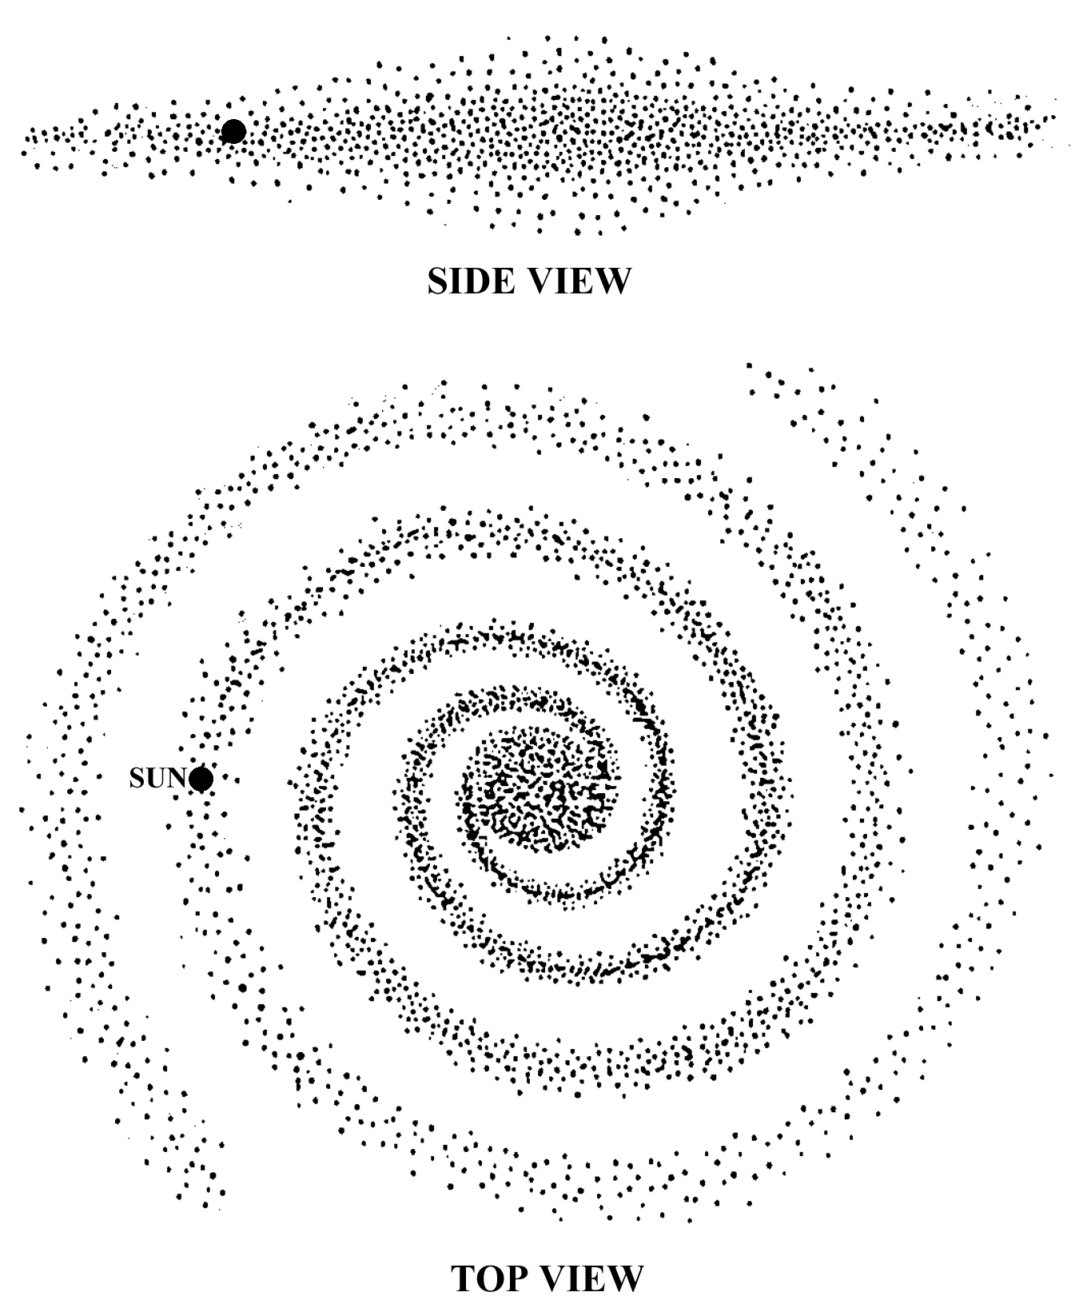
A galaxy is a very large group of stars, space dust and gasses held together by gravity. The stars in a galaxy revolve around a central point. Our Sun is one star in a galaxy that contains billions of stars. Some galaxies have as few as 100,000 stars while others have as many as three trillion. Astronomers classify galaxies according to their shape. The shapes are spiral, elliptical, barred spiral and irregular.
The galaxy to which the Sun belongs is called the Milky Way Galaxy and it has a spiral shape.
The Milky Way Galaxy got its name because from Earth it appears as a hazy, milky band of light that stretches across the sky. The Sun, Earth and the rest of our solar system are located near the outer edge of the galaxy. The Milky
Way Galaxy is so large that the
Earth is 26,000 light years away from the galaxy’s center.

What To Do:
1. Observe the four galaxies below. Determine which shape of galaxy is shown. Label each picture.
2. Look at the pictures on the next page and compare the pictures to the pictures below. Write the type of galaxy next to the picture.

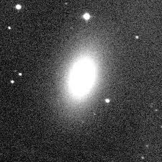 | 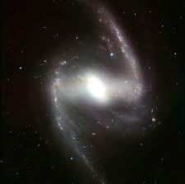 | 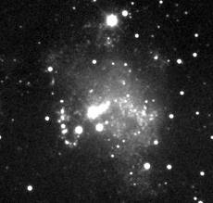 | 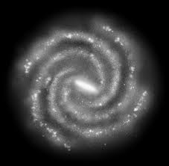

Galaxy Picture | Type of Galaxy
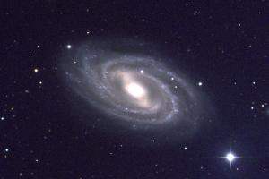
1
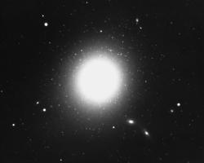
2
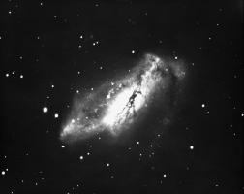
3
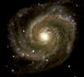
4
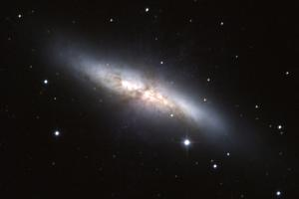
5
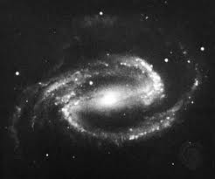
6

Watch the video segment Galaxies and write down one idea you learned in the space below.

Name __________________ period _____
EXIT TICKET
What are Galaxies?
1. The relationship between mass and volume is called density and is written g/cm³. Calculate the density of a star that has a mass of 500g and a volume of 10 cm³. Don’t forget your unit!
_______________

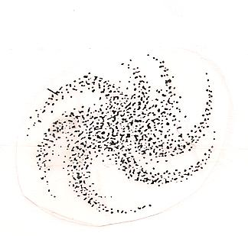 |  | 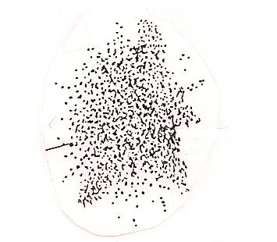
A | B | C

Use the pictures above to answer the following questions.

2. The pictures show three types of galaxies. What are
galaxies made of?

A. Black holes and dust only
B. Stars, space dust and gasses
C. Helium and Hydrogen only

3. Which of the pictures shows the shape of the Milky Way Galaxy?
A B C

4. Make an X in the galaxy above that represents the Milky Way to show where our Solar System is located.

Name __________________ period _____
EXIT TICKET
What are Galaxies?

A | B | C

Use the pictures above to answer the following questions.

1. The pictures show three types of galaxies. What are galaxies made of?

A. Black holes and dust only
B. Stars, space dust and gasses
C. Helium and Hydrogen only

2. Which of the pictures shows the shape of the Milky Way Galaxy?
A B C

3. Make an X in the galaxy above that represents the Milky Way to show where our Solar System is located.

4. The relationship between mass and volume is called density and is written g/cm³. Calculate the density of a star that has a mass of 500g and a volume of 10 cm³. Don’t forget your unit!
____________________

