Tools of an Astronomer
You can see some stars and Planets from Earth with your eyes alone. However, you cannot see these objects in great detail. Many other objects in space you cannot see at all with just your eyes. Still, we know a lot about these objects. Since Galileo used one of the earliest telescopes to study the sky, scientists have used many tool and kinds of technology to gather information about space.
A telescope is one of the most common instruments used to study space. An optical telescope is a device that uses lenses or a combination of lenses and mirrors to gather visible light from space. The lenses make distant objects appear closer and brighter. Other types of telescopes pick up radio signals or other types of radiation.
There are ground-based telescopes and space-based telescopes that astronomers use to gather information. Let’s look at several of these types. Fill in the chart below with information about each telescope.

Telescope | Information | Ground/Space based
Backyard

Domed

Dish

Satellite

Do you remember that Isaac Newton
experimented with prisms and discovered that
sunlight contains many colors? It was his view that the prism separated light into colors that were already in sunlight.
We have learned about the speed of light. But just what is light? Light can be thought of as a series of waves. Light waves have wavelengths and each wavelength allows us to see a different color.
White light has the wavelengths of all the colors of the rainbow in it and this allows us to see the colors that we do. But what would happen if the room had a different color of light. Would we still be able to see all the colors? Let’s find out.
Materials: markers, red bulb, blue bulb, clear bulb
What To Do:
1. Use a marker to color the areas in the chart below.
2. The teacher will turn off the lights and turn on a
red bulb.
3. Place a check mark under each color you can see
4. Repeat for the blue light and the white light bulb.
5. Answer the questions on the next page.
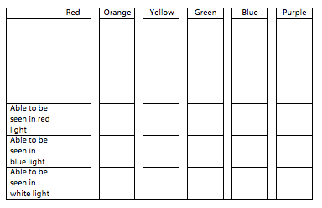

Questions:
1. What colors did you observe when the red light was on? _______________________________________
2. What colors did you observe when the blue light was on? ________________________________________
3. Why were these different than the clear light bulb?
___________________________________________
With the clear light bulb we were able to observe the entire spectrum of visible light. With the red a blue light bulbs we were only able to observe a part of the spectrum.
As we said waves have wavelengths and these different wavelengths allow us to see color. Blue light has a shorter wavelength than red light. Green light has a intermediate wavelength between blue and red. Our eyes interpret light of different wavelengths as different colors.

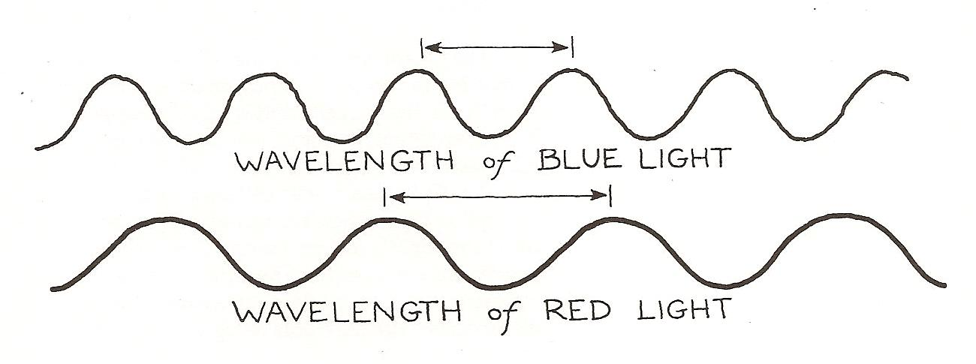

So now back to the tools of an astronomer. As we know stars are different colors. These colors come from the elements that are burning in the Sun’s atmosphere. By looking at the spectrum from each star, scientists can determine the elements in the atmosphere. They do this by using a tool called a spectroscope. A spectroscope is a tube with a piece of plastic called a diffraction grating in it. The plastic has thousands of fine grooves scratched

closely together. When light passes through the grooves most of it goes straight through but some light is spread out to the left and right.

Materials: Red, blue and clear bulbs, spectroscope, markers
What to Do:
1. Use the spectroscope to observe each type of light bulb.
2. Write the letter of each color in the order that you see it in the spaces below.
3. After all the lights are on use the markers to draw the colors you observed.

Clear Bulb
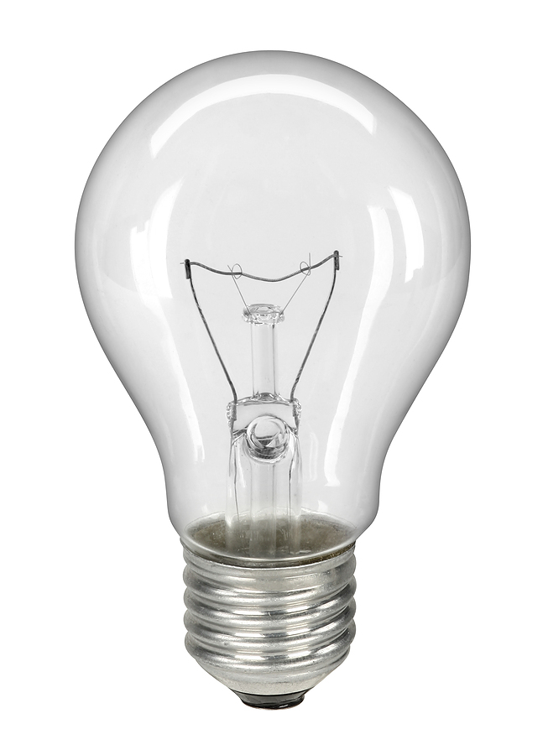

Red Bulb
Blue Bulb
Questions:
1. What color is closest to the light bulb? __________
2. What color is farthest from the light bulb? ________
3. List the colors in order of their appearance from the clear light bulb. ______________________________

Name _______________ period ______
EXIT TICKET
Tools of an Astronomer

1. Which of the following is NOT a type of telescope?

A. Dish
B. Backyard
C. Balloon

2. How do telescopes help astronomers?

A. They tell them the elements in the stars
B. They make objects appear closer and brighter
C. They allow them to see aliens

3. What tool allows astronomers to determine the elements in a star?

A. Spectroscope
B. Telescope
C. Microscope

4. Why can astronomers determine the elements in a star?

A. All the element have labels when you look
through a telescope
B. each element burns with a different color
C. There are no elements in the stars

5. What colors were visible with the red bulb?

A. red and orange
B. blue and purple
C. all the colors

Name _______________ period ______
EXIT TICKET
Tools of an Astronomer
1. Why can astronomers determine the elements in a star?

A. All the element have labels when you
look through a telescope
B. each element burns with a different
color
C. There are no elements in the stars

2. What colors were visible with the red bulb?

A. red and orange
B. blue and purple
C. all the colors

3. Which of the following is NOT a type of telescope?

A. Dish
B. Backyard
C. Balloon

4. How do telescopes help astronomers?

A. They tell them the elements in the stars
B. They make objects appear closer and
brighter
C. They allow them to see aliens

5. What tool allows astronomers to determine the
elements in a star?

A. Spectroscope
B. Telescope
C. Microscope

