

The Electromagnetic Spectrum

Visible light is one form of electromagnetic radiation. Electromagnetic radiation is energy that travels through space in the form of waves. In addition to visible light the electromagnetic spectrum includes radio waves, infrared light, ultraviolet light, X-rays and gamma rays. The length of the energy waves defines each type with radio waves being the longest and gamma rays being the shortest.

Our Sun is a source of energy across the full spectrum, and its electromagnetic radiation bombards our atmosphere constantly. However, the Earth’s atmosphere protects us from exposure to gamma rays, x-rays and some ultraviolet waves that can cause damage to cells in organic matter. Let’s see how astronomers use the electromagnetic spectrum to learn about the universe.

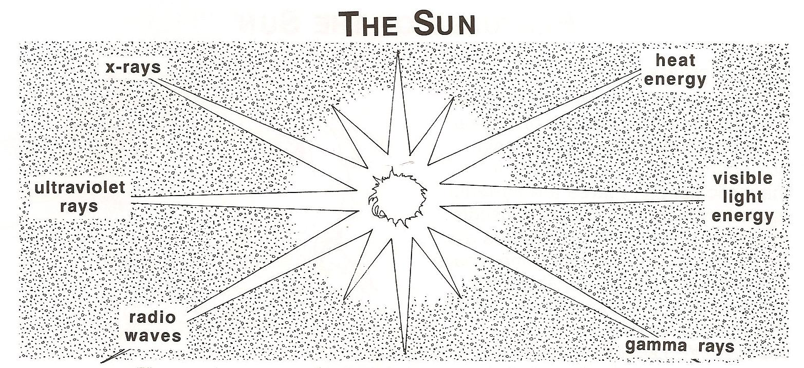

**Materials:** Scissors, glue, EMS symbols

**What To Do:**

1. Read each of the descriptions in the table on the

next page.

2. Match the symbol to each description.

3. Glue it to the table.

Radio waves and visible light energy can be collected from the earth so we have ground-based telescopes that look at stars using this part of the electromagnetic spectrum. Our atmosphere blocks the other types of radiation and so to view the sun and other stars in the rest of the spectrum we must use space based telescopes. Lets look at some pictures taken by some space-based telescopes.

**Materials:** Space Objects power point

**What To Do:**

1. Observe the pictures your teacher shows you.

2. Answer the questions below about each picture.

1. How are the pictures of the Sun different from each other?______________________________________

2. How are they alike? ________________________

3. The first picture of the Sun was taken with a camera that collects visible light and the second was taken with a radio telescope. What do radio waves tell astronomers about the object they are viewing? ____________________________

4. How are the pictures of the Andromeda Galaxy different?_____________________________________

5. How are they alike? ______________________

6. The large picture was taken with a camera that collects visible light and the small ones were taken with an X-ray telescope. What do X-rays tell astronomers about the object they are viewing? _______________

7. What might the bright blue spots be? ____________

8. How are the pictures of the constellation Orion different?____________________________________

9. How are they alike? _________________________

10. The first picture was taken with a camera that collects visible light while the second picture was taken with a camera with an infrared filter. What does infrared tell astronomers about the object they are viewing? _______________________________

Visible light is the only type of electromagnetic radiation you can see. It is made up of the color spectrum. We saw the entire color spectrum when we looked at the clear light blub through the spectroscope.

Scientists use spectroscopes to study stars. Different substances give off different colors. These colors are like an element’s fingerprints. By looking at starlight that passes through a spectroscope, scientists can study these fingerprints. This information shows what elements make up the different stars.

**Materials:** spectrum analysis power supply, tubes of various elements, spectroscope

**What To Do:**

1. Your teacher will place a tube in the power supply.

2. In the table below write down the name of the element under Tube.

3. Use your spectroscope to observe the tube with the classroom lights turned off.

4. Place a check mark in the colors that appear.

|  |  |  |  |  |  |  |  |
| --- | --- | --- | --- | --- | --- | --- | --- |
| **Tube** | **V** | **I** | **B** | **G** | **Y** | **O** | **R** |
| 1. |  |  |  |  |  |  |  |
| 2. |  |  |  |  |  |  |  |
| 3. |  |  |  |  |  |  |  |

If we compare the spectral lines of an unknown star with the spectral lines of elements, we can determine the chemical composition of the star, the temperature, rotational rate and the relative motion with regard to the Earth.

**Materials:** Spectral Analyzer

**What To Do:**

1. Observe the spectral analyzer. It shows the Spectrogram of an unknown star – Star A.

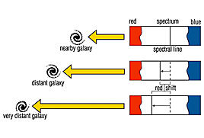2. Pull the “Pull Tab Out” card so you can see Neon on the right side of Star A.

3. Compare the lines of Neon to Star A. Are all of the lines of Neon present in star A? No – so Star A doesn’t contain Neon.

4. Continue with each element placing a check in the box in the chart below if Star A contains that element.

5. Work with your partners to determine the composition of Stars B, C and D.

|  |  |  |  |  |  |  |  |  |
| --- | --- | --- | --- | --- | --- | --- | --- | --- |
|  | Ne | Hg | Ar | He | H | Na | Ca | Fe |
| Star A |  |  |  |  |  |  |  |  |
| Star B |  |  |  |  |  |  |  |  |
| Star C |  |  |  |  |  |  |  |  |
| Star D |  |  |  |  |  |  |  |  |

Astronomers have recorded the spectral lines of many stars and galaxies. They use a phenomenon called the “Red Shift” to find out which direction galaxies are moving.

As any source of light moves toward or away from an observer, there is a shift in the wavelength of the light. For objects moving away, the wavelength is lengthened. Because each color has a specific wavelength, a galaxy that is moving away from the earth has its spectral lines shifted toward the red end of the spectrum. Using this red shift, the velocities at which galaxies are moving away from the earth can be calculated. Astronomers were astonished to discover that ALL the galaxies close to the Milky Way had a red shift in their spectral lines.

In the picture below you observe a nearby galaxy has a spectral line on the spectrum close to the middle. A more distant galaxy has its line shifted toward the red end and a very distant galaxy has its line shifted even closer to the red end of the spectrum.

Compare the spectra below. Spectrum A shows the possible spectrum of a galaxy NOT moving toward or away from earth. Spectra B and C show moving galaxies. Using your red shift knowledge determine which direction the galaxies B and C are moving.

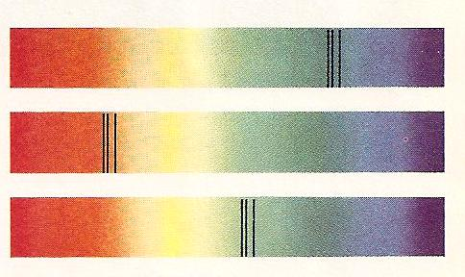

A

B

C

**Questions:**

1. Is galaxy B moving away or toward the Earth? ____

2. How do you know? __________________________

3. Is galaxy C moving away or toward the Earth? ____

4. How do you know? __________________________

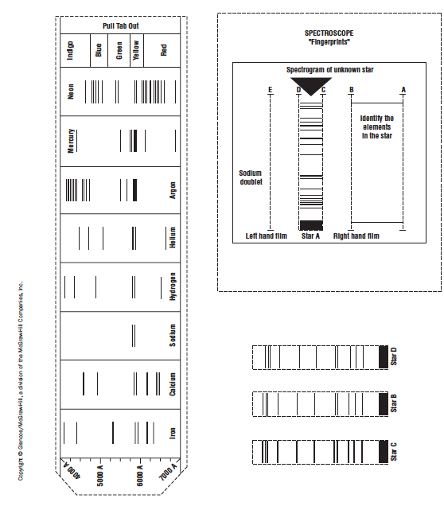

Make a class set from cardstock.

One per student

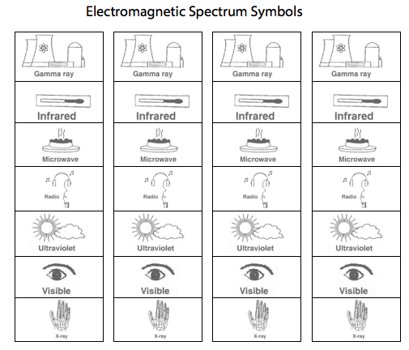

Each sheet makes copies for 8 students

Name _________________ period _______

EXIT TICKET

The Electromagnetic Spectrum

1. Which of the following are NOT examples of EM radiation?

A. visible light waves

B. radio waves

C. sound waves

2. What phenomenon tells us that galaxies are moving away from us?

A. Spectroscope shift

B. Blue shift

C. Red shift

3. Why can’t we view the stars with a ground-based X-ray telescope?

A. The Earth’s atmosphere blocks X-rays

B. They are too far away

C. There is no such thing as an X-ray

telescope

4. What do the fingerprints from spectral lines tell us?

A. The color of the star

B. The elements found in a star

C. If a star has water on it

5. Which type of electromagnetic radiation causes sunburn?

A. Ultraviolet waves

B. Gamma rays

C. Visible light waves

Name _________________ period _______

EXIT TICKET

*The Electromagnetic Spectrum*

1. What do the fingerprints from spectral lines tell us?

A. The color of the star

B. The elements found in a star

C. If a star has water on it

2. Which type of electromagnetic radiation causes sunburn?

A. Ultraviolet waves

B. Gamma rays

C. Visible light waves

3. Which of the following are NOT examples of EM radiation?

A. visible light waves

B. radio waves

C. sound waves

4. What phenomenon tells us that galaxies are moving away from us?

A. Spectroscope shift

B. Blue shift

C. Red shift

5. Why can’t we view the stars with a ground-based X-ray telescope?

A. The Earth’s atmosphere blocks X-rays

B. They are too far away

C. There is no such thing as an X-ray

telescope