Convection in Air and Water

Materials: Lamp with incandescent light bulb, paper spiral hanging above lamp
What To Do:
1. Observe the paper spiral. It should not be moving.
2. Make sure the lamp is placed directly below the spiral but not touching it.
3. Turn on the lamp.
4. Draw or describe what you observe.
5. Your teacher will call one student to the lamp to place their hand above it. DO NOT touch the light bulb.

Before After

Questions:
1. Did you observe anything touching the spiral? ___
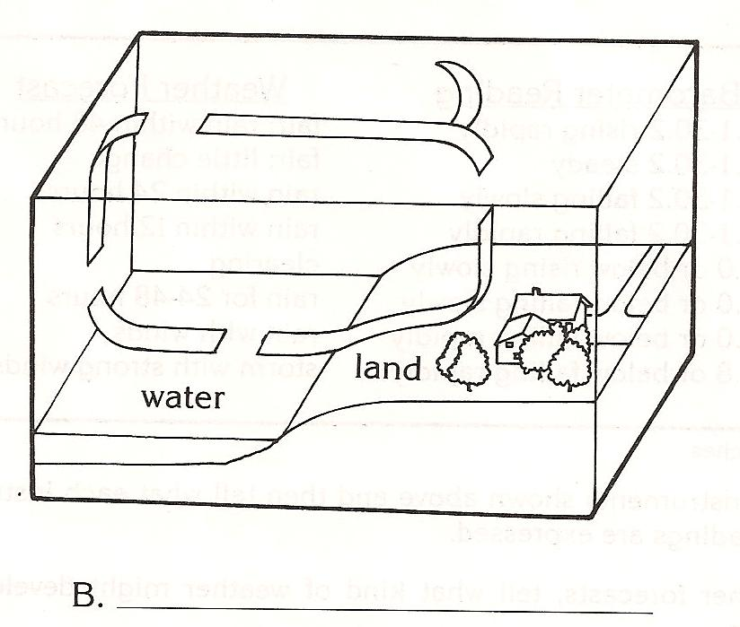
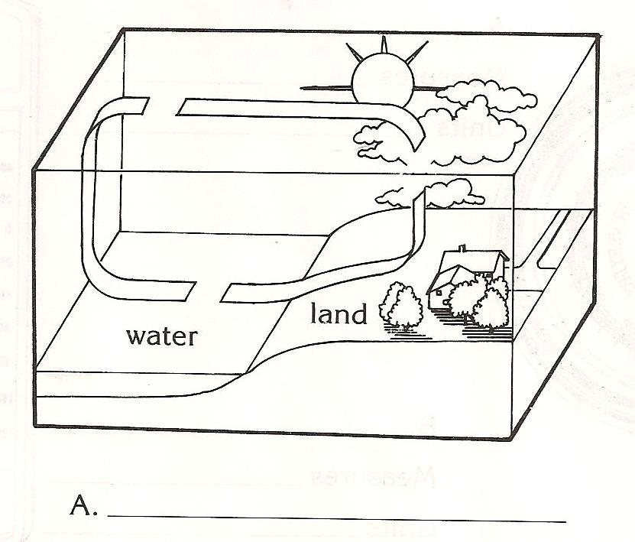
2. What do you think caused the spiral to move? ____________________________________
3. What did your classmate feel? _________________

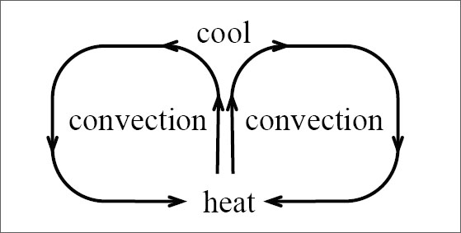
Heat is transferred in fluids (both liquids and gases) by convection. Convection is the transfer of heat by the movement of currents that form as a fluid is heated. When you first observed the spiral it was not moving. After the light bulb was turned on, the heat began to rise and this current of air caused the spiral to start moving.
Convection happens because the molecules that are heated begin to move faster and the area that the molecules are in begins to expand. This makes the air less dense allowing it to rise. The cooler air is denser and sinks.

This happens in nature, too. The Earth’s

atmosphere is heated by the sun but because of the tilt of the Earth’s axis and the Earth’s round shape the heating is uneven. As a result, some areas are warmer than others. These differences cause convection. Convection in the atmosphere causes winds.
Wind is simply moving air. A breeze is a gentle wind that is from 4 to 27 knots. The scenes below show two types of breezes, a water breeze and a land breeze.
A water breeze occurs during the day when the Sun heats up the land faster than the ocean. The land heats the air, which rises, moves over the ocean and cools. The air then sinks. The cool air is pushed back to the land causing the breeze.
A land breeze occurs during the night because the ocean water is still warm from the Sun while the land cools off. The warmer air rises and is pushed to the land where is cools off and sinks.
1. Determine which of the scenes in the water breeze and which is the land breeze.

2. Draw the arrows to show the wind flow in each scene.

Convection currents also happen in the ocean. Currents move for hundreds and thousands of miles in the Earth’s oceans. Currents circulate warm and cool water. Warm currents flow away from tropical regions near the equator. Cool currents flow away from cold areas near the poles.

Materials: 2-liter bottles of water, clear plastic shoebox, 5 Styrofoam cups, red food coloring, medicine dropper, coffee maker
What To Do:
1. Fill the shoebox about half full of room temperature water.
2. Turn 4 of the Styrofoam cups upside down and place them under the shoebox at each corner.
3. Allow the box to settle for about 2 minutes without bumping the table. It is important that the water be a still as possible.
4. Fill the other Styrofoam cup about ¾ full of hot water from the coffee maker.
5. Slide the cup of hot water under the shoebox at one end. Try not to bump the table or shoebox.
6. Use the medicine dropper to pick up a small amount of red food coloring and place 1 drop of the food coloring at the bottom of the water in the shoebox right above the cup of hot water.
7. Observe the drop of red food coloring and draw what happens below.

Questions:

1. What happened to the drop of red food coloring?____________________________________
2. Why did that happen? _______________________
___________________________________________
3. If this set up were the ocean what does the cup of hot water represent? _________________________
4. In what location on the Earth was the red food coloring located? ___________________________

Materials: map with ocean currents, colored pencils
What To Do:
1. Your teacher will project the map on the board. Color the warm currents red and the cool currents blue.
2. Answer the following questions.

1. Warm water from the equator flows up the East Coast of the United States, bringing warmer temperatures. What is the name of this current? __________________________
2. Cold water from the pols flows down the West Coast of the United States, bringing colder temperatures. What is the name of this current?
3. Identify 2 other warmer currents that flow away from the equator. ____________________________
4. Identify 2 other colder currents that flow away from the poles. __________________________________
5. Ocean currents affect the temperature of the land near them. Which current most affects OUR weather in Texas?____ Is it a warm or a cold current? _____
6. How does convention cause the ocean currents to move?______________________________________
_____________________________________________________________________________________

Name _______________ period _____

EXIT TICKET
Convection in Air and Water
1. Which of the following is NOT caused by convection?

A. Breezes
B. Ocean currents
C. Flowing rivers

2. In what direction does heat move?

A. from warmer areas to cooler areas
B. from cooler areas to warmer areas
C. between areas of equal temperatures

3. What is the transfer of heat through a fluid called?

A. Conduction
B. Convection
C. Radiation

4. Why do heated molecules rise?

A. Because they are less dense than the molecules
around them
B. Because they are denser than the molecules
around them
C. Because they are moving slower than the other
molecules

5. What provides the energy that drives convection in the atmosphere and oceans?

A. Reflected light from the moon
B. Direct rays of the Sun
C. Heat from the Earth’s core

Name _______________ period _____
EXIT TICKET
Convection in Air and Water
1. Why do heated molecules rise?

A. Because they are less dense than the
molecules around them
B. Because they are denser than the molecules
around them
C. Because they are moving slower than the other
molecules

2. What provides the energy that drives convection in the atmosphere and oceans?

A. Reflected light from the moon
B. Direct rays of the Sun
C. Heat from the Earth’s core

3. Which of the following is NOT caused by convection?

A. Breezes
B. Ocean currents
C. Flowing rivers

4. In what direction does heat move?

A. from warmer areas to cooler areas
B. from cooler areas to warmer areas
C. between areas of equal temperatures

5. What is the transfer of heat through a fluid called?

A. Conduction
B. Convection
C. Radiation

