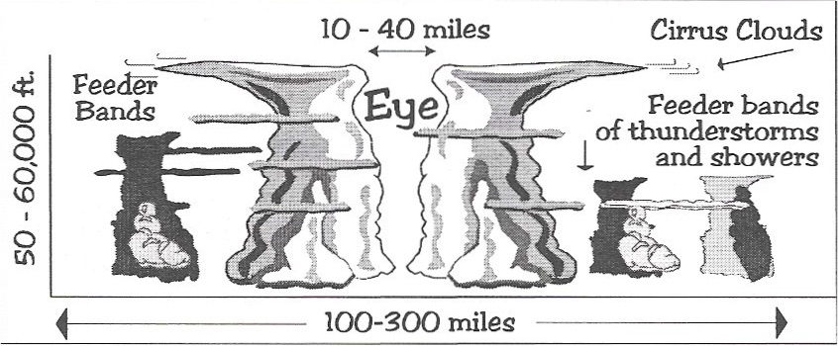

The Ocean’s Role in Weather Systems

The ocean covers more than 70 percent of the Earth’s surface. It is very effective at absorbing and storing heat from the Sun. Because of this absorbing and storing heat, the ocean plays an important role in shaping our climate and weather patterns.

Warm ocean waters provide the energy to fuel weather systems that bring needed rain to the dry land. Warm water evaporates from the ocean into the atmosphere, where it can condense and form clouds, which can eventually lead to rain. Tropical storms form over warm ocean waters, which supply the energy for hurricanes and typhoons to grow and move, often over land.

The most destructive of all weather phenomena is the hurricane. Winds in a tornado can momentarily exceed those of a hurricane, but the life cycle of a tornado is measured in minutes while the life cycle of a hurricane is measured in weeks.

Several phases of development take place before a tropical cyclone develops into a hurricane. Growth is determined by the strength of the sustained wind. The tropical depression has winds less than 36 mph; winds of a tropical storm range from 36-74 mph. The hurricane has sustained winds greater than 74 mph.

Hurricanes begin as tropical storms over the warm moist waters of the Atlantic and Pacific Oceans near the equator. Hurricanes over the Atlantic, drift west on the Trade Winds, and veer north as they meet the prevailing winds coming eastward across North America.

In the chart below list the type of storm and the range

of sustained winds.

|  |  |
| --- | --- |
| **Type of Storm** | **Sustained Winds** |
|  |  |
|  |  |
|  |  |

**Diagram of a Hurricane**

Use the diagram below to answer the following questions.

**Questions:**

1. How wide can a hurricane be? ___________________

2. What is the center of a hurricane called? ____________

3. How wide can it be? ___________________________

4. How tall can a hurricane be? ____________________

5. What are the thunderstorms and showers outside a hurricane called? ________________________________

Watch the video Hurricanes 101 from [www.missdoctorbailer.com](http://www.missdoctorbailer.com) and answer the following question.

The diagram above was published in the 1980’s. Why is the information in the video different?

____________________________________________________________________________________________

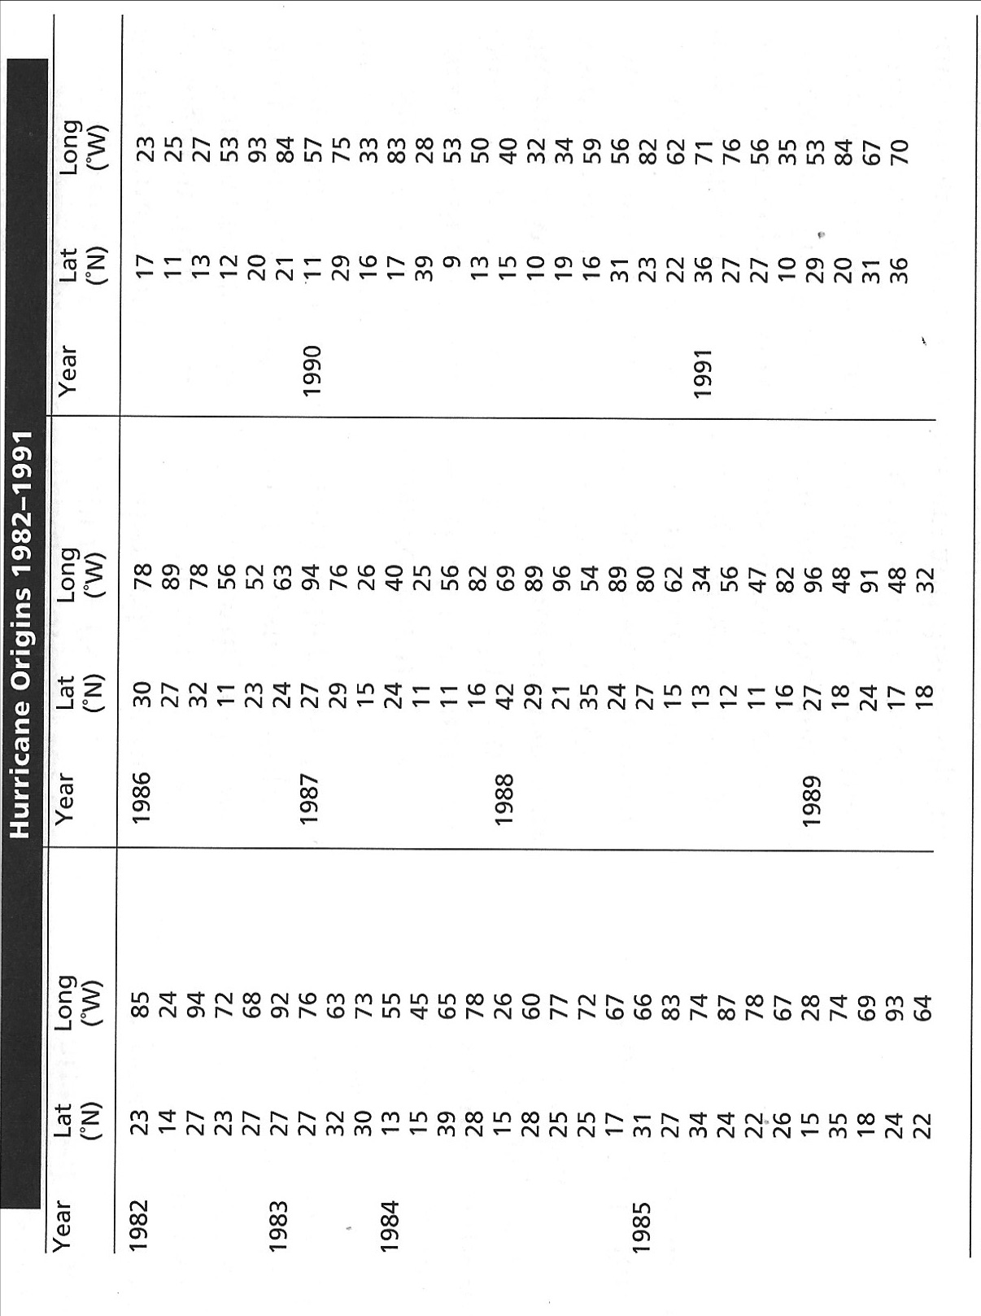

**Materials:** hurricane-tracking map

**What To Do:**

You and your partner are part of a research team working for the National Oceanic and Atmospheric Administration (NOAA). Your job is to put out a large number of floating instrument packages to student the weather and ocean conditions that lead to the formation of hurricanes. But first you must choose the best possible location for these instruments. The area must be not larger than five degrees latitude and fire degrees longitude.

You have already gathered ten years of data on where hurricanes are “born.” You and your partner decided to define “born” as the place where hurricanes first become tropical storms and were given a name. You are each ready to plot hurricane origins on a hurricane-tracking map. Each coordinate is a different hurricane so don’t connect the dots!

The resulting map is like a scatter plot. Use this visual display of hurricane origins to determine where to place the instrument platforms.

**Conclusions:**

1. Where do you recommend placing the platforms?

________________________________________________

2. Why did you choose that area? ____________________

________________________________________________________________________________________________

Be ready to present your recommendation and your reasons to the class.

Name ___________________ period _____

EXIT TICKET

Ocean’s Role in Weather Systems

1. At what sustained wind speed does a tropical storm become a hurricane?

A. greater than 35 mph

B. greater than 50 mph

C. greater than 74 mph

2. What is the source of energy for all weather systems?

A. The Sun

B. The Moon

C. The Tides

3. What role does the ocean play in the formation of hurricanes?

A. The water stirs up the atmosphere

B. The water absorbs and stores heat

C. The water cools the atmosphere

4. What is the middle of the hurricane called?

A. Galactic center

B. The center

C. The eye

5. What are the feeder bands made of?

A. Thunderstorms

B. Tornadoes

C. Dust storms

Name ___________________ period _____

EXIT TICKET

*Ocean’s Role in Weather Systems*

1. What is the source of energy for all weather systems?

A. The Sun

B. The Moon

C. The Tides

2. What is the middle of the hurricane called?

A. Galactic center

B. The center

C. The eye

3. What role does the ocean play in the formation of hurricanes?

A. The water stirs up the atmosphere

B. The water absorbs and stores heat

C. The water cools the atmosphere

4. At what sustained wind speed does a tropical storm become a hurricane?

A. greater than 35 mph

B. greater than 50 mph

C. greater than 74 mph

5. What are the feeder bands made of?

A. Thunderstorms

B. Tornadoes

C. Dust storms