Science Shorts -6
Write your notes about what you are reading in this space.
What is the Moon?
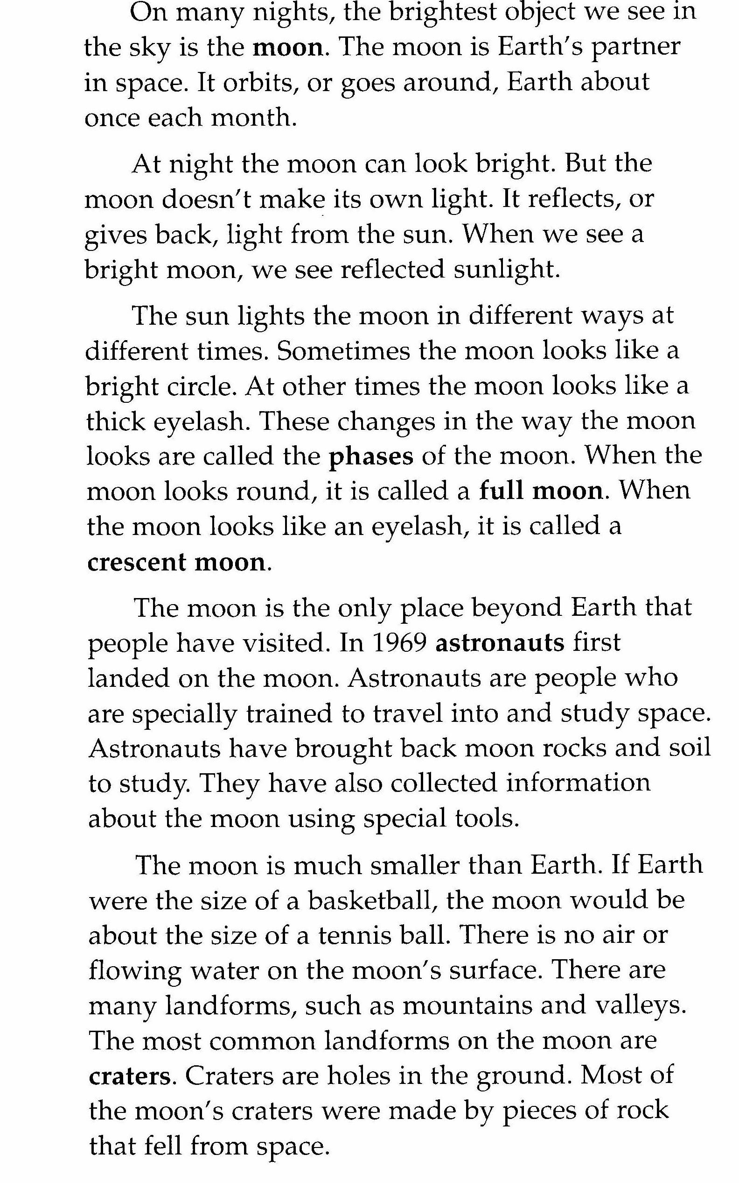

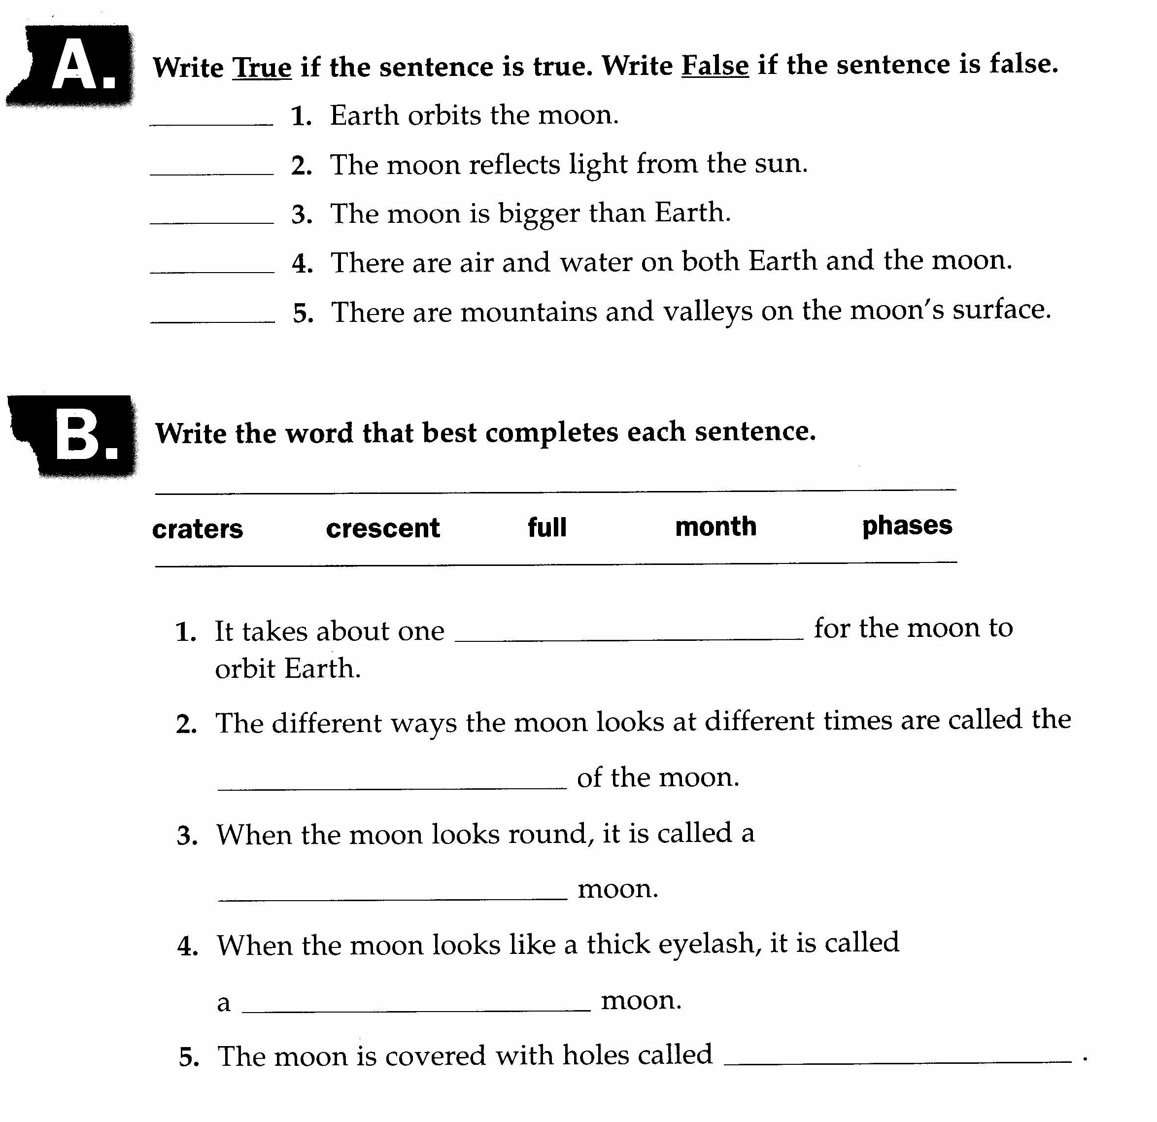


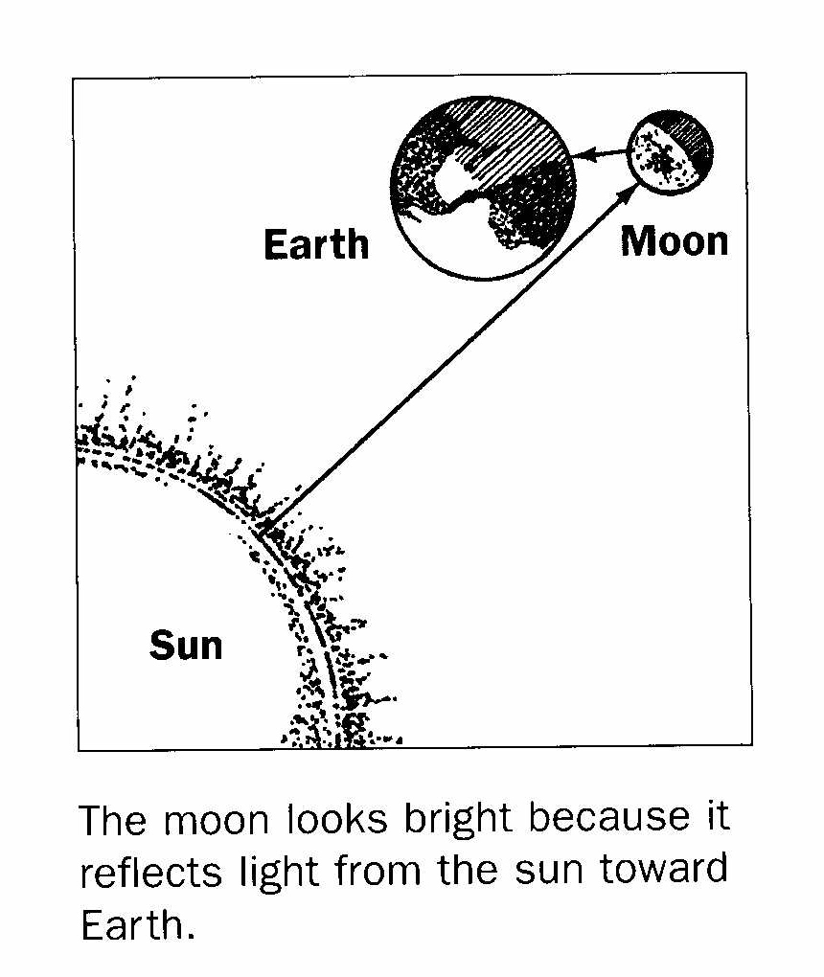
Explain what you see in the picture.

_________________________________

________________________________________

________________________________________

________________________________________

