Two Kinds of Cells
Watch the Power Point called Cell Theory. Answer the questions about each picture below.
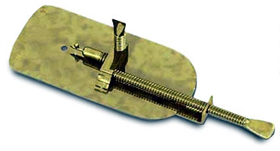 | 1. When was the microscope invented?  ____________________  2. Whose microscope is this? _____________
3. Whose microscope is this? ______________  4. How did he light the specimen? ___________ | 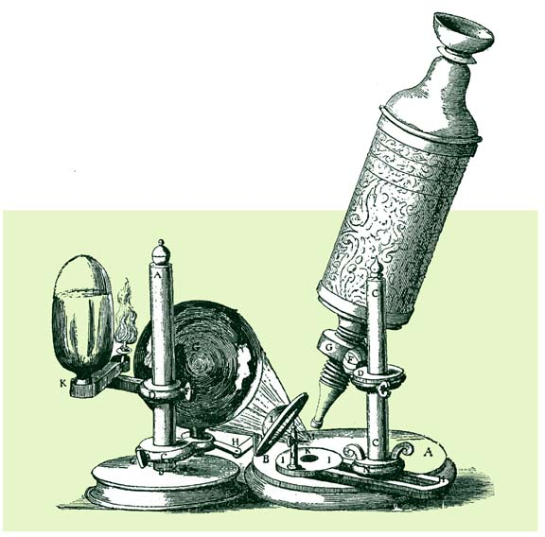
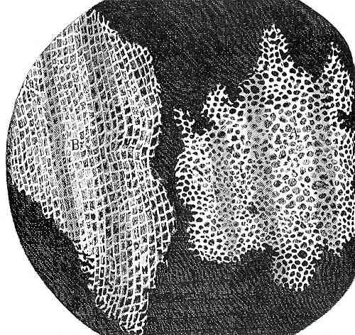 | 5. What is this? _______  6. What are the small boxes called? _______
7. What are the small rooms called? ________  8. Who lives in them?  __________________ | 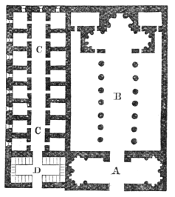
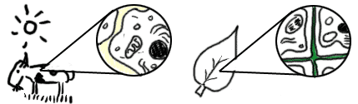 | 9. What is pictured here?  _____________________  10. What does it represent? ____________  11. What does the cell theory say? __________  ____________________

After the microscope was improved scientists were able to see inside living cells. Living cells have parts called organelles. The most important organelle of most cells is called the nucleus. The nucleus can be thought of as the brain of the cell. It directs the cell’s activities. Imagine the surprise of scientists to find that some cells don’t have a nucleus! These cells without a nucleus have similar nuclear material as cells with a nucleus but it is just spread out within the whole cell. Cells with a nucleus are called Eukaryotic Cells and cells without a nucleus are called Prokaryotic Cells.

Materials: colored pencils
What To Do:
1. Color the nucleus blue.
2. Color the nuclear material blue.
3. Outline the cell membrane in red.
4. Color the cytoplasm yellow.
5. Color the organelles purple.
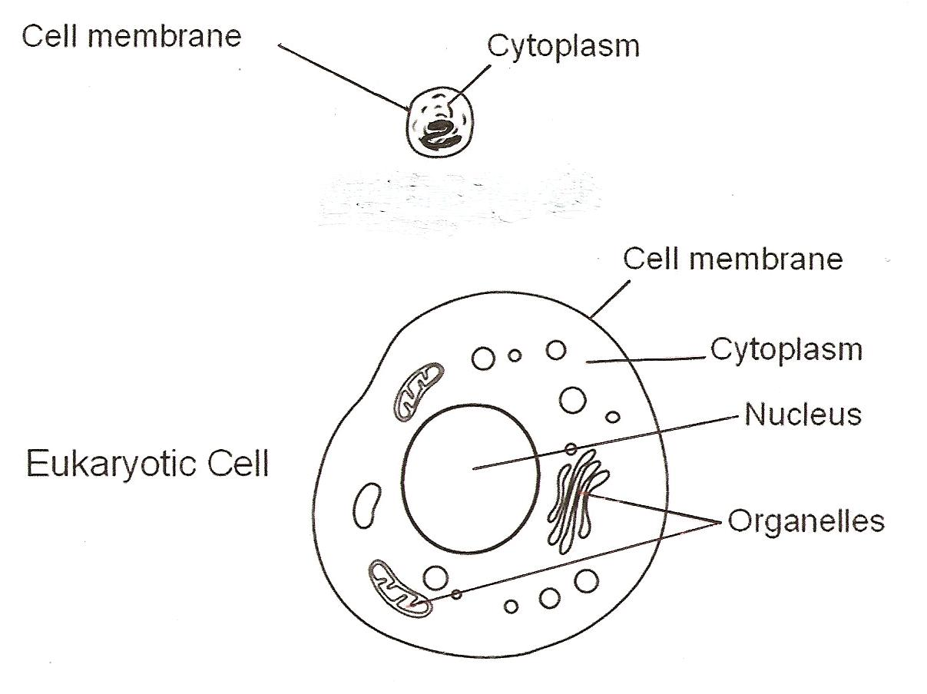
Prokaryotic Cell
Nuclear Material

Complete the Venn diagram comparing Prokaryotic
Cells with Eukaryotic Cells below.

Prokaryotic Cells Eukaryotic Cells

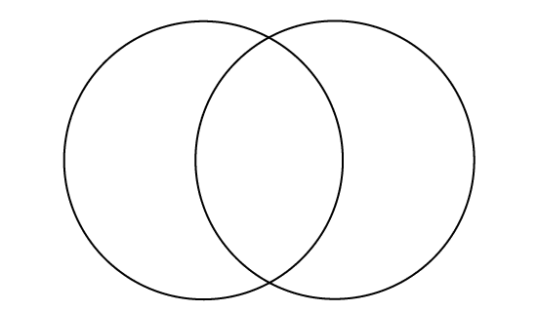

Materials: construction paper - various colors, scissors, glue
What To Do:
- Make a Prokaryotic Cell and a Eukaryotic Cell out of construction paper.
- Glue them to the next page.
- Use different colors for each organelle.
4. Label each organelle with its correct name.

Name ________________ period _____
EXIT TICKET
Two Kinds of Cells
1. What does the cell theory state?

A. Non-living things are made of cells
B. All living things are made of cells
C. Only people are made of cells
D. Rocks are made of cells

2. What are small parts inside a cell called?

A. small parts
B. organs
C. organelles
D. cell membrane

3. Which of the following is NOT found in prokaryotic
cells?

A. Cell membrane
B. Cytoplasm
C. Nuclear material
D Nucleus

4. What does a nucleus do?

A. Directs cell activities
B. Carry for to the cell
C. Get rid of waste materials
D. Make oxygen

Name ________________ period _____
EXIT TICKET
Two Kinds of Cells
1. Which of the following is NOT found in
prokaryotic cells?

A. Cell membrane
B. Cytoplasm
C. Nuclear material
D Nucleus

2. What does a nucleus do?

A. Directs cell activities
B. Carry for to the cell
C. Get rid of waste materials
D. Make oxygen

3. What does the cell theory state?

A. Non-living things are made of cells
B. All living things are made of cells
C. Only people are made of cells
D. Rocks are made of cells

4. What are small parts inside a cell called?

A. small parts
B. organs
C. organelles
D. cell membrane

