What Can We See Under A Microscope?

An Introduction To the World of the Microscope

Booklet Set #101
Directions: Your teacher will help you read the front of
the booklet. Answer the following questions from that information.
1. An instrument that helps the eyes to see tiny objects is
the __________________.
2. What is in a microscope that enlarges things so our eye
can see them? ________
3. What does a lens do to light? _________________
4. How were the photographs on the slides taken? ___________________________
5. What does the number 40x mean? ______________________________________
6. What does the word “stained” mean? ____________________________________

Directions: Then use the Micro-viewer and the booklet and slides to draw the photographs and answer the questions for each slide. Be sure to write the title of the slide and the magnification under the line. The first one is done for you.

1  The letter “e” (10x) | 7. What is the paper made of in this slide? __________________
2  ______________ | 8. What is pollen? ____________________________
3  ______________ | 9. Where was the Hydra found? __________________________  10. What do they use the tentacles for? _____________________
4.  ____________ | 11. What do the bacteria on this slide do?  _____________________________
5.  ____________ | 12. Name 4 different types of cells.  ___________________________  13. What are the two different types of blood cells seen in the slide? _____________________________

6  ______________ | 14. Where did these shells come from? ___________________  15. What are the animals that made the shells called? _________
7  ____________ | 16. How are cross-sections helpful? ________________________________  ________________________________  17. How does a biologist make one? ________________________________  ________________________________
8  ____________ | 18. What type of microscope let us see this virus? ______________________  19. What is different about this slide than all the other slides? ___________  _____________________________

Below you will see three close up pictures taken with a camera and a microscope. Look at them closely and guess what they are.

Picture | What is it?
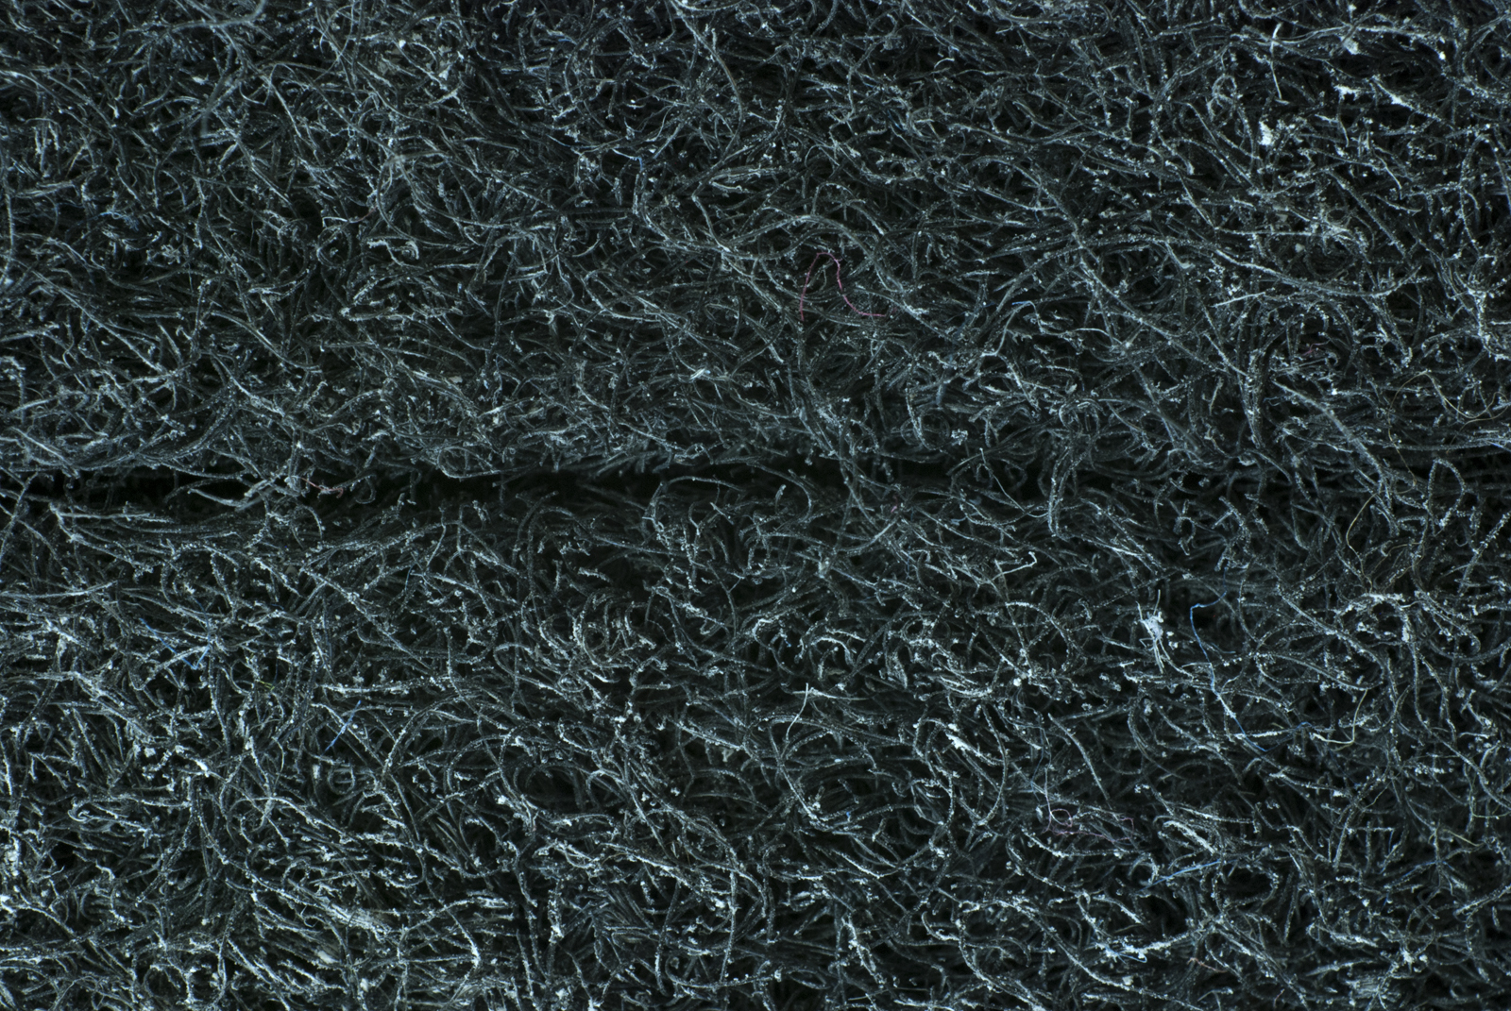

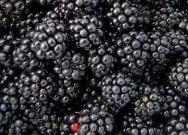
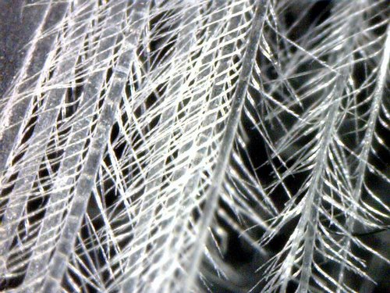

Name __________________ period _____

EXIT TICKET
What Can We See Under a Microscope?

1. What was strange about the e you obseved?

1. It was many different colors.
2. It was made from paper
3. It was magnified ten times
4. It was upside down.

2. What does 30x mean?

A. There are thirty different specimen
B. It’s part of a math problem
C. The image has been magnified 30 times
D. There are 30 x’s on the slide

3. What are two types of microscopes?

A. big and little
B. compound and electron
C. single and compound
D. electron and single

4. What does cross section mean?

A. The specimen has be cut across the body.
B. A cross is under the microscope
C. The specimen has been cut from top to bottom
D. It can’t be viewed with a compound microscope.

Name __________________ period _____

EXIT TICKET
What Can We See Under a Microscope?

1. What are two types of microscopes?

A. big and little
B. compound and electron
C. single and compound
D. electron and single

2. What does 30x mean?

A. There are thirty different specimen
B. It’s part of a math problem
C. The image has been magnified 30 times
D. There are 30 x’s on the slide

3. What was strange about the e you obseved?

1. It was many different colors.
2. It was made from paper
3. It was magnified ten times
4. It was upside down.

4. What does cross section mean?

A. The specimen has be cut across the body.
B. A cross is under the microscope
C. The specimen has been cut from top to bottom
D. It can’t be viewed with a compound microscope.

