What is Classifying?
To classify means to group similar things together. We use classification every day. Your school has 3 classifications of students – 6th grade, 7th grade and 8th grade. When you go into a grocery store all the types of soup are in one area. All the types of canned soda are in another area. Imagine what it would be like if they just put everything piles. It would take you hours to find the food you wanted to buy.
Scientists believe that there are over 10 million kinds of living things on Earth. Imagine trying to study and understand the lives, behaviors of so many different kinds of organisms. In order to make their job easier, scientists classify living things into groups based on how they are the same and how they are different.
In the 1700’s a Swedish scientist named Carl Linnaeus developed the classification system biologists use today. There have been some changes in his system but he came up with the idea. We will learn about his system in the next lesson.

Materials: 10-15 various classroom items such as marble, eraser, push pin, small rock
What To Do:
1. Pour out all of the items your teacher gives you.
2. Place them in groups according to the chart below.
3. List the items you place in each group. Add another column if you need to.

Color
Items

4. Mix the items up and place them in groups by type of material.
5. List the items you place in each group.

Material | Plastic | Wood | Metal | Paper | Rock
Items

6. Choose another way to group the items and place your information in the chart below.

Items

Questions:
1. Why do people classify things? ________________
2. Why do you think scientists classify living things?
____________________________________________
3. Name another place where things are classified.
____________________________________________

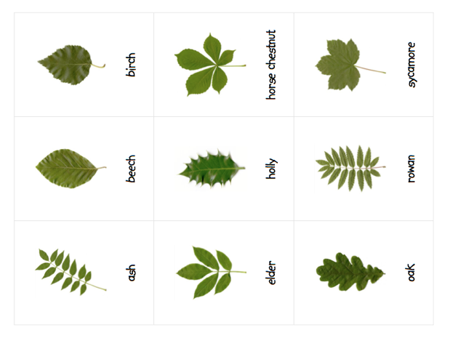
Materials: scissors, glue, Leaf Cards
What To Do:
1. Cut apart the leaf cards on the next page.
2. Work with your partner to classify them into groups.
3. Name your groups and place them in the chart below.
4. List the names of the leaves in the chart.
5. You may add another column if you need to.
6. Glue them in their groups on the next page of your notebook.

Group Name
Leaf Name

Name ________________ period _____
EXIT TICKET
What is Classifying?
1. Sorting things into groups is called –

A. Observing
B. Inferring
C. Classifying
D. Graphing

2. Biologists sort things into groups to –

A. Make their work harder
B. Make their work easier
C. To be able to find things in the store
D. To be able to tell the names of animals

3. Classify the following animals into groups.

Horse, zebra, chicken, dog, blackbird, hummingbird

Category
Animal

4. Circle the three things that can be classified in one group.

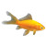



5. What category did you put the answers to #4 in?
____________________

Name ________________ period _____
EXIT TICKET
What is Classifying?
1. Classify the following animals into groups.

Horse, zebra, chicken, dog, blackbird, hummingbird

Category
Animal

2. Circle the three things that can be classified in one group.

3. What category did you put the answers to #2 in?
_________________
4. Sorting things into groups is called –

A. Observing
B. Inferring
C. Classifying
D. Graphing

5. Biologists sort things into groups to –

A. Make their work harder
B. Make their work easier
C. To be able to find things in the store
D. To be able to tell the names of animals

