Kingdom Archaebacteria

Archaebacteria are the oldest organisms living on the Earth. They are unicellular prokaryotes and belong to the kingdom, Archaea. They were first discovered in 1977 and classified as bacteria. Most archaebacteria appear like bacteria, when observed under the microscope. However, they are quite different from bacteria and eukaryotic organisms.
Archaebacteria are found in very harsh conditions such as in the volcanic vents or at the bottom of the sea.
Archaebacteria survive only in oxygen-free environments and are known as extremophiles. Some species can live in the temperatures above boiling point at 100 degree Celsius or 212 degree Fahrenheit. Like all prokaryotes, archaebacteria don't have nuclei. They can easily survive in such extreme environments as sea vents releasing sulfide-rich gases, hot springs, or boiling mud around volcanoes.
Methanogens harvest energy by converting H2 and CO2 into methane gas. They are found in the intestinal tracts of humans and some animals such as cows, and in marshes. Halophiles survive in a high-salt atmosphere. They can be found in the Great Salt Lake, Dead Sea and other areas with a high salt concentration. Thermoacidophiles are found in the areas with very high temperatures and extremely acidic conditions. They can be found in hydrothermal and volcanic vents.
The discovery and study of archaebacteria has opened up a whole new possibility of finding life in the most extreme of environments - places where till now, it was thought, life could not exist.

What Does It Mean?

What To Do:
1. Look at the list of Latin and Greek prefixes and suffixes below.
2. Determine what each of the different types of archaebacteria does by their names.

Prefix/Suffix | Meaning | Prefix/Suffix | Meaning
acido | acid | methano | methane
gen | that which produces | philes | loving
halo | salt | thermo | hot temperature

Methanogens ________________________________
Halophiles ___________________________________
Thermoacidophiles ____________________________

Watch the video Extremophiles from www.missdoctorbailer.com and answer the following question.

1. Extremophiles were shown in what 3 places?
____________________________________________

2. What extreme did the bacteria in Mono Lake like?
__________________________________________

3. What would they be called? _________________

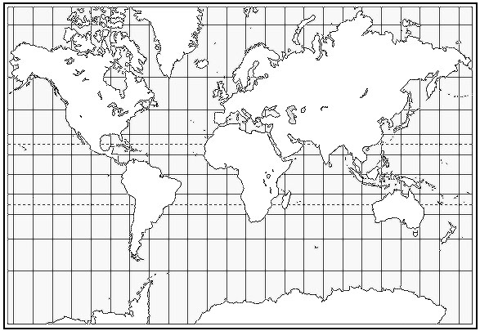

What To Do:
1. Research 5 of the following types of extremophiles.

2. Find where they live on the earth and mark their
location on the map on the next page.

3. Next to the mark write the location and name and of
the extremophile.

Types of Extremophiles:

Aciophiles
Alkalinphiles
Thermophiles
Psychrophiles
Barophiles/piezophiles
Xerophiles
Halophiles
Radioresistant

Name ___________________ period _____
Exit Ticket
Kingdom Archaea
1. What does philes mean?

A. cold temperatures
B. loving
C. hating

2. What do all extremophiles have in common?

A. They are all like plants
B. They are all found in outer space
C. They are all found in harsh conditions

3. How are the members of Kingdom Archaea like the members of Kingdom Monera?

A. They are all prokaryotes
B. They are all eukaryotes
C. They all have flagella

4. How are the members of Kingdom Archaea different from the members of Kingdom Plantae?

A. They don’t have a nucleus
B. They don’t have cells
C. They don’t need water to live

5. Where would you probably NOT find a member of the Kingdom Archaea?

A. In a deep ocean vent
B. In a very salty lake
C. On your skin

Name ___________________ period _____
Exit Ticket
Kingdom Archaea
1. How are the members of Kingdom Archaea different from the members of Kingdom Plantae?

A. They don’t have a nucleus
B. They don’t have cells
C. They don’t need water to live

2. Where would you probably NOT find a member of the Kingdom Archaea?

A. In a deep ocean vent
B. In a very salty lake
C. On your skin
3. What does philes mean?

A. cold temperatures
B. loving
C. hating

4. What do all extremophiles have in common?

A. They are all like plants
B. They are all found in outer space
C. They are all found in harsh conditions

5. How are the members of Kingdom Archaea like the members of Kingdom Monera?

A. They are all prokaryotes
B. They are all eukaryotes
C. They all have flagella

