Kingdom Eubacteria
As we have learned, bacteria are prokaryotic – they do not have nucleus – and that places them in the Kingdom Eubacteria. We sometimes call bacteria germs, but there are many types of germs but only bacteria belong in this kingdom.
Bacteria cover your hands, body and clothing. They are on the desk, on the floor, on everything you touch. They float on dust in the air. They live in water and in the ground. Look at the period at the end of this sentence. How many bacteria do you think can fit on it? Would you believe from fifty thousand to one-quarter million?
All bacteria need water and proper temperature to survive. Most also need oxygen. Some can live without oxygen. Most bacteria cannot move by themselves, but some can. The ones that move use long hair-like structures called flagella to move in liquids.

Materials: colored pencils
What To Do:
1. Color the nuclear material dark blue.
2. Outline the cell wall in light blue.
3. Outline the plasma membrane in black
4. Color the cell yellow.
5. Color the flagellum orange.
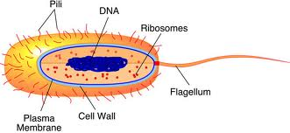
Nuclear Material

Bacteria are found in three basic shapes – round,
rod and spiral.
Round | Rod | Spiral
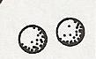 | 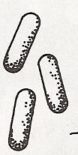 | 

The scientific name for round bacteria is coccus, for rod-shaped bacteria is bacillus and for spiral shaped is spirilla.
Bacteria are also found in twos called diplo- chains called strepto- and clusters called staphylo-. So some bacteria may be called diplococcus, streptobacillus or staphylococcus.

Look at the pictures below and place a name with each type of bacteria.

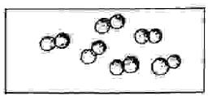 1. _______________________

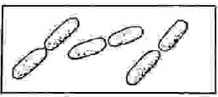 2. _______________________

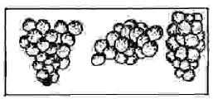 3. _______________________

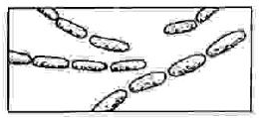 4. _______________________

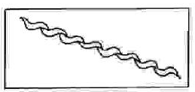 5. _______________________

Watch the video of bacteria reproducing at www.missdoctorbailer.com
About half way through the video you will see a white blood cell chasing the small bacterial cell. Try to observe it absorbing the bacterial cell.

Draw what you see of the bacteria reproducing below.

Draw the white blood cell chasing the small bacterial cells below.

Questions:
1. What type of bacteria is shown in most of this video?
_________________________________________

2. What type of bacteria is being chased by the white blood cell? _________________________________________
3. How many are there? _________________________

When conditions are right, bacteria grow and reproduce. They reproduce by dividing in half. Each half then grows into a new bacterial cell. Some bacteria can do this every 20 minutes. At this rate, at the end of one day the bacteria would weigh 2,000 tons. Fortunately, this never happens. As the mass of bacteria increases, food is used up. Less space is available, wastes accumulate and growth and reproduction slow down.

Some bacteria reproduce every twenty minutes. To find
out how many bacteria would be produced in five hours, complete the table below.

Time | Number of Bacteria
0 hr 00 min | 1
0 hr 20 min | 2
0 hr 40 min | 3
1 hr 00 min | 4
1 hr 20 min | 8
1 hr 40 min
2 hr 00 min
2 hr 20 min
2 hr 40 min
3 hr 00 min
3 hr 20 min
3 hr 40 min
4 hr 00 min
4 hr 20 min
4 hr 40 min
5 hr 00 min

Questions:
1. What keeps bacteria from taking over the world?
_________________________________________
2. What are the characteristics of the Kingdom Eubacteria?__________________________________

Name __________________ period _____

EXIT TICKET
Kingdom Monera
1. There are three major shapes of bacteria. They are coccus, bacillus and spirilla. Which of the three is always a single organism?

A. Diplococcus
B. Streptococcus
C. Spirilla
D. Staphlobacillus

2. Draw a coccus bacterium in the space below.

3. Bacteria do not have a nucleus but they still have a cell wall. Which type of organism has these characteristics?

A. Archeabacteria
B. Plants
C. Prokaryotes
D. Eukaryotes

4. When conditions are right bacteria start to grow and reproduce. Conditions needed for bacteria to grow are a food source, water and appropriate temperature. What would happen if the food ran out?

A. The bacteria would grow faster
B. The bacteria would stop growing
C. The bacteria would just slow down
D. The bacteria would start to move away.

Name __________________ period _____

EXIT TICKET
Kingdom Monera
1. Bacteria do not have a nucleus but they still have a cell wall. Which type of organism has these characteristics?

A. Archeabacteria
B. Plants
C. Prokaryotes
D. Eukaryotes

2. When conditions are right bacteria start to grow and reproduce. Conditions needed for bacteria to grow are a food source, water and appropriate temperature. What would happen if the food ran out?

A. The bacteria would grow faster
B. The bacteria would stop growing
C. The bacteria would just slow down
D. The bacteria would start to move away.

3. There are three major shapes of bacteria. They are coccus, bacillus and spirilla. Which of the three is always a single organism?

A. Diplococcus
B. Streptococcus
C. Spirilla
D. Staphlobacillus

4. Draw a coccus bacterium in the space below.

