Kingdom Protista

The protists are a kingdom of very simple organisms. Most protists are made up of only one cell. Some are many-celled. Unlike bacteria, all protists have a nucleus so they are part of the Eukaryote Domain. Some protists live in water. They live in lakes, streams, ponds and in the ocean. Some live in moist soil. Some even live in the bodies of animals.
There are three large groups of protists. The three groups are the protozoans, the algae, and the slime molds.
Protozoans are one-celled animal-like organisms. Like animals, protozoans cannot make their own food. Protozoans do not have a cell wall. Algae are simple plant-like organisms. Most algae have only one cell. However, some algae have many cells and grow to be very large. All algae have chlorophyll. Like plants, they can make their own food.
Watch the Kingdom Protista video from www.missdoctorbailer.com and answer the following questions.

1. Name two diseases that protists cause?

____________________________________________

2. What are the two functions of cilia?

____________________________________________

3. What does pseudopod mean? ________________

4. What structures of the euglena are found in plants?

___________________________________________

5. How does the euglena sense light?

__________________________________________

6. Name one function of vacuoles.

_________________________________________

7. What does phagocytosis mean?

_________________________________________

8. What is the most diverse phylum of protists?

_________________________________________

9. What are two ways green algae are very important

_________________________________________

10. What are groups of green algae called?

___________________________________________

11. What is the most common type of gold algae?

________________________________________
On the next page you will find 3 general examples of protozoa. They have many organelles that are similar and several that are different.

Materials: colored pencils
What To Do:
1. Color the nucleus in each of the protozoans blue.
2. Color any vacuoles yellow.
3. The amoeba moves using a pseudopod. Color one orange.
4. The euglena moves using a flagellum. Color it
orange.
5. The paramecium moves using cilia. Color the little hairs orange.
6. The euglena has chloroplasts to make it’s own food. Color them green.

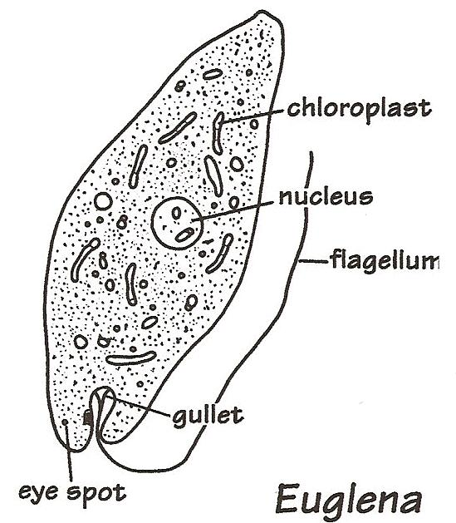
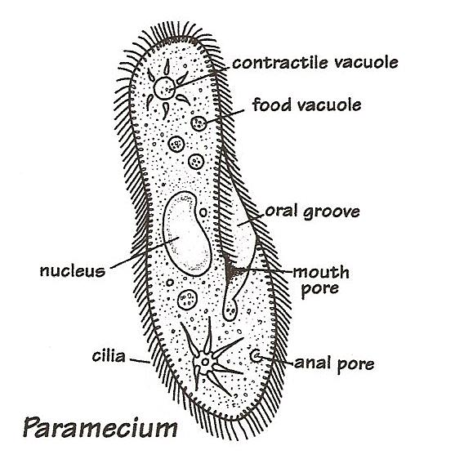
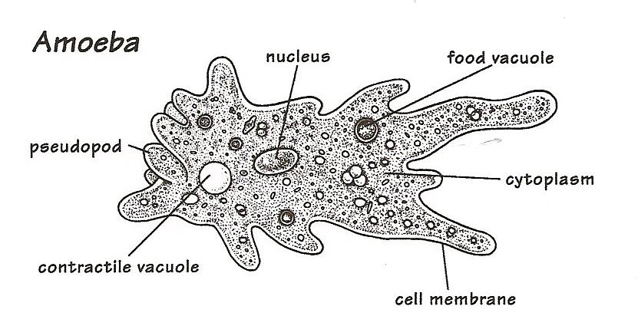
Questions:

1. What structure does an amoeba use to move?
_______________

2. What structure does an amoeba use to capture food?
_______________
3. What structure does an euglena use to move? ________________

4. How does a euglena get its food?
_________________

5. What structures does a paramecium use to move?
________________

Most protozoa and algae live in the water. There are
many other organisms that also live in pond water.
Below you will find a jar of pond water with many
different types of organisms. Your teacher will go to
the site http://www.microscopy-uk.org.uk/ponddip/index.html
so you can identify the different organisms.

What To Do:
1. Circle any protozoans in red.
2. Circle any algae in green
3. Circle any microscopic animals in orange.
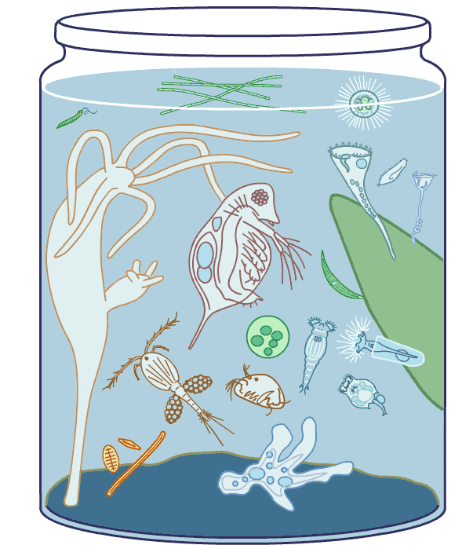

Name ________________ period _____
EXIT TICKET
Kingdom Protista
1. Protozoans use various structures for locomotion.
Which of the following lists gives ways protozoans use
to move around?

A. Arms, legs and feet
B. Legs, flagella, vacuoles
C. Flagella, cilia, pseudopodia

2. Organisms in the Kingdom Protista have a nucleus as
one of their organelles. What Domain does the
presence of a nucleus place the organism within?

A. Archeabacteria
B. Prokaryote
C. Eukaryote

3. The euglena is able to obtain food two different ways.
It can use the chloroplasts to make food from light and
use its flagellum to move around in the water to find
food. How is this ability helpful?

A. It can escape predators
B. It can capture food when light is not available
C. It can always make food.
D. The flagellum helps it move faster.

4. Organisms that live in the water must be able to
regulate how much water stays inside the cell and how
much water goes outside the cell. What might happen
if too much water goes inside a cell?
A. The cell will shrink
B. The cell will pop like a balloon
C. The cell will divide into two parts

Name ________________ period _____
EXIT TICKET
Kingdom Protista
1. The euglena is able to obtain food two different
ways. It can use the chloroplasts to make food from
light and use its flagellum to move around in the
water to find food. How is this ability helpful?

A. It can escape predators
B. It can capture food when light is not available
C. It can always make food.
D. The flagellum helps it move faster.

2. Organisms that live in the water must be able to regulate how much water stays inside the cell and
how much water goes outside the cell. What might happen if too much water goes inside a cell?
A. The cell will shrink
B. The cell will pop like a balloon
C. The cell will divide into two parts

3. Protozoans use various structures for locomotion. Which of the following lists gives ways protozoans
use to move around?

A. Arms, legs and feet
B. Legs, flagella, vacuoles
C. Flagella, cilia, pseudopodia

4. Organisms in the Kingdom Protista have a nucleus
as one of their organelles. What Domain does the
presence of a nucleus place the organism in?

A. Archeabacteria
B. Prokaryote
C. Eukaryote

