Kingdom Fungi
Have you ever wondered what bread is made of? Most bread starts with flour and water, but there is a secret ingredient that makes bread fluffy and light. Let’s do an experiment to see what it is! Observe as your teacher mixes the following materials in a large beaker.

Mixture 1 |  | Mixture 2
1 pkg dry yeast |  | ¼ c warm water
¼ c warm water |  | ½ c sugar
½ c sugar |  | 1 c plain white flour
1 c plain white flour

Observe and draw in the beakers below how tall the mixture is after it is mixed. We will observe them again at the end of the class.

Mixture 1 Beginning Mixture 2 Beginning
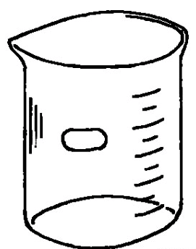

Mixture 1 End Mixture 2 End

Do you think that the mushrooms in a salad
are related to the lettuce? Many people think that mushrooms are plants. However, mushrooms are not plants. Mushrooms are one type of fungi (Fun-Guy). Fungi are like plants in some ways. For example, fungi often grow well in soil like most plants. The cells of fungi have cell walls. Plants have cell walls, too.
Scientists, however, have discovered that fungi and plants are not really much alike. The cells of fungi do not have chloroplasts or chlorophyll. Therefore, fungi cannot make their own food as plants do. Fungi must get food from their surroundings. Most fungi feed on dead organisms. Fungi have large cells with many nuclei. This makes them eukaryotes like plants but fungi usually grown well in moist dark places while plants need light. You now know that mushrooms are
a kind of fungi. The Fungi Kingdom also includes yeasts and molds.

Watch the video called Fungi Kingdom from www.missdoctorbailer.com. In the space below write three things you learned from the video.

As we have learned there five major divisions of the Fungi Kingdom. Match the descriptions of the divisions on the next page with the example pictures.

Fungi Description | Picture
These fungi have a stalk and a cap. We use them in salads.

These fungi are molds and grow on bread and can be black, green or white.

These fungi are little balls filled with spores that burst open when hit by a raindrop.
These fungi grow on trees often sticking out like little ruffles or shelves.

These fungi are so small they can only be seen under a microscope. They produce carbon dioxide that makes bread light and fluffy.

After finishing the matching your teacher will show you the beakers again. Draw what you observe in the End beakers. Can you smell anything? The yeast is a fungus that stays dormant while it is dry. When it becomes wet and has some food (sugar) it begins to grow. As it grows it produces carbon dioxide bubbles. These bubbles cause the flour and water mixture to rise (grow larger). Look for evidence of bubbles on the next piece of bread you eat.

Fungi Puzzle

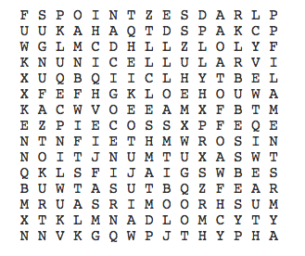
cap decomposer filaments
fruiting fungus gills
hypha mold multicellular
mushroom parasite spore
stalk yeast unicellular

Name ________________ period _____
EXIT TICKET
Kingdom Fungi
1. The Fungi Kingdom has man different types of organisms. Which of the following shows a list of different types of fungi?

A. Mushroom, yeast, poison ivy
B. Yeast, puffball, rose
C. Puffball, mushroom, yeast

2. Many people think that members of the Fungi Kingdom are plants. What characteristic of plants are fungi lacking?

A. Cell walls
B. Chlorophyll
C. Grow in soil

3. Yeast cells are dormant when they are dry. Other than water, what do yeast cells need to be able to grow?

A. Air
B. Food (sugar)
C. Carbon dioxide

4. The three major Domains are Archeabacteria, Prokaryote and Eukaryote. Why are fungi considered Eukaryotes?

A. They have cell walls
B. They become dormant when dry
C. They have at least one nucleus in their cells

Name ________________ period _____
EXIT TICKET
Kingdom Fungi
1. Yeast cells are dormant when they are dry. Other than water, what do yeast cells need to be able to grow?

A. Air
B. Food (sugar)
C. Carbon dioxide

2. The Fungi Kingdom has man different types of organisms. Which of the following shows a list of different types of fungi?

A. Mushroom, yeast, poison ivy
B. Yeast, puffball, rose
C. Puffball, mushroom, yeast

3. Many people think that members of the Fungi Kingdom are plants. What characteristic of plants are fungi lacking?

A. Cell walls
B. Chlorophyll
C. Grow in soil

4. The three major Domains are Archeabacteria, Prokaryote and Eukaryote. Why are fungi considered Eukaryotes?

A. They have cell walls
B. They become dormant when dry
C. They have at least one nucleus in their cells

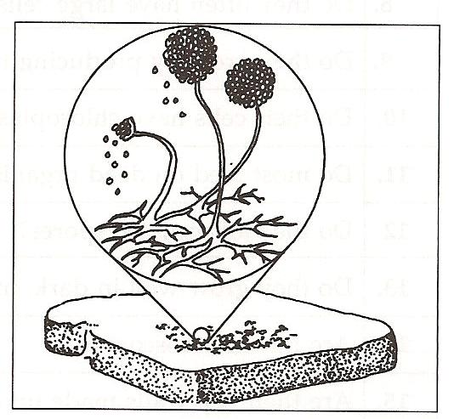
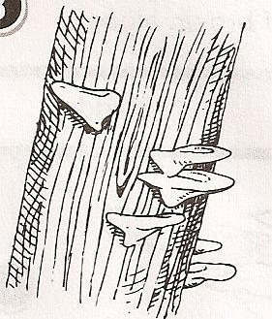
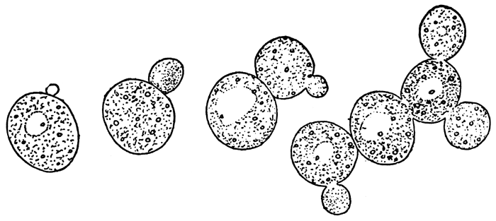
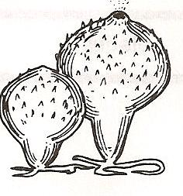
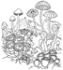
Copy one sheet for each set of partners

