Kingdom Plantae
How many types of plants can you name? Did you know that trees, bushes and flowers all get their energy the same way? All plants have a special way of getting food. They make it! This is the characteristic that places these living things in the Kingdom Plantae. Remember that plant cells have structures called chloroplasts that animal cells do not. Inside the chloroplast is a liquid called chlorophyll. The chlorophyll allows plants to undergo photosynthesis. The process of photosynthesis uses the gas carbon dioxide and water to make sugar (food for plants) and oxygen when the plants are in the sunshine.

Look at the diagram below and answer the questions.
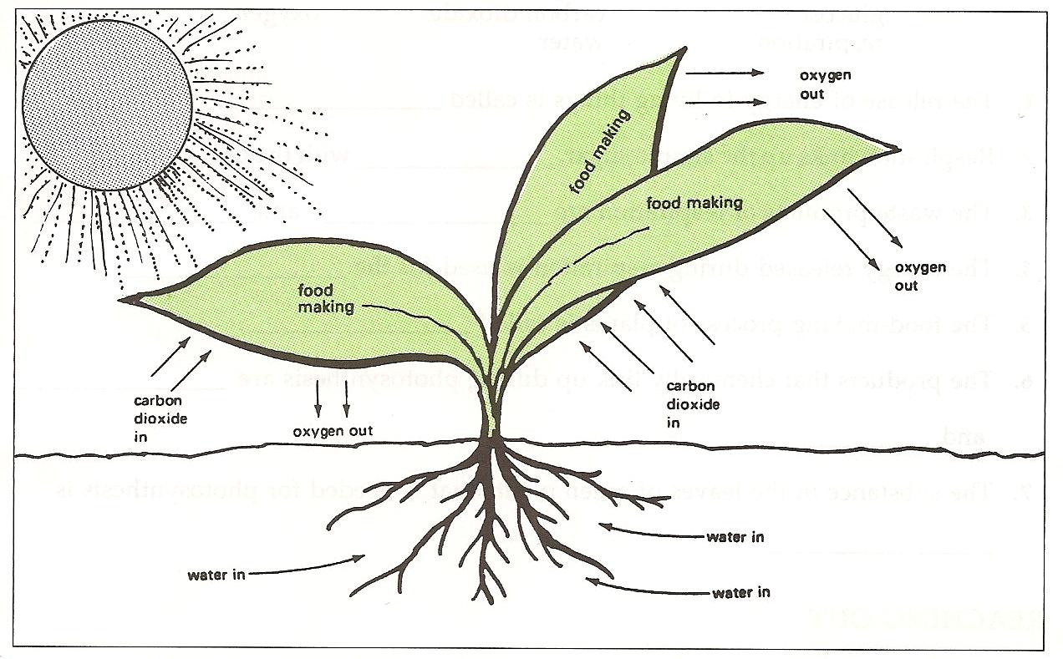

Questions:
1. What part of the plant makes the food? ________
2. What part of the plant takes in water? _________
3. What part of the plant takes in carbon dioxide? _____
4. What part of the plant gives off oxygen? _________
5. Where does the plant get the carbon dioxide? ______
6. What living things use oxygen? ________________
7. What would happen to us if all the plants died?
___________________________________________

Most plants grow from seeds. In the next
activity your group will start some seeds and observe them for several days to see how they grow.

Materials: 3 kidney bean seeds per group, paper towel, snack size plastic bag, water, pipette, Sharpie marker
What To Do:
1. Use the Sharpie marker to put your period and group number along the bottom of the bag.
2. Fold the paper towel so that it fits inside the plastic bag.
3. Place 75 drops of water in the bag.
4. Place the three beans on the paper towel so you can see them through the bag.
5. Seal the bag and give it to your teacher.
6. Observe it each day and draw what you observe below.

Initial
Observation

Day 1

Day 2

Day 3

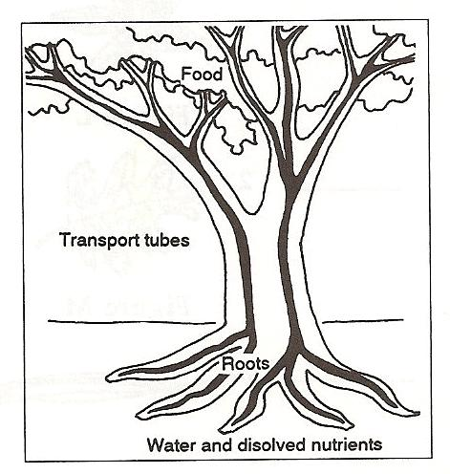
How does water get from the roots to the leaves? All plants have transport tubes in their stems. One group of tubes carries water up from the roots and another group of tubes carry sugar down to the roots.

Materials: Celery stalks in red water, celery stalks in clear water, red food coloring, knife, hand lens
What To Do:
1. Your teacher will have place some celery stalks in a beaker of red water and a beaker of clear water yesterday.
2. Observe one of each of the stalks. Look for red lines running through one of them.
3. Draw what you observe below.
4. Obtain a thin slice of each of the stalks. Observe with
the hand lens. Look for areas of red.
5. Draw and color what you observe below.
Celery Stalk Slice of Celery

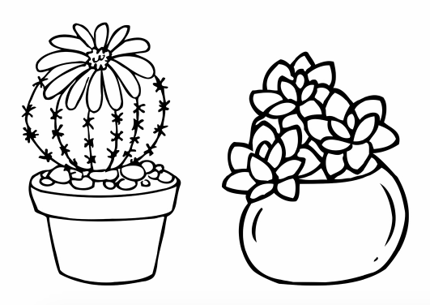

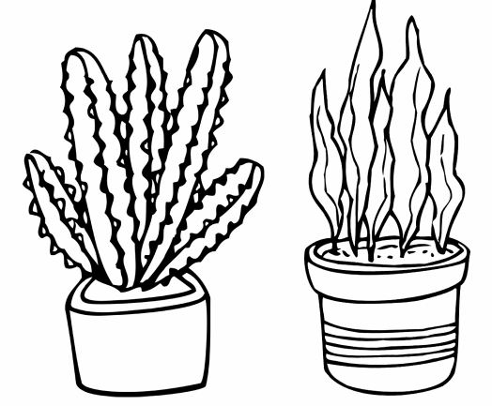

Watch the video Classification of Plants from www.missdoctorbailer.com. Write down three things you learned below.

Do you have any of the following plants at home? They are known as succulents and many live in the desert because they can store water in their leaves.
Color the plants green and pots any color you like.

Name _______________ period ____
EXIT TICKET
Kingdom Plantae
1. What structures characterize plant cells?

A. Cell membranes
B. Chloroplasts
C. Nucleus

2. What is the process that allows plants to make their own food?

A. Photosynthesis
B. Phototropism
C. Photoperiodism

3. A student was taking care of the classroom plants. As she watered the plants she place 10 drops of water on the leaves of the plants. The plants died! What did she do wrong?

A. The water on the leaves did not allow the plant to
take in carbon dioxide.
B. Placing the water on the leaves did not allow the roots to take in any water.
C. The water on the leaved prevented the oxygen
from leaving the plant.

4. A student wanted to see what would happen if he took all of the leaves off a plant. What do you predict will happen?

A. The plant will make food using its flowers.
B. The plant will probably die because it can’t make
any food.
C. The plant will have prettier flowers.

Name _______________ period ____
EXIT TICKET
Kingdom Plantae
1. What structures characterize plant cells?

A. Cell membranes
B. Chloroplasts
C. Nucleus

2. A student wanted to see what would happen if he took all of the leaves off a plant. What do you predict will happen?

A. The plant will make food using its flowers.
B. The plant will probably die because it can’t make any food.
C. The plant will have prettier flowers.
3. What is the process that allows plants to make their own food?

A. Photosynthesis
B. Phototropism
C. Photoperiodism

4. A student was taking care of the classroom plants. As she watered the plants she place 10 drops of water on the leaves of the plants. The plants died!
What did she do wrong?

A. The water on the leaves did not allow the plant to take in carbon dioxide.
B. Placing the water on the leaves did not allow the roots to take in any water.
C. The water on the leaved prevented the oxygen from leaving the plant.

