Kingdom Animalia
The Invertebrates
Animals can be found almost everywhere. They live in very hot places and in very cold places. They live in the deep oceans and on high mountains. Some animals even live in the ground.
Animals are made up of many cells. Animal cells do not have a cell wall. Animals do not make their own food. They do not have chlorophyll in their cells. Animals must take in food from outside.
Animals are classified into two major groups. One group is made up of animals with backbones. The other group is made up of animals without backbones. Animals without backbones are called invertebrates. From what you know about the Kingdoms, label the six kingdoms on the inside of the pie chart below.

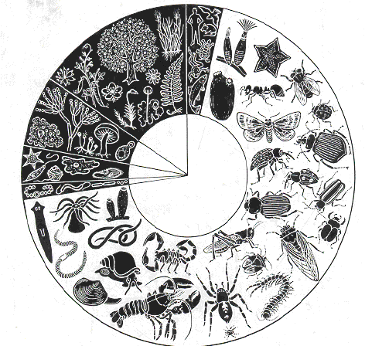

Directions:
Your teacher will show you a power point presentation about invertebrates. Fill in the blanks below with the information and then color the invertebrate on the pie chart.

Slide 2 What are the characteristics of invertebrates?
Invertebrates are animals without _______________.

Slide 3 Sponges
Sponges live in the _________. They are attached to the _________ and cannot __________ around. Color the two sponges on the pie chart purple.

Slide 4 Cnidarians
Cnidarians have _________ with _________ cells to catch their _________. Color the sea anemone pink.

Slide 5 Flatworms
Flatworms have long, flat ___________ bodies. Some are ___________ while others are _________.
A __________ is an organism that lives ________ another organism. Color the planarian yellow.

Slide 6 Roundworms
Most roundworms are ________. They get their food from _________ inside another _________. Color the roundworm orange.

Slide 7 Segmented Worms
Segmented worms have long _______ bodies that are divided into __________. Color the earthworm tan.

Slide 8 Mollusks
Mollusks have _______ bodies but many have ______. Color the snail and clam brown.

Slide 9 Echinoderms
Echinoderm means _______ ________. They all live in the ______ and have an ________ skeleton. Color the sea star and feather star red.

Slide 10 Arthropods
Arthropod means ________ _______. The have a hard outer covering called an _________________. They have ____________ bodies. They are the most __________ phylum of invertebrates. All of the rest of the invertebrates on the pie chart are arthropods. Color them blue.

Watch the video Classification of Animals from www.missdoctorbailer.com. Write three things you learned about invertebrates below.

Questions:
1. Which phylum has mostly parasitic members? _______
2. Which phylum has spiny skin? __________________
3. Which phylum of invertebrates has the most members?
______________________________________________
4. Name some of the members of that phylum. ________
______________________________________________
5. Why do you think they have been so successful?
_______________________________________________

Invertebrates



Clam Cnidarians Earthworm
Echinoderms Flatworms Feather Star
Mollusks Planarian Roundworm
Snail Sea Anemone Segmented Worms
Sponges Sea Star

Name __________________ period ____
EXIT TICKET
The Invertebrates

1. To which kingdom do invertebrates belong?

A. Plants
B. Fungi
C. Animals

2. What characteristic do all invertebrates share?

A. They do not have a backbone
B. They all live in the ocean
C. None of them have cells

3. Which invertebrate phylum has the most members?

A. Echinoderm
B. Arthropod
C. Sponge

4. A student stepped on a grasshopper and heard a “crunch”. He then remarked, “I must have crushed a lot of bones!” What is wrong with his statement?

A. A grasshopper has only two bones.
B. A grasshopper is an invertebrate and doesn’t
have bones.
C. A grasshopper wouldn’t crunch if you stepped
on it.

Name __________________ period ____
EXIT TICKET
The Invertebrates
1. Which invertebrate phylum has the most members?

A. Echinoderm
B. Arthropod
C. Sponge

2. A student stepped on a grasshopper and heard a “crunch”. He then remarked, “I must have crushed
a lot of bones!” What is wrong with his statement?

A. A grasshopper has only two bones.
B. A grasshopper is an invertebrate and
doesn’t have bones.
C. A grasshopper wouldn’t crunch if you stepped on it.

3. To which kingdom do invertebrates belong?

A. Plants
B. Fungi
C. Animals

4. What characteristic do all invertebrates share?

A. They do not have a backbone
B. They all live in the ocean
C. None of them have cells

