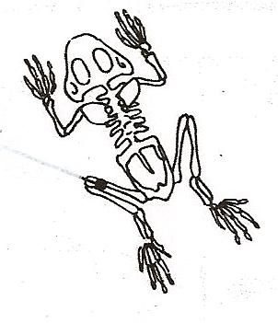
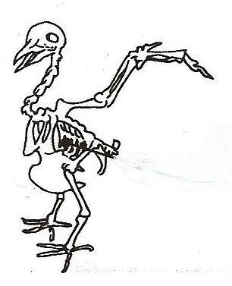
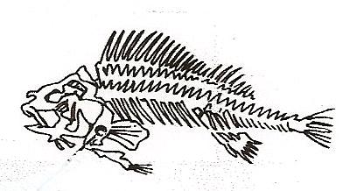
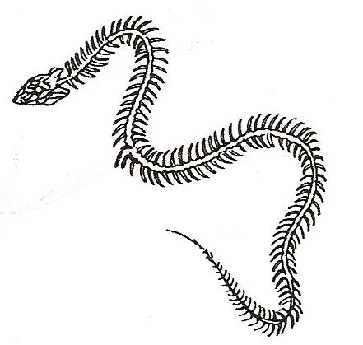
Kingdom Animalia – Vertebrates

Animals are classified into two major groups according to one characteristic. One group is made up of animals with backbones. Animals with backbones are called vertebrates. The backbone protects the spinal cord and gives support to the body. There are five groups of vertebrates. They are the fish, amphibians, reptiles, birds and mammals.

What To Do:
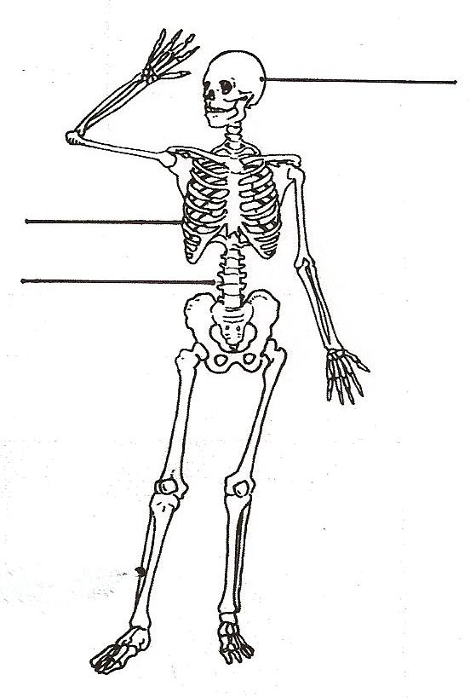
1. Label the bones indicated below. Use the word bank to spell them correctly.
Word Bank

Ribs
Skull
Vertebral Column

2. Observe the skeletons of each type of vertebrate animal.
3. Find and label the skull, ribs and vertebral column in each picture.

Watch the video “Phylum of Chordates” from www.missdoctorbailer.com and write down one thing about each class of animals below as you watch.

Cartilage Fish
Bony Fish
Amphibians
Reptiles
Birds
Mammals

Materials: Vertebrate Cards and Classification titles
What To Do:
1. Find the bag with the vertebrate cards and titles.
2. Place the titles in a row across your table.
3. Use your knowledge to determine into which group the animals belong.
4. Write your answers below.
Vertebrates

Class | Examples
Fish

Amphibians

Class | Examples
Reptiles

Birds

Mammals

Questions:
1. What characteristic do all these animals have in common? ________________________________________________
2. What characteristics do fish have? ___________________
_________________________________________________
3. What characteristics do birds have? __________________
_________________________________________________
4. What characteristics do mammals have? ______________
_________________________________________________

Name ________________ period _____
EXIT TICKET
Vertebrates

1. An animal breathes oxygen, is warm-blooded and
has feathers. What class of animal is it?

A. Bird
B. Mammal
C. Reptile

2. An animal has dry scaly skin, a backbone and lives
on the land. What class of animal is it?

A. Mammal
B. Bird
C. Reptile
3. What characteristic is used to classify snakes into a different phylum than the earthworm, sea star and spider?

A. Snakes live on land.
B. Snakes have a backbone.
C. Snakes breath oxygen.

4. What does vertebrate mean?

A. Without a backbone
B. With a backbone
C. Wanting a backbone

Name ________________ period _____
EXIT TICKET
Vertebrates

1. What characteristic is used to classify snakes into a different phylum than the earthworm, sea star and spider?

A. Snakes live on land.
B. Snakes have a backbone.
C. Snakes breath oxygen.

2. What does vertebrate mean?

A. Without a backbone
B. With a backbone
C. Wanting a backbone

3. An animal breathes oxygen, is warm-blooded and
has feathers. What class of animal is it?

A. Bird
B. Mammal
C. Reptile

4. An animal has dry scaly skin, a backbone and lives
on the land. What class of animal is it?

A. Mammal
B. Bird
C. Reptile

