Ecosystem Organization
In order to study ecology, scientists need to see how organisms are related to one another and also to the environment in which they live. To do this, it is useful to think about a hierarchy of ecosystem organization ranging from the individual organism to the biosphere.
To begin with, consider a single organism, the individual. An “organism” is any living thing, whether it is a human being, a germ, a rose bush, or a panda bear.
A group of organisms of the same kind is a population. A “population” can be defined as a group of interbreeding organisms living in the same area. You might imagine a human population such as the population of the city in which you live or the population of a certain country.
A community is the next largest level of organization. A “community” includes all the organisms, sometimes hundreds of different types, in a given area. Several different populations are usually found in a community. The populations within a community are interdependent because of the food webs that bind them together.
Until now, we have only considered the living things in an area. The next level of the organization, an ecosystem, begins to include the nonliving parts as well. An “ecosystem” includes all organisms in a defined area and their nonliving environment.

Materials: colored pencils
What To Do:
1. Choose an animal that lives in the wild - not a dog or a cat or other pet.
2. This is an individual. Draw it in the top of the pyramid on the next page.

3. Imagine this animal interacting with other of its own kind. This group is a population. Draw them in the level of the pyramid labeled population.
4. Think of other types of living things your animal might interact with. Think about what it eats and uses for shelter. This is its community draw all of these things in the level called community.
5. What non-living things does your animal interact with? Where does it live? Where does it find water? What is the weather like where it lives? This is its ecosystem. Draw all of these things in the level called
ecosystem.
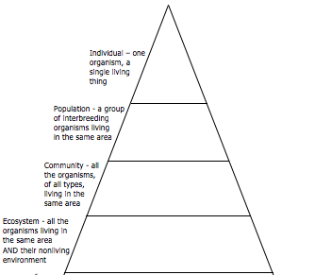

Question:
1. What is the difference between a community and an ecosystem? __________________________________
____________________________________________
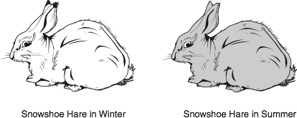
Remember a population is a group of organisms of the same kind. A group of mice in a field, a school of fish in the Gulf of Mexico and all the humans in your city or town, these are all examples of a population. Populations do not stay the same. There are many reasons for a population change such as limited resources, predator-prey cycles, human impact, habitat change or the loss of a large company.

The snowshoe hare is a common species of rabbit found in North America, its range extending throughout Canada, Alaska, and into the northern United States. One distinctive quality is its 2 different coloration patterns – brown in the summer, and white in the winter to better camouflage with the snow. Its diet consists of grasses, berries, twigs, bark and leaves.
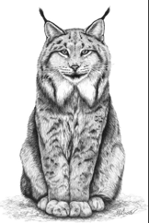
The Canada lynx is a wild cat that
resembles a large house cat with a
short tail and prominent tufts on its
ears. It is very secretive and even
experienced hunters rarely see one in
the wild. Its range overlaps with the
snowshoe hare, on which it almost
exclusively preys upon.
To understand how the population of lynx and hares changes year to year, we need to collect information about the number of individuals in a population. Unfortunately, it is impossible to count the exact number of hares in Canada in any given year. Therefore, this information must be gained by capturing a small number of individuals and then estimating the actual number out in the wild. For over 300 years, the Hudson Bay Company has been involved in the fur trade in Canada. Detailed company records list the number of snowshoe hare pelts and the number of lynx pelts collected by hunters and trappers every year since

the late 1700’s. A small sample of this data is presented in the table below.
What To Do:
1. On the graph paper on the next page, use one color of pencil to graph the number of hares trapped each year between 1900 and 1920.
2. Use another color to graph the number of lynx trapped.
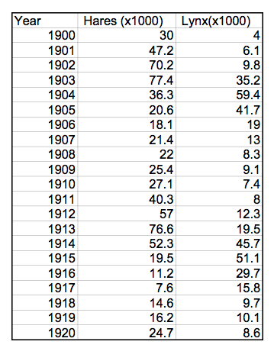

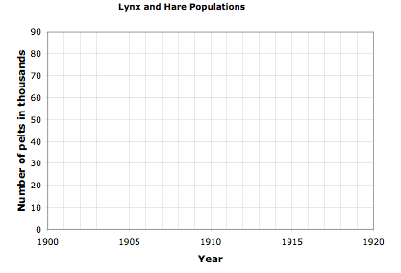

Questions:
1. What patterns do you notice? Describe at least 3 patterns.

2. What do you think happens to the grass and seeds the hare eat as the population gradually increases?

3. Where is this shown on the graph?

4. After a few years, the hare population begins to increase. Why?

5. In general, are there more lynx or more hares?
Why?

Name ____________________ period_____
EXIT TICKET
Ecosystem Organization

Match the example to the correct word. Write the letter of the correct word in the blank beside the example.
a) ecosystem b) community

c) individual d) population

_____ 1. Rosie the rattlesnake

_____2. rattlesnakes, mice, small birds, small birds,
crickets, grass, hawks, cacti and tumbleweed

_____3. the community, the water, the air, the rocks,
the soil, and the mountains

_____4. all the rattlesnakes in the area

5. Which of the following is an example of a predator-prey relationship?

A. Canadian lynx - snowshoe hare
B. Canadian lynx - butterfly
C Butterfly - snowshoe hare

Name _____________________ period_____
EXIT TICKET
Ecosystem Organization

Match the example to the correct word. Write the letter of the correct word in the blank beside the example.

1. Which of the following is an example of a predator-prey relationship?

A. Canadian lynx - snowshoe hare
B. Canadian lynx - butterfly
C. Butterfly - snowshoe hare

Match the example to the correct word. Write the letter of the correct word in the blank beside the example.
a) ecosystem b) community

c) individual d) population

_____ 2. All the rattlesnakes in the area

_____3. Rattlesnakes, mice, small birds, small birds,
crickets, grass, hawks, cacti and tumbleweed

_____4. The community, the water, the air, the rocks,
the soil, and the mountains

_____5. Rosie the rattlesnake

