Interaction in the Environment

Ecology is the study of the responses and interactions of living things with their environment. In order to stay alive, organisms must interact constantly with both the living and non-living factors of the environment. The living factors of the environment are called biotic, with “bio” meaning life. The non-living factors of the environment are called abiotic. The prefix “a” in front of the word means “without,” so abiotic means without life. The combined biotic and abiotic factors of an environment make up an ecosystem.
As you learned earlier, living organisms are made up of cells. This means that the biotic factors of the environment are made up of cells. We have learned that the five kingdoms of living things are plants, animals, bacteria, fungi and protists. All of these living things need energy, water, and air to continue to live. This means that they must get these things from the environment. Water and air are examples of abiotic factors within an environment.

Watch the video Abiotic and Biotic Factors” from www.missdoctorbailer.com. Write down three things you learn from the video below.
_________________________________________________
_________________________________________________
________________________________________________
Materials: Interactions sheet
What To Do:
1. The table on the next page lists six different abiotic factors in an environment.
2. Cut out the boxes from the Responses sheet and glue them in the column that matches the abiotic factor that causes the response.
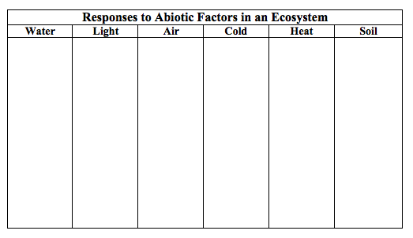

What To Do:

1. Observe the picture above of a pond ecosystem.
2. In the blanks below write if the factor is biotic or abiotic.

1. Sunlight __________ 8. Pickerel weed ___________
2. turtle ____________ 9. Air __________________
3. water lily ________ 10. Swamp bush ___________
4. mud _____________ 11. Water ________________
5. rock _____________ 12. bacteria, algae and other
6. frog _____________ one-celled organisms (not shown
7. catfish ____________ but always present in a pond ecosystem)__________
Questions:
1. What does biotic mean? _________________________
2. Name three examples of biotic factors. _______________
3. What does abiotic mean? __________________________
4. Name three examples of abiotic factors. ______________

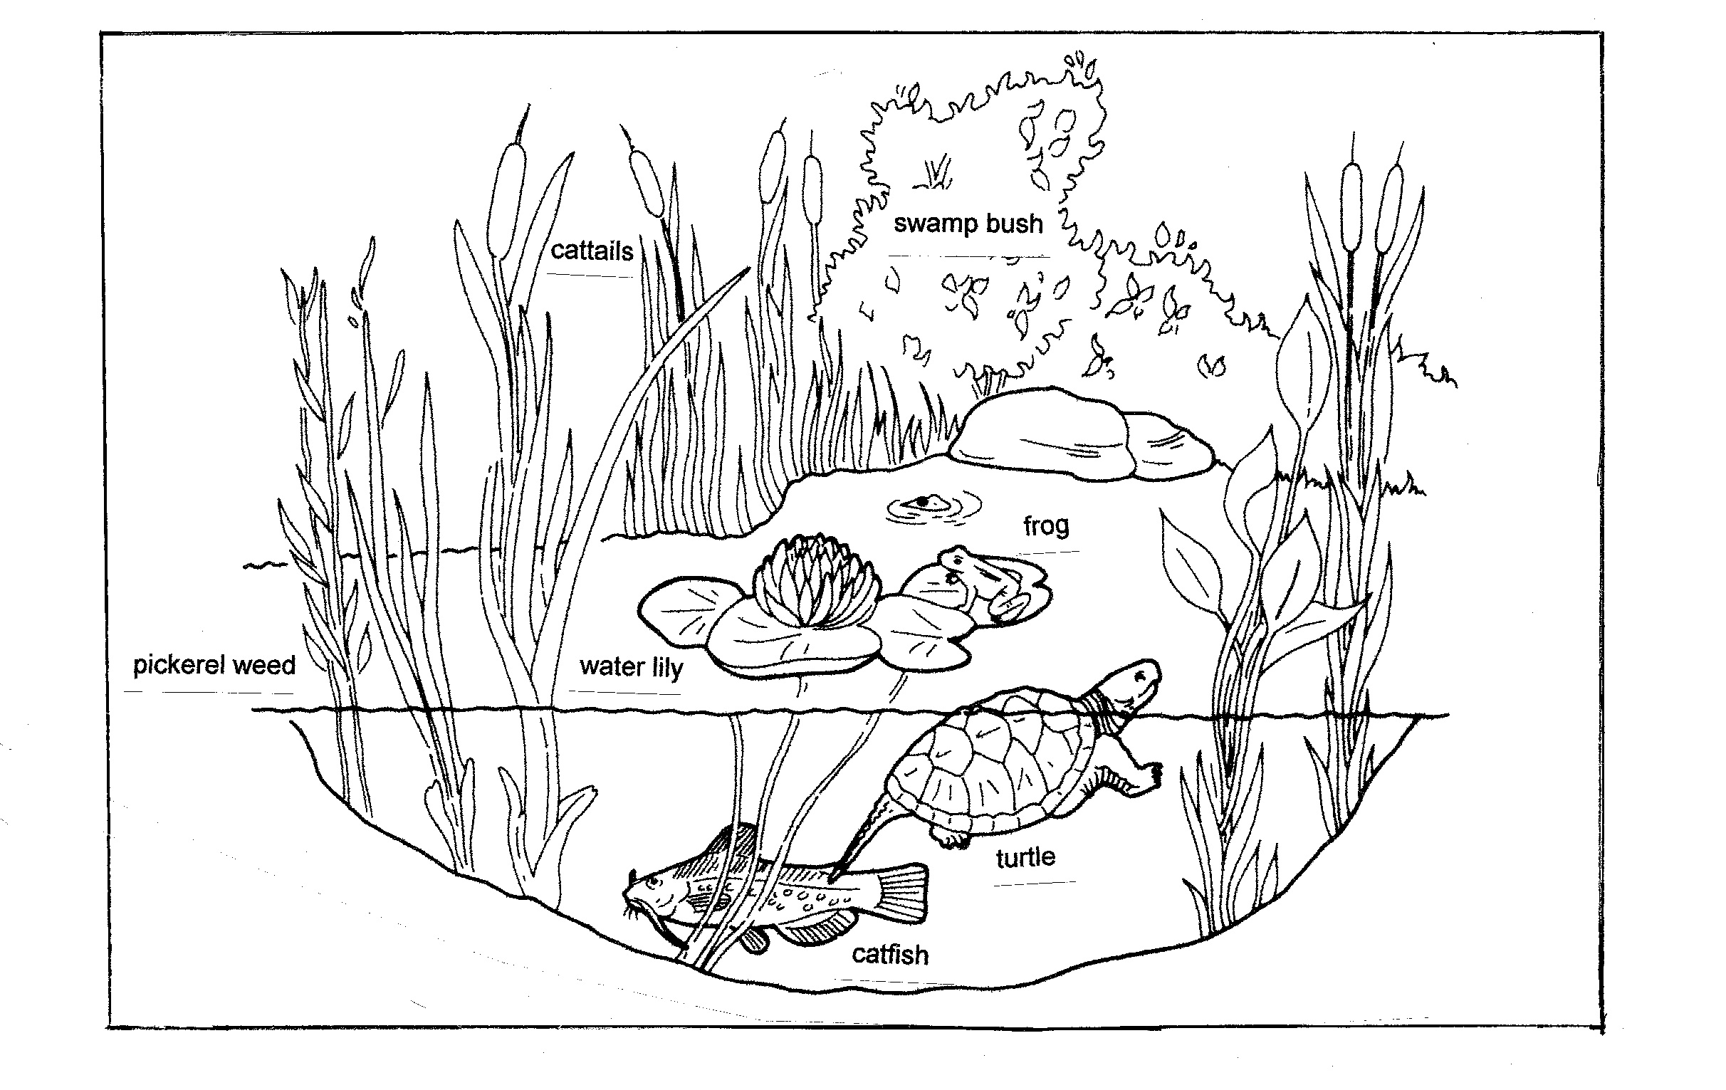

Interactions
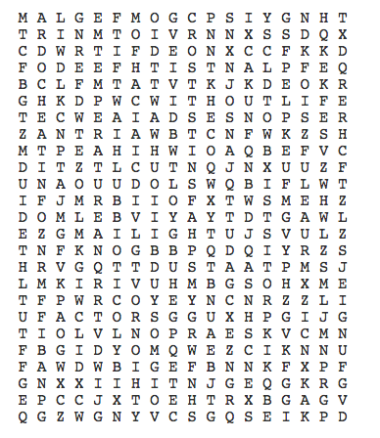

abiotic air animals bacteria
biotic cold energy environment
factors fungi heat interactions
light living plants nonliving
protists responses soil temperature
water without life

Name _________________ period _____
EXIT TICKET
Interactions in the Environment

1. Which of the following is an abiotic factor in the
environment?

A. water
B. tiger
C. bacteria

2. Which of the following is a biotic factor in the
environment?

A. water
B. air
C. duck

3. What do all of the following have in common? Lion,
pine tree, paramecium, mushroom, bacteria

A. They are all abiotic factors in the environment
B. They are all made of at least one cell
C. They are all members of the same kingdom

4. Where do plants get their energy?

A. water
B. soil
C. The Sun

Name _________________ period _____
EXIT TICKET
Interactions in the Environment

1. What do all of the following have in common? Lion,
pine tree, paramecium, mushroom, bacteria

A. They are all abiotic factors in the environment
B. They are all made of at least one cell
C. They are all members of the same kingdom

2. Where do plants get their energy?

A. water
B. soil
C. The Sun

3. Which of the following is an abiotic factor in the environment?

A. water
B. tiger
C. bacteria

4. Which of the following is a biotic factor in the
environment?

A. water
B. air
C. duck

