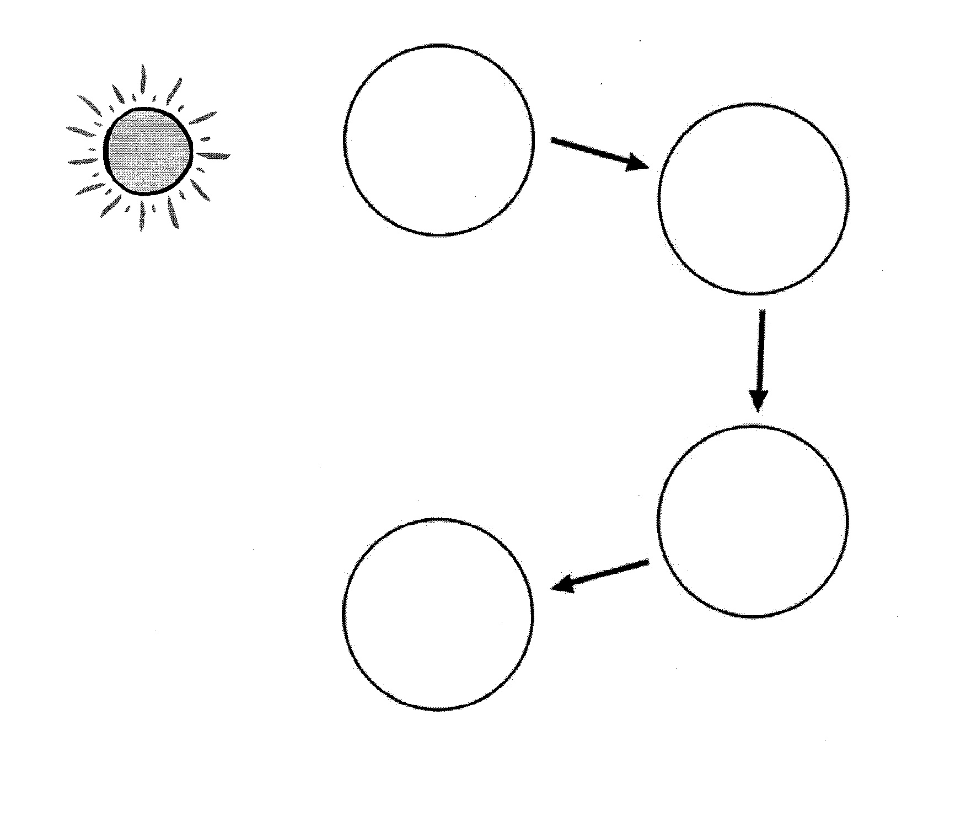
Food Chains

The study of the relationship between living things and their environment is called ecology. The biotic and abiotic factors of a specific environment make up an ecosystem. Each ecosystem is made up of different kinds of organisms.
The plants that transform solar energy into food are called producers. On land the main producers are plants, while in lakes and oceans, algae are the main producers. Consumers get food by eating other organisms. Some consumers eat only plants. They are called herbivores. Others eat meat, or other animals and they are called carnivores. And some, like you, eat both plants and animals and they are called omnivores. Bacteria and fungi break down the remains of organisms and return it to the soil. They are called decomposers. An ecosystem must have all of these parts to be a stable ecosystem. If even one factor is missing the ecosystem will become unstable and all the living things will suffer and die.
Energy enters an ecosystem when producers use the process of photosynthesis to transform solar energy into food. A food chain is a special type of graphic that shows how this energy is then passed from one organism to another. Arrows are used in a food chain to show the direction of the energy flow.

Materials: Food chain organisms, scissors, glue
What to Do:
1. Cut out the organisms from the food chain sheet.
2. Glue them in the food chain graphic below.
3. Label the circles – producer, consumer or decomposer

Questions:

1. What producer did you use in this diagram? _________

2. What 2 consumers did you use? ________ _________

3. What decomposer did you use? ___________________

4. Where does the energy start? ___________________

Materials: Food Chain Choice Cards

What To Do:
1. Look at the cards your teacher gives you.
2. Make at least 2 more food chains.
3. Write the names of the organisms in the circles below.

Questions:
1. Why does the food chain start with the sun? _______________________________
2. What type of organism is at the end of the food chain? ______________________
3. What is the animal that eats the plants called? ______________________________
4. What is the animal that eats the other animals called? ____________________________________
5. In which direction do the arrows go in a food chain? _________________________________

Watch video from missdoctorbailer.com - Fabulous Food Chains and write 3 things you learned from it below.

Name ________________ period _____

EXIT TICKET
Food Chains
1. Which of the following is a producer?

A. Bird
B. Tree
C. Bacteria

2. Which of the following is a consumer?

A. Bird
B. Tree
C. Bacteria

3. Which of the following is a decomposer?

A. Bird
B. Tree
C. Bacteria

4. Where does the energy for a food chain start?

A. Decomposers
B. Producers
C. The Sun

5. Which list below shows what is needed for a stable ecosystem?

A. Sunlight, producers, consumers, rainfall
B. Sunlight, producers, consumers, decomposers
C. Sunlight, producers, decomposers, rainfall

Name ________________ period _____
EXIT TICKET
Food Chains
1. Which of the following is a decomposer?

A. Bird
B. Tree
C. Bacteria

2. Where does the energy for a food chain start?

A. Decomposers
B. Producers
C. The Sun

3. Which of the following is a producer?

A. Bird
B. Tree
C. Bacteria

4. Which of the following is a consumer?

A. Bird
B. Tree
C. Bacteria

5. Which list below shows what is needed for a stable ecosystem?

A. Sunlight, producers, consumers, rainfall
B. Sunlight, producers, consumers, decomposers
C. Sunlight, producers, decomposers, rainfall

