Exploring Food Webs

You have been learning about food chains. Remember that a food chain is a series of events in which one organism eats another and obtains energy. A food chain is one possible path along which energy can move through an ecosystem. But just as you don’t eat the same food every day, neither do most other organisms. Most producers and consumers are part of many food chains.
A more realistic way to show the flow of energy through an ecosystem is a food web. A food web is made up of many overlapping food chains in an ecosystem. Remember that every food chain starts with the energy from the sun. This energy enters the food web through the producers when plants make their own food through photosynthesis and every food chain ends with decomposers such as bacteria or fungi.
An autotroph is an organism that can produce its own food using light, water, carbon dioxide, or other chemicals. Because autotrophs produce their own food, they are sometimes called producers.
Heterotrophs cannot make their own food, so they must eat or absorb it. For this reason, heterotrophs are also known as consumers.
Materials: colored pencils or markers or different colored highlighters
What To Do:
1. Use the words in the Word Bank to label one organism
of each kind.
2. Two things are missing from the picture and draw them
in and label them.
3. Use 4 different colored pencils/markers/highlighter to
trace the arrows of at least 4 different food chains.

Word Bank
Producer Carnivore
Consumer Herbivore
Autotroph Heterotroph

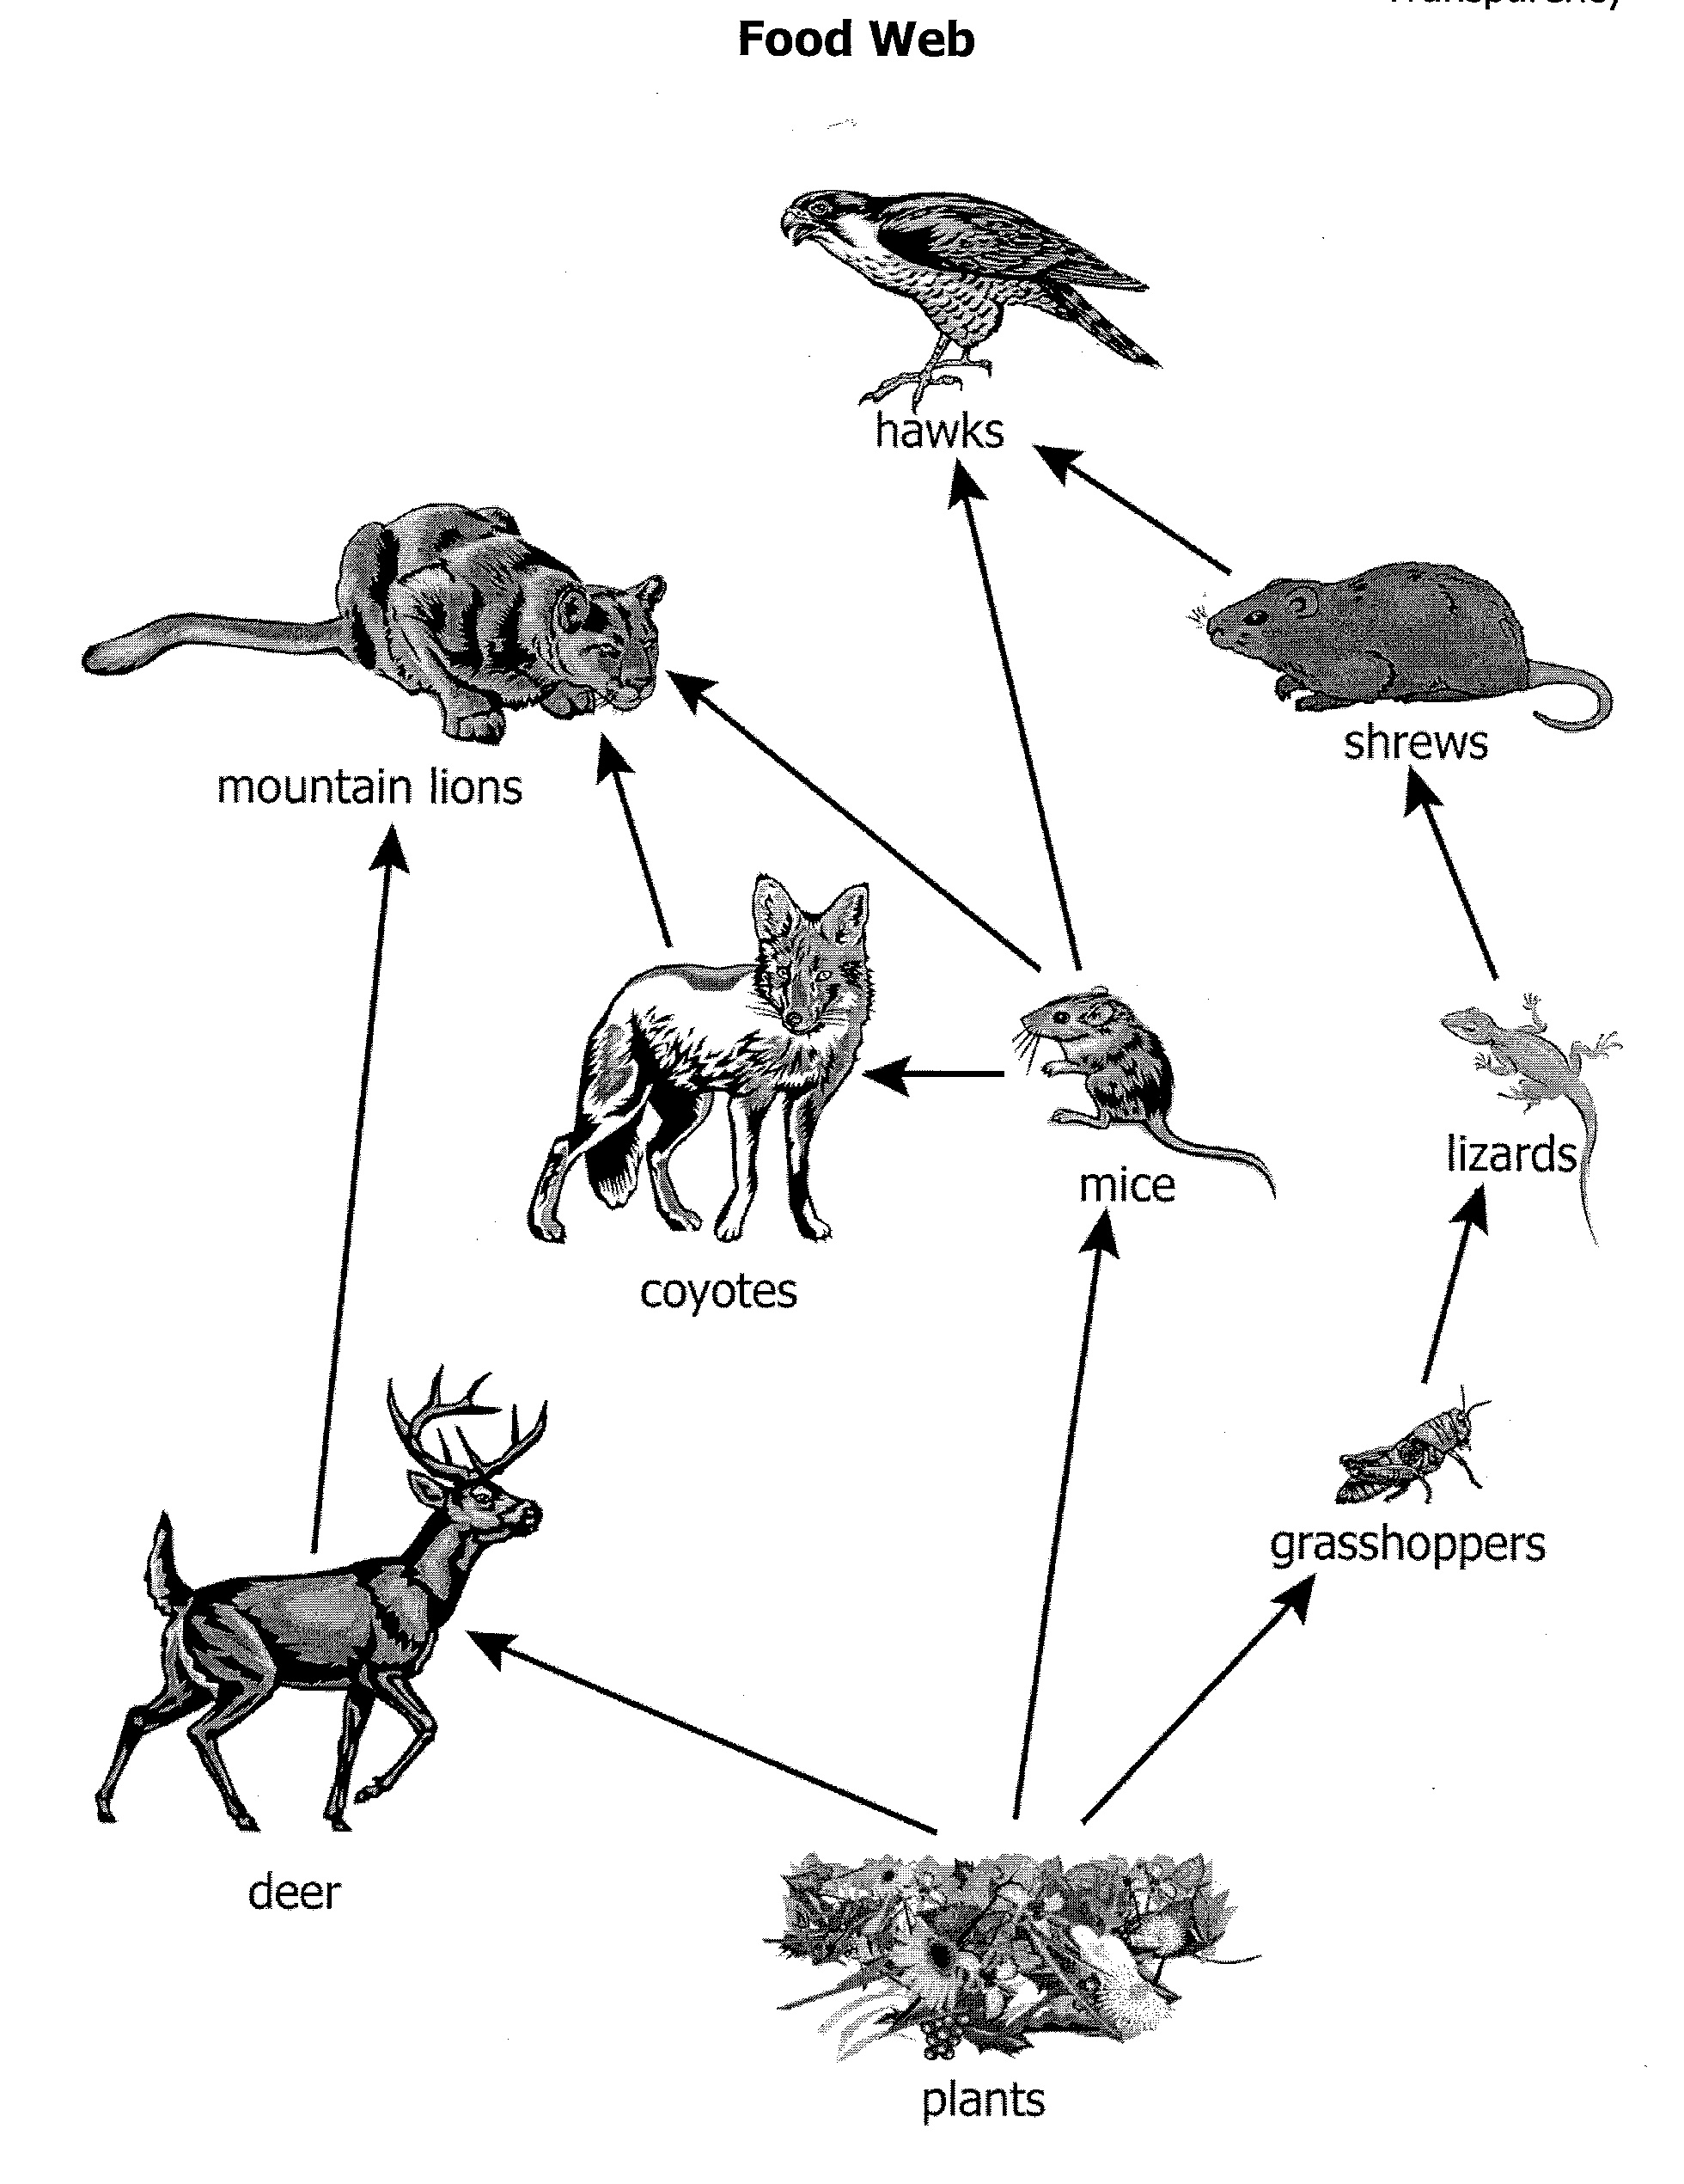

Questions:
1. Where does a food web get its energy? ____________
2. What type of organisms is at the end of a food web? _______________________
3. What is an example of a heterotroph? ______________
4. What is an example of an autotroph? ______________

DO NOT GLUE THIS PAGE INTO YOUR NOTEBOOK

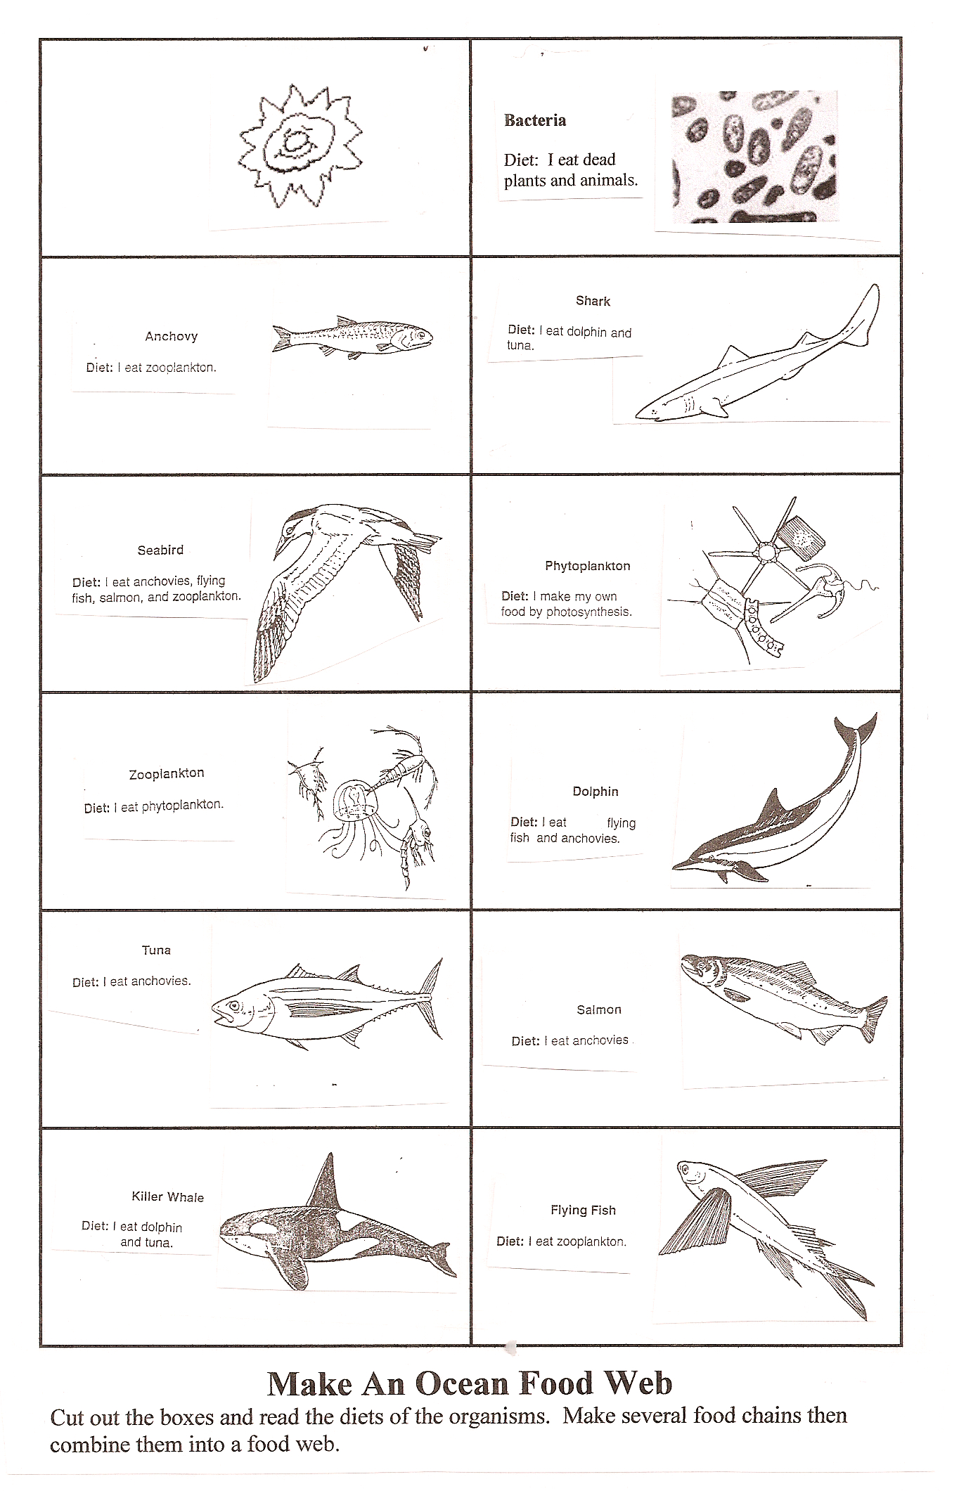

Questions:

1. How many food chains were you able to create? _____
2. What is the function of the bacteria in the food chain? ____________________________________________
3. What is the function of the Sun in the food chain? _________________________________________
4. How do the phytoplankton get their food? _______________________________________
5. Which organisms in the food web are carnivores? _________________________________________
6. Which organisms in the food web are herbivores? _________________________________________
7. What is the autotroph in this food web? ________
8. Name 2 of the heterotrophs in this food web.
____________________________________________
Watch the video Autotrophs vs Heterotrophs from missdoctorbailer.com. Write down 2 things you learned.

Name __________________ period _____
EXIT TICKET
Exploring Food Webs
1. How do plants get their energy?
A. From decomposers
B. From consumers
C. From the Sun

2. What part of a food web breaks down dead plants and animals?
A. Decomposers
B. Producers
C. Consumers

3. Draw the arrows that show which direction the energy flows in the food web below.

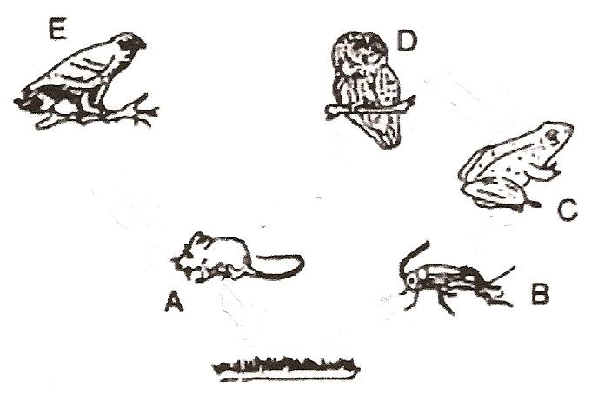
4. What is an example of an autotroph?

A. grass
B. mouse
C. frog

Name __________________ period _____
EXIT TICKET
Exploring Food Webs
1. Draw the arrows that show which direction the energy flows in the food web below.

2. What is an example of an autotroph?

A. grass
B. mouse
C. frog
3. How do plants get their energy?
A. From decomposers
B. From consumers
C. From the Sun

4. What part of a food web breaks down dead plants and animals?
A. Decomposers
B. Producers
C. Consumers

