Learning About Lab Safety

“Hands-on” experiences are part of many school activities. Science, especially, is suited to “learning by doing.” You investigate; you make things happen; you learn from what you do.
Science investigations can be exciting. However, they can also be dangerous. Science laboratories have equipment and materials that can be dangerous if not handled properly. For this reason, it is important for you to always follow proper safety guidelines. Safety rules are for your own protection-as well as the protection of everyone around you.

Materials: Safety equipment labels
What To Do:
1. When your teacher tells you to do so, leave your seat and walk around the classroom.
2. Find where each of the following safety equipment is stored.

1. Eyewash fountain
2. Fire Blanket
3. Fire Extinguisher
4. Safety Glasses
5. First Aid Kit

3. Be ready to place a label on the piece of equipment when your teacher asks you to.

Materials: Safety Statements
What To Do:
Read the following 10 guidelines about safety in the science classroom. Be ready to listen to the statements made by your teacher. If it is breaking a safety rule write wrong in the blanks below. If it is following a safety rule write correct in the blanks below.

Lab Safety Guidelines

Preparation and Neatness
- Before beginning your investigation, ask your teacher to explain any procedure you do not understand.
- Clean off table of any extra materials before starting.
- Tie back long hair when working with chemicals or fire.
- Roll up long sleeves when working with chemicals or fire.
- Eat or drink only when directed to do so by your teacher.

Eye Safety
- Wear safety glasses when handling liquid chemicals, using fire or performing any activity that could harm the eyes.
- If chemicals get in your eyes, wash them for at least 15 minutes with at the eyewash fountain.

Chemicals and other Dangerous Substances
- Wash any chemical spill with plenty of water.
- Never taste chemicals or put chemicals near your eyes.
- When smelling chemicals, wave the fumes toward your nose with your hand with a wafting motion.

Statements
1. ______________
2. ______________
3. ______________
4. ______________

Materials: Safety Statements, part 2, Safety Contract

What To Do:

Read the following 13 guidelines about safety in the science classroom. Be ready to listen to the statements made by your teacher. If it is breaking a safety rule write wrong in the blanks below. If it is following a safety rule write correct in the blanks below.

Safety Equipment
- Know the location of all safety equipment, including fire extinguishers; fire blankets, first-aid kits and eyewash.
- Report all accidents to your teacher immediately.
- Report any cuts you received in the science classroom to the teacher so that first-aid may be given.

Heating and Electricity
- Use a hot plate to heat liquids.
- Do not point a heating test tube toward anyone.
- Do not let loose electrical cords hang over the table edge.

Knives and Glassware
- Be careful when using knives, scalpels and razor blades.
- Never use cracked or chipped glassware.
- Use a broom and dustpan to pick up broken glassware.

Unauthorized Experiments and Clean Up
- Do not perform any experiment that has not been assigned or approved by your teacher.
- Clean up all work areas and put away all equipment
- Leave your basket and work area neat and clean
- Do not play around during laboratory.

Statements
5. ______________
6. ______________
7. ______________
8. ______________

What’s wrong here?
What to Do:
1. Read the following scenarios.
2. In your small group explain what is wrong.

Scenario #1
Sam was heating a test tube. He didn’t put on safety goggles since he was wearing glasses. He slanted the tube away from his work area, but toward students on the opposite side of his table.

Scenario #2
Cindy broke a test tube. Carefully she picked up pieces with one hand and placed them in her other hand. Then she dumped the glass pieces into the wastebasket.

Scenario #3
The cuff of Sam’s long-sleeved shirt caught fire. He ran to show his teacher.

Scenario #4
Diana and Mike were going to be late to their next class. After rushing to put away a few materials, they left the rest of the materials on the lab table.

Scenario #5
Gina didn’t pay attention when the teacher explained where safety equipment was found and how it was used. She thought to herself, “I’ll never need that.”

Sign the Safety Contract and glue into your notebook.

EXIT TICKET

Circle the students who are breaking any safety rules.
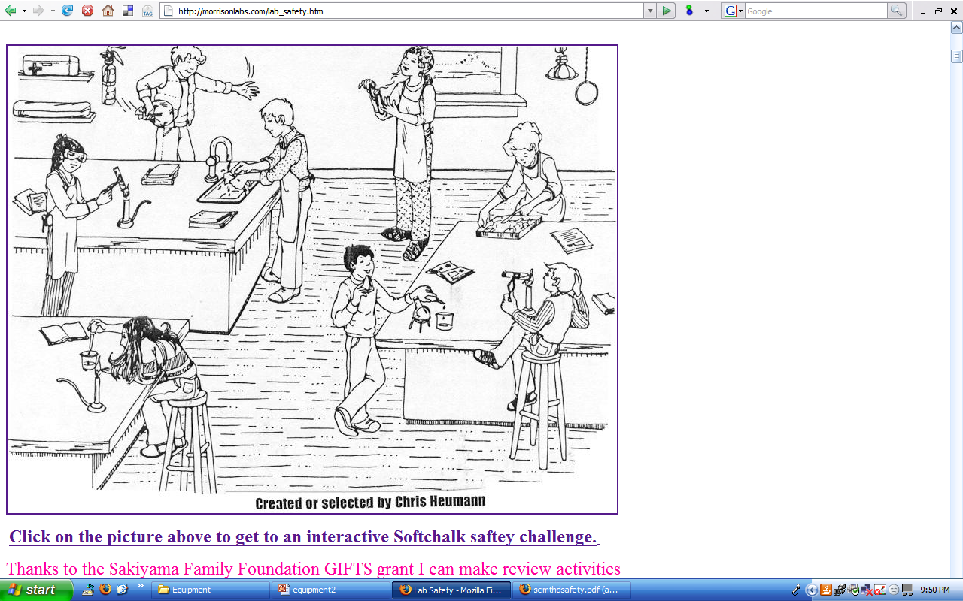

List 3 rules that are being broken.
1.

2.

3.

EXIT TICKET

Circle the students who are breaking any safety rules.

List 3 rules that are being broken.
1.

2.

3.
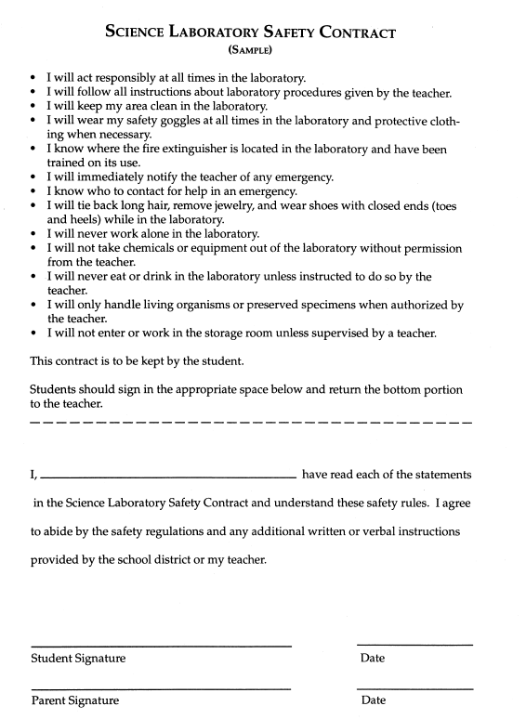

Teacher page

Safety statements

First 10

1. I will eat a candy bar during laboratory.

2. I will taste the chemical to see if it is sour.

3. I will wear my safety glasses when working with fire.

4. I will put my nose next to a test tube to smell it.

Second 13

5. I will not tell the teacher if I cut myself.

6. I will use a broom and dustpan to pick up broken glass.

7. I will run and play during laboratory.

8. I will not point a heating test tube toward my classmate.

