How Living Things Are Organized

How can we tell the difference between living and non-living things? For something to be called living, it must have all the characteristics of living things. Living things like humans, other animals and plants can:

breathe (take in oxygen)
take in food or nutrients
respond to things around them, like light and heat
move (by themselves, either whole body or part of their body)
reproduce (have babies, or grow from seeds or spores)
grow
give off wastes

Non-living things have never been alive. They do not exhibit all of the characteristics of life. These are things like rocks, air, water and sunlight.
Once living things can be items such as a piece of fruit or a picked flower. It can be a piece of wood or a fossil. These things were once living but are no longer exhibiting all the characteristics of life.
Man-made things are usually a combination living and non-living things. Think of a pencil. The wood was once a part of a tree, so it was once living. The “lead” is actually graphite, which is a form of carbon that is non-living.

Directions: Your teacher will show you some pictures of objects or the objects themselves. Decide in your group which of the following categories they belong in. List them in the chart below.
Living | Non-living | Once living | Man-made
Watch the following video from www.missdoctorbailer.com

The Basics of Biology: How Living Things are Structured and answer the following questions.

1. What are the basic building blocks of all living things? _____
2. How many cells are the Protozoa made of? ____________
3. What color are chloroplasts? _______________________
4. What are the simplest multicellular animals? ___________
5. What are cells working to serve a common purpose called?
_________________
6. When tissues unite to perform complicated activities, they are called ___________.
7. What are a group of organs that work together called?
________________________________________________
8. When organ systems are organized to work together they make an ___________________.

As we have learned from the video all living things are made up of small parts called cells. The cell is the basic unit of living things. Examples of cells are cheek cells, white blood cells and plant cells. Most cells do not work alone. Similar cells join together to form tissues. Examples of tissues are muscle tissue, skin tissue and plant tissue. Tissues, in turn, form organs. Examples of organ are the stomach, heart and brain. Organs do important jobs. But even organs don’t work alone.
Usually, several organs work together to carry out a specific life function. A group of organs that work together to do a specific job is called an organ system. Examples of organ systems are the circulatory system, the respiratory system and the digestive system. When organ systems join together they make an organism. Examples of organisms are a mountain lion, blue crab and a horse.

You may remember learning the order of the planets in the solar system by memorizing the sentence; “My Very Energetic Mother, Just Served Us Nachos!”

All living things are organized in the same way.

Cells -> Tissues -> Organs -> Organ Systems-> Organisms

We can remember the levels of organization with another silly sentence.

Can Tigers Own Orange-Spotted Orangutans?

What to Do: In the space below draw a cartoon to help you remember the silly sentence above.

Materials: Picture cards, Title cards

What To Do:
1. Look at the Picture cards with your partner.
2. Determine which cards go together.
3. Use the Title cards to name your groups of cards
4. While you have the cards in the groups answer the
questions below.

Questions:

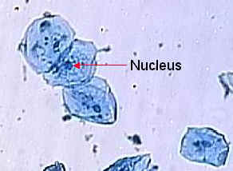 | 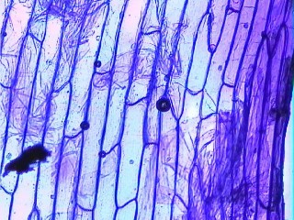 | 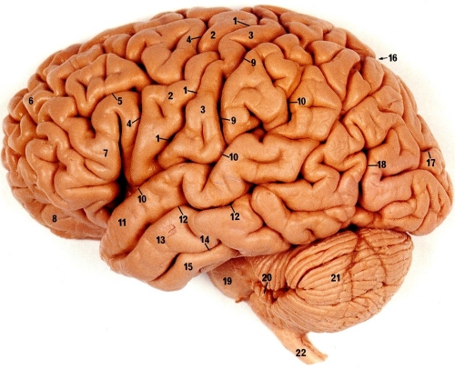 | 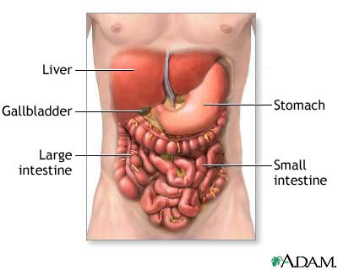 | 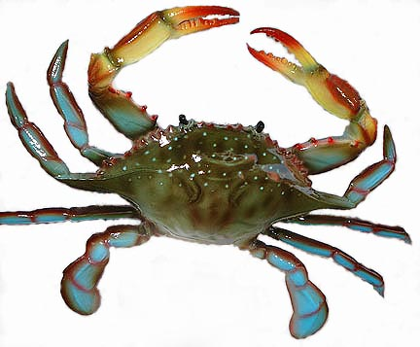
A | B | C | D | E

1. Under which Level of Organization did you place picture A? _______________
2. Under which Level of Organization did you place picture B? _______________
3. Under which Level of Organization did you place picture C? _______________
4. Under which Level of Organization did you place picture D? _______________
5. Under which Level of Organization did you place picture E? _______________

Name ________________ period _______

EXIT TICKET
How living things are organized
1. What level of organization does this picture belong to?

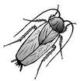
______________

2. What level of organization does this picture belong to?
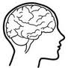
_______________

3. Cloze paragraph: Use the following words to fill in the blanks below. (cell, tissue, organs, organism, horse, brain, organ systems)
The basic unit of living things is the _________. The next level of organization is the ________. Tissues make ________. An example of an organ is the ________. Organs make up _______ _______. Organ systems work together to make an __________. An example of an organism is a ________.

Name ________________ period _______

EXIT TICKET
How living things are organized
1. Cloze paragraph: Use the following words to fill in the blanks below. (cell, tissue, organs, organism, horse, brain, organ systems)

The basic unit of living things is the _________. The next level of organization is the ________. Tissues make ________. An example of an organ is the ________. Organs make up _______ _______. Organ systems work together to make an __________. An example of an organism is a ________.

2. What level of organization does this picture belong to?
______________

3. What level of organization does this picture belong to?
_______________

