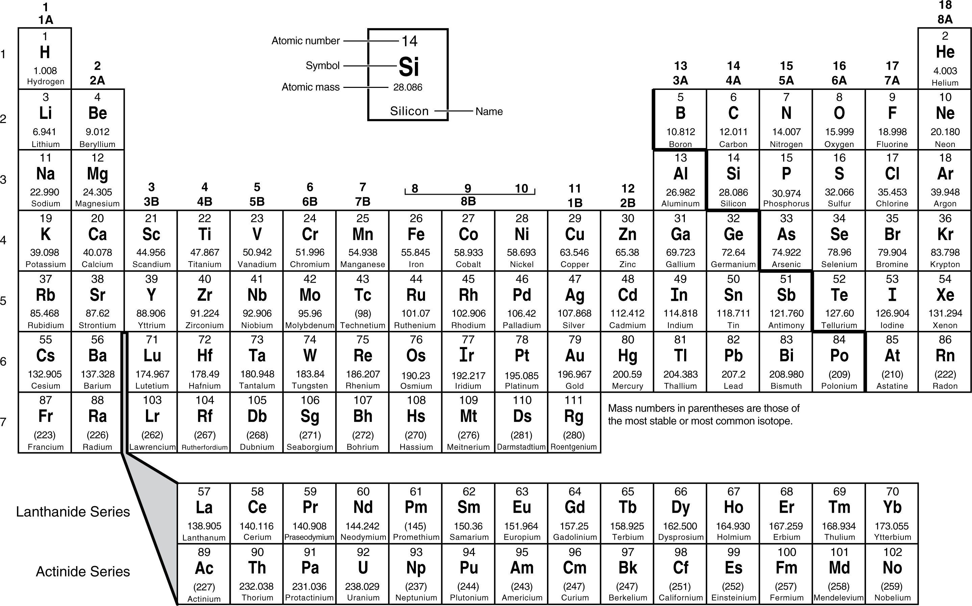

Learning About Organic Compounds
Last year you learned about elements found on the periodic table. You also learned that elements could combine to create compounds. All living things are made of elements. Some of these elements are combined into what are called organic compounds. Organic compounds are compounds that usually come from organisms. They always have carbon but may contain other elements like hydrogen, oxygen, nitrogen, phosphorus or sulfur.
Materials: scissors and glue
What to do:
1. Use the periodic table to find information on the following elements.

Element | Symbol | Atomic number | Metal or Nonmetal
Carbon
Hydrogen
Oxygen
Nitrogen
Phosphorus
Sulfur

When elements combine with each other we say they are making chemical bonds. Elements can bond together in straight rows or in rings as seen below.
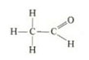
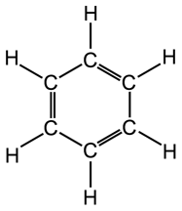

DO NOT GLUE TO NOTEBOOK PAGE
What to Do:
1. Cut out the squares below.
2. Determine some ways of dividing these compounds into 4 different groups.
1  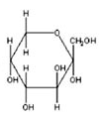 | 2  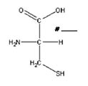 | 3  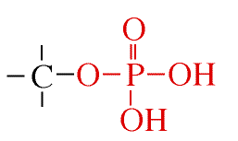
4  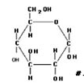 | 5  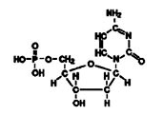 | 6  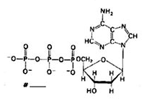
7  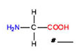 | 8  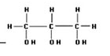 | 9  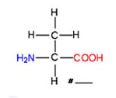
10  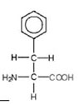 | 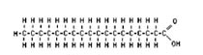  11 | 12  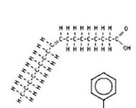

33
3. Group your compounds and be ready to share your reasoning.

Questions:
1. Look at your first group. Why did you put those compounds together? ______________________

2. Look at your second group. Why did you put those compounds together? _________________________

3. Look at your third group. Why did you put those compounds together? ________________________

4. Look at your fourth group. Why did you put those compounds together? ________________________

5. What do all of these compounds have in common? ___________________________________________

6. Glue the compounds in their groups in your science notebook.

7. List the elements used in the compounds below.

8. We can remember the elements found in organic compounds by remembering the silly word below.

CHONPS
What does each letter stand for? _________________
___________________________________________

Name __________________ period _____

EXIT TICKET
Learning About Organic Compounds

1. What element is found in every living thing?

A. Nitrogen
B. Phosphorus
C. Carbon

2. Which of the following compounds is most likely to be found in living organisms?

A. SiO₂
B. C₆H₁₂O₆
C. KI

3. Below you will find pictures that chemists use to represent various compounds. Which of the compounds is NOT an organic compound?

A  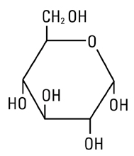 | B  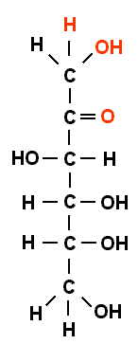 | 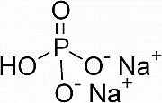  C

Name __________________ period _____

EXIT TICKET
Learning About Organic Compounds
1. Below you will find pictures that chemists use to represent various compounds. Which of the compounds is NOT an organic compound?

A | B | C

2. What element is found in every living thing?

A. Nitrogen
B. Phosphorus
C. Carbon

3. Which of the following compounds is most likely to be found in living organisms?

A. SiO₂
B. C₆H₁₂O₆
C. KI

