Different Types of Cells

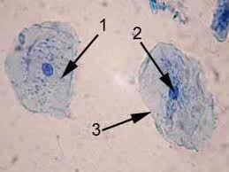
1.  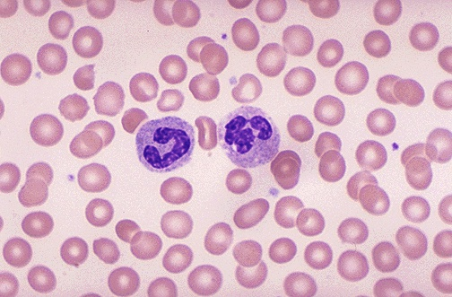  Blood Cells  100X | 2.  Cheek Cells  100X
3.  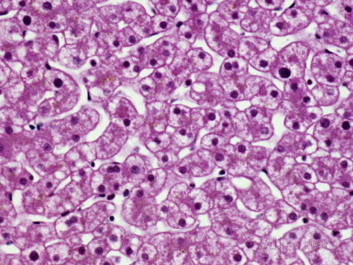  Human Liver Tissue  100X | 4.  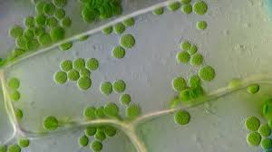  Leaf Cells  100X

5.  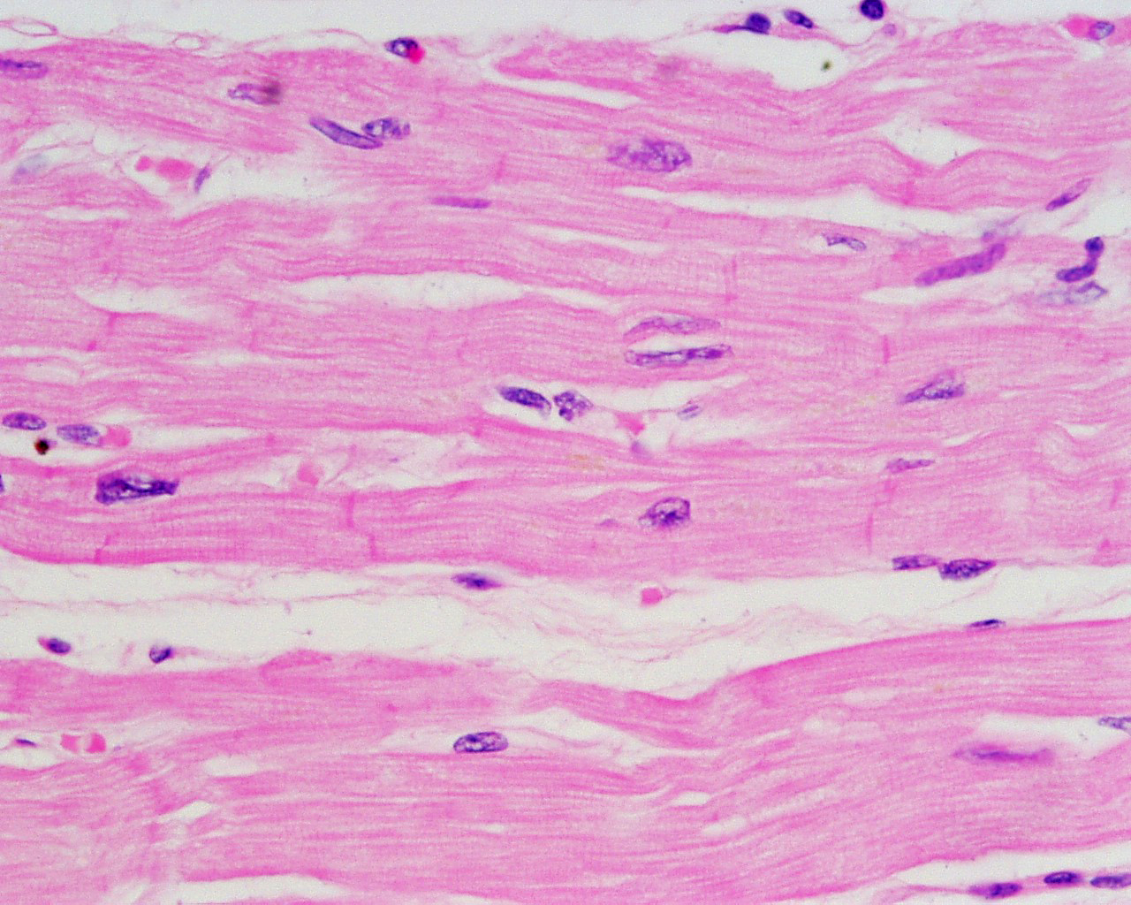  Muscle Cells  100X | 6.  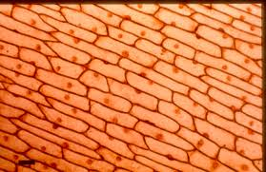  Onion Skin (stained)  100X
7.  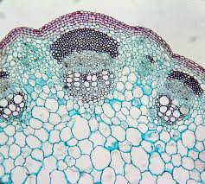  Plant Stem  100X | 8.  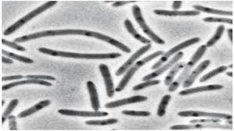  Bacterial Cells  10,000 X

