Teacher Information
Unit 2 Structure and Function of Cells

Objectives
SCI.7.12C Recognize levels of organization in plants and animals including cells, tissues, organs, organ systems, and organisms.
SCI.7.12D Differentiate between structure and function in plant and animal cell organelles including cell membrane, cell wall, nucleus, cytoplasm, mitochondrion, chloroplast, and vacuole.
SCI.7.12E Compare the functions of a cell to the functions of organisms such as waste removal.
SCI.7.12F Recognize that according to cell theory all organisms are composed of cells and cells carry on similar functions such as extracting energy from food to sustain life.

Activity 1 Cell Organelles
Materials: Colored pencils

The third page is a foldable and not numbered. It shouldn’t be glued in the book until cut out.
1. Have students cut out large double-lined rectangle and then fold on
the single line between the edge and the vocabulary words.
2. Glue the skinny rectangle to the notebook page.
3. Write Cell Organelles in the skinny rectangle.
4. Have students cut the dotted lines to make flaps.
5. Student should use the first two pages to find the structure
mentioned.
6. Draw a picture of the structure next to the vocabulary word.
7. Write the function of each organelle under the flap.

Focus: I can differentiate between structure and function in plant and animal cell organelles.
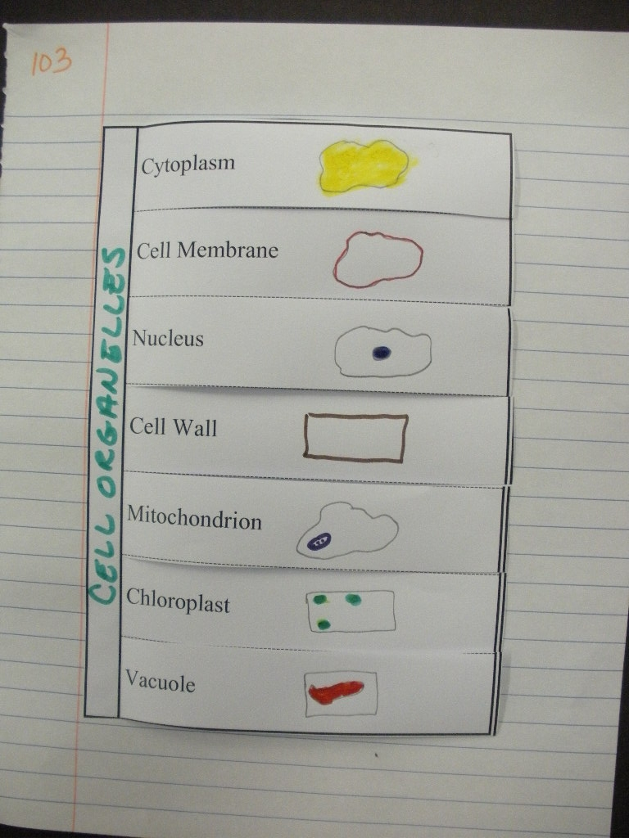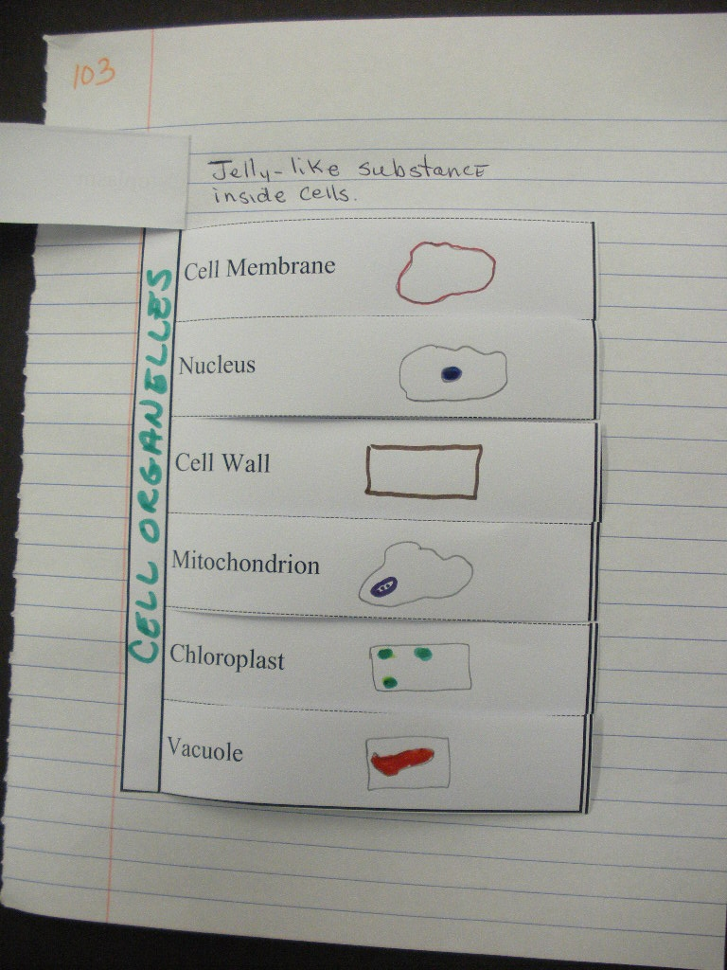
Page 4 Build a Cell
Suggested Materials: Ziploc bags, beads, pipe cleaners, marbles, string, plastic storage container, jelly beans, erasers, other misc. items.

Activity 2 Using the Microscope*
Materials: microscope for each side of the table, lens paper, miscellaneous slides, colored pencils

Focus: I can describe how to care for a microscope.

Activity 3 Observing Plant and Animal cells
Materials: Did You Really See That Power point

Materials: microscope, lens paper, onion skin, tooth pick, methylene blue stain, iodine stain, 2 cover slips, 2 slides

Focus: I can recognize various organelles inside living cells.

Activity 4 Comparing Cells and Organisms
Materials: microscope, lens paper, live or prepared slides of paramecia, amoeba and euglena.

Focus: I can compare the functions of a cell to the functions of organisms such as waste removal.

