Cell Organelles

As we have learned the cell is the basic unit of structure and function in a living thing. There are two major divisions of cells, plant and animal cells. Animal cells have a cell membrane that forms the outside of the cell. Inside the cell membrane is a large structure called the nucleus. The nucleus is the control center and its job is to direct the cell’s activities. The mitochondrion is the power plant of the cell. It uses food and oxygen to make energy. Vacuoles are found all around the cell. They carry food in and wastes out of the cell. The area between the cell membrane and the nucleus is called the cytoplasm. The cytoplasm is a clear, jelly-like substance in which these important cell structures, called organelles, are found.

Materials: colored pencils, various items to make a model of a cell
What To Do:
1. Label the vacuole and color it orange.
2. Label the mitochondrion and color it purple.
3. Label the nucleus and color it blue.
4. Label the cytoplasm and color it yellow.
5. Label the cell membrane and color it red.
The Animal Cell
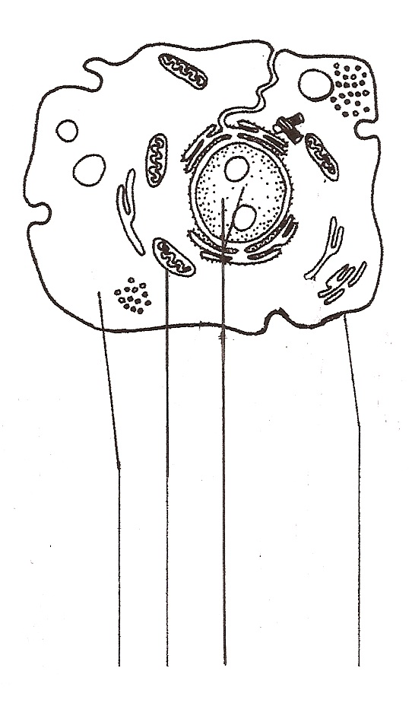
1.

2.
3.

4.

5.

Plant cells and animal cells are not exactly alike. Plant cells have certain parts that animal cells do not. These parts are the cell wall and chloroplasts. The cell wall surrounds the cell membrane of a plant cell. Its job is to give a plant cell stiffness and shape. Chloroplasts are found in the cytoplasm of a plant cell. They contain a green substance called chlorophyll. The chlorophyll inside plant cells allows them to make their own food. The very large empty space is a vacuole. This is where the place cells fills up with water to keep its shape.

1. Label the chloroplast and color it green.
2. Label the cell wall and color it brown.
3. Label the cytoplasm and color it yellow.
4. Label the mitochondrion and color it purple.
5. Label the nucleus and color it blue.
6.Label the cell membrane and color it red.
7.Label the vacuole and color it orange.
The Plant Cell

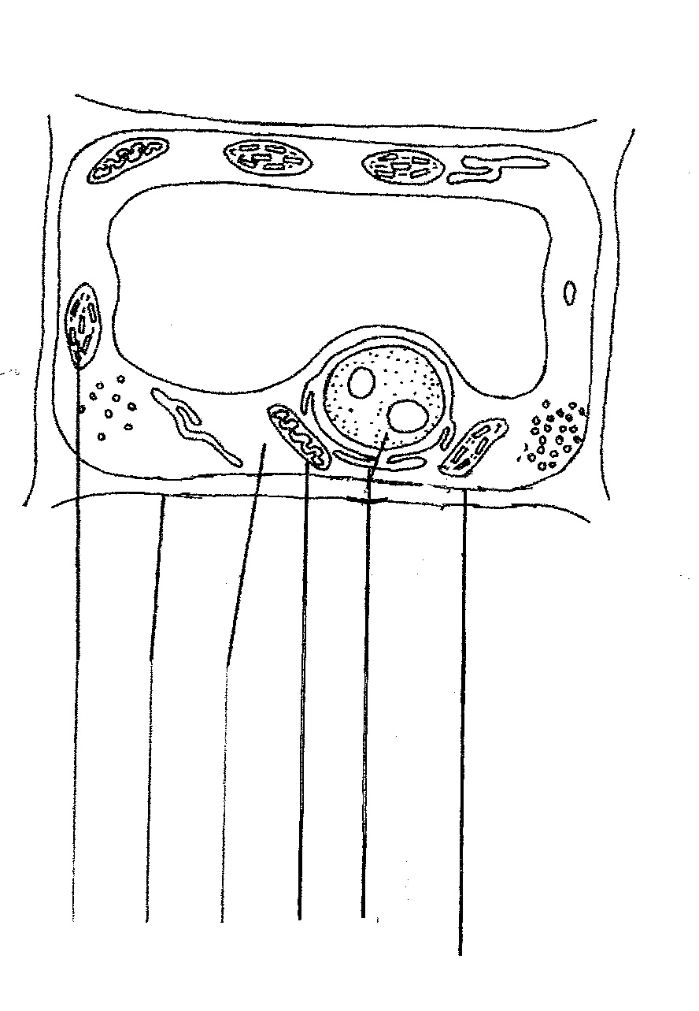

1.
2.

3.

4.
5.

6.

7.0

Cytoplasm

Cell Membrane

Nucleus

Cell Wall

Mitochondrion

Chloroplast

Vacuole

Make a Model of a Cell

What To Do:
1. Use the materials your teacher gives you to make either a plant cell or an animal cell.
2. In the space below write the name of each organelle in your cell and the material you used to represent it in your model.

Name of Organelle | Material used to represent it
1.
2.
3.
4.
5.
6.
7.

3. Share your model with your small group.

Name _____________ period _____

EXIT TICKET
Cell Organelles

1. Label the organelles of the cells found below.

WORD BANK

Nucleus Cytoplasm Vacuole

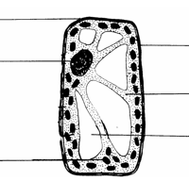
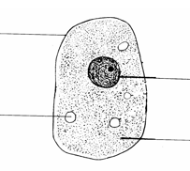

2. Circle the animal cell in the drawings above.

3. Cloze Paragraph: Use the following words to fill in the blanks. (food, animal, plant, chlorophyll, cell wall)
There are two kinds of cells _________ and _________ cells. The two structures that plant cells have that animal cells don’t have are the chloroplasts and the _______ _______. The chloroplasts contain __________ which allow the plant to use the sun to make __________.
Name _____________ period _____

EXIT TICKET
Cell Organelles

1. Cloze Paragraph: Use the following words to fill in the blanks. (food, animal, plant, chlorophyll, cell wall)
There are two kinds of cells _________ and _________ cells. The two structures that plant cells have that animal cells don’t have are the chloroplasts and the _______ _______. The chloroplasts contain __________ which allow the plant to use the sun to make __________.

2. Label the organelles of the cells found below.

WORD BANK

Nucleus Cytoplasm Vacuole

3. Circle the plant cell in the drawings above.

