Using the Microscope

The microscope is an essential tool in the study of life science. It allows you to see things that are too small to be seen with the unaided eye. The compound microscope has more than one lens that magnifies the objects you view. Typically, the compound microscope has one lens in the eyepiece, the part you look through and it also has at least one other objective lens.

In a compound microscope the eyepiece lens usually magnifies 10 times. This is written 10X. Any object you view through this lens would appear 10 times larger than
it is. The other objective lenses are called low power and high-power.

The low-power lens magnifies 4X and the high-power lens magnifies 43X. To calculate the total magnification with which you are viewing an object,
multiply the magnification of the eyepiece lens by the magnification of the objective lens you are using.

Magnification Problems
1. The eyepiece magnifies 10X and the low power
magnifies 4X. What is the total magnification? _____________
2. The eyepiece magnifies 10X and the high power
magnifies 10X. What is the total magnification? ____________

What To Do:

1. Label the parts of the compound microscope as your teacher demonstrates them to you. Use the word bank to spell them correctly.
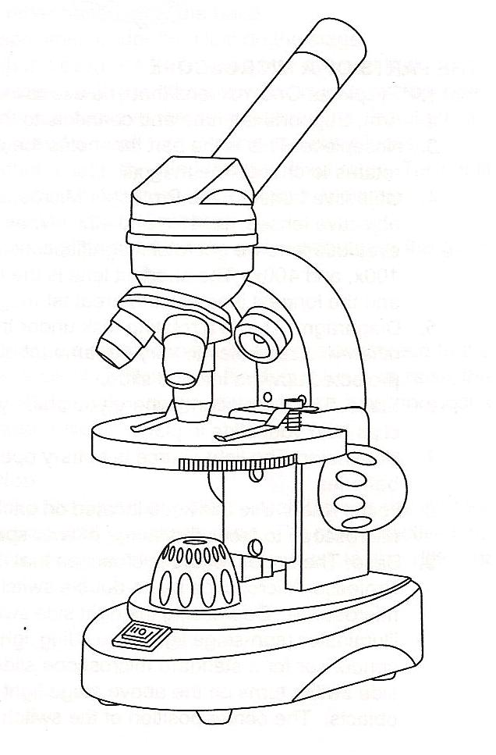
1
2
3
4
5
6
7
8
9
10
11

WORD BANK
eyepiece stage power switch
arm high power objective
base low power objective
diaphragm focus knob
upper light lower light

What To Do:

1. Your teacher will go over the procedures for using
the low-power objective.
2. Highlight or underline important ideas.

Focusing the Microscope on Low Power
Materials: microscope for each side of the table, lens paper, miscellaneous slides, colored pencils
What To Do:
1. Set up your microscope as directed.
2. Place a slide on the stage and focus on low power.
3. Draw and color what you observe in the circles.
4. Label each image on the line and write the total
magnification below it.

Questions:
1. At what magnification did you observe each slide? _______________________
2. Which adjustment makes the lens move up and down?
_______________________
3. Which adjustment brings the image into clear focus?
___________________________________________
What To Do:

1. Your teacher will go over the procedures for using
the high-power objective.
2. Highlight or underline important ideas.

Focusing the Microscope on High Power
Materials: microscope for each side of the table, lens paper, miscellaneous slides, colored pencils
What To Do:
1. Set up your microscope as directed.
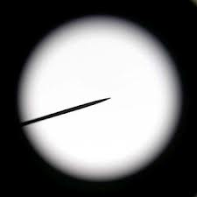
2. Place a slide on the stage and focus on low power.
pointer
3. Make sure the pointer is pointing at something you want to look at.
4. Turn the nose piece so that the high power
moves into position.
5. Turn the adjustment knob slightly and bring
the object into focus.
6. Draw and color what you observe in the circles.
7. Label each image on the line and write the total
magnification below it.
8. Put the microscope away following procedures.

Questions:
1. At what magnification did you observe each slide? ____________________________________________
Name _______________ period _____

EXIT TICKET
Using the Microscope
1. Look at the pictures and tell what is right or what is
wrong in each.

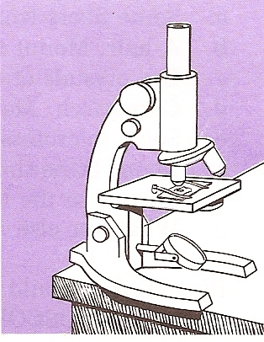
_________________________________________________________________________________

_____________________________________________________________________________
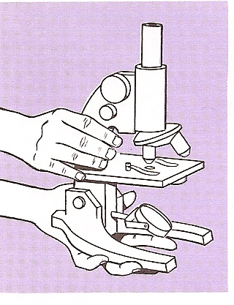

Cloze Paragraph: Use the following words to fill in the blanks. (objective, eyepiece, compound, multiply)
The ____________ microscope has two lenses. The lens you look through is called the __________. The low power and high power lenses are called ___________ lenses. To calculate the total magnification you must __________ the eyepiece by the objective.
Name _______________ period _____

EXIT TICKET
Using the Microscope

1. Cloze Paragraph: Use the following words to fill in the blanks. (objective, eyepiece, compound, multiply)
The ____________ microscope has two lenses. The lens you look through is called the __________. The low power and high power lenses are called ___________ lenses. To calculate the total magnification you must __________ the eyepiece by the objective.
2. Look at the pictures and tell what is right or what is
wrong in each.

_________________________________________________________________________________

_____________________________________________________________________________

Procedures for the Cordless Compound Microscope
Appendix

When carrying the microscope be sure to place one hand under the base and the other on the arm.

1. Make sure your microscope is placed about 2 inches away from the edge of the table.
2. Clean the objective and eyepiece with a small piece of lens paper - never use a paper towel.
3. The microscope has two lights – the upper light for large objects and the lower light for looking at slides.
3. Turn on the lamp by pushing the power switch. The right side of the switch controls the lower light.
4. Check to make sure the lowest power objective (4X) has been clicked into place. If it is not clicked into place, you won’t be able to see much.
5. Place the slide on the stage over the hole and gently place the clips on the slide.
6. Turn the focus knob to raise the stage up until it stops.
7. While looking through the eyepiece, slowly rotate the focus knob so the stage move downward until you can see the specimen.

When finished with the microscope:

A. Return the objective to low power.
B. Take the slide off the stage.
C. Turn off the light.
D. Carry it correctly where your teacher tells you.

Appendix

USING THE HIGH POWER OBJECTIVE.

11. After finding the object with low power you can then find it with high power.
12. Make sure what you want to see is focused on low power.
13. Watch from the side while you rotate the high power objective into place. The high power objective is longer than the low power objective and it can break the slide if you don’t watch carefully.
14. Click the high power objective into place.
15. You may need to focus to adjust to the different magnification.

When finished with the microscope:

A. Return the objective to low power.
B. Take the slide off the stage.
C. Turn off the light.
D. Carry it correctly where your teacher tells you.

