Observing Animal and Plant Cells

We have looked at pictures of cells and focused the microscope on several prepared slides. Today we will make two slides using a technique called Stained Wet Mount. When making our own slides there are usually some common mistakes that we observe as we look through the microscope.

Materials: Did You Really See That Power point

What To Do:
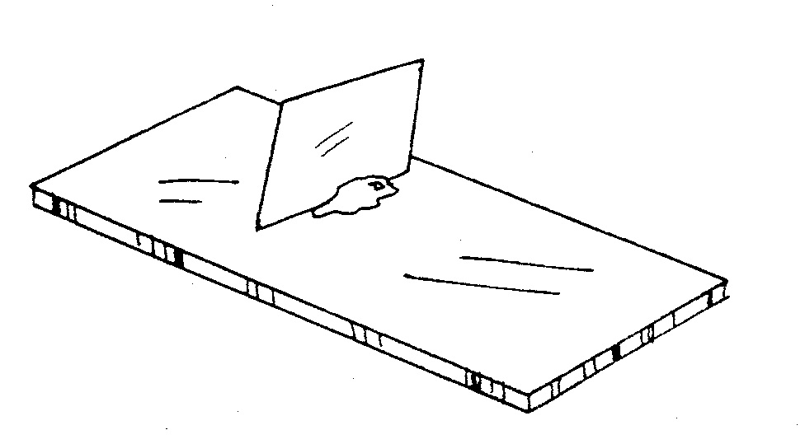
1. Your teacher will show you the following common mistakes that students make when learning to focus the microscope – AIR BUBBLE, COVER SLIP EDGE and TRASH.
2. Your teacher will also show you what you should look for – CELLS.
3. Draw and color what you observe in the circles below.
4. Label what you observe on the line below the circle.

_________ _________ _________ ___________
Questions:
1. Write some words that describe an air bubble.
_____________________________________________
2. How do you know when you come to the edge of a cover slip? _______________________________________
3. How can you tell the difference between trash on
the slide and what you should be looking at?
___________________________________________
What To Do:

1. Observe the pictures and directions below.
2. Use them to make your own wet mount slides.
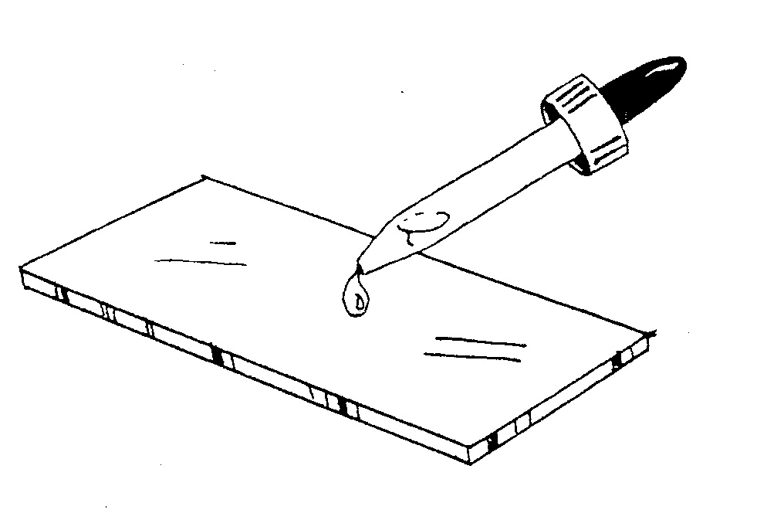
1. Place a drop of culture
on the slide and then place a drop of stain.

2. Place a cover slip at a right angle to the slide with the edge of the cover slip at the edge of the drop of culture and stain.

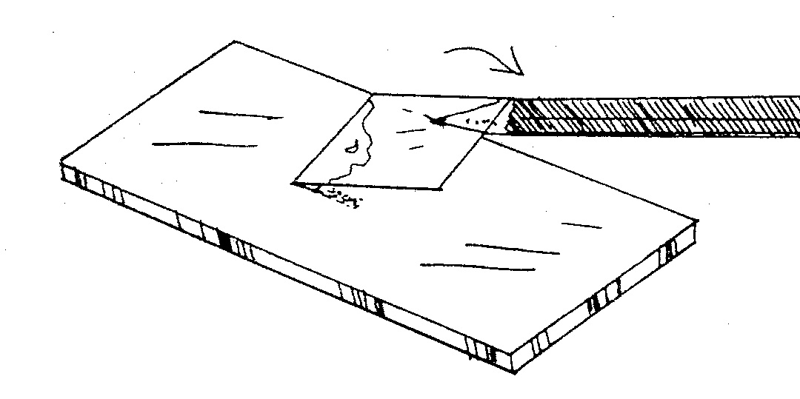
3. Use a pencil to gently lower the cover slip. If you drop the cover slip, the slide will be full of air bubbles.

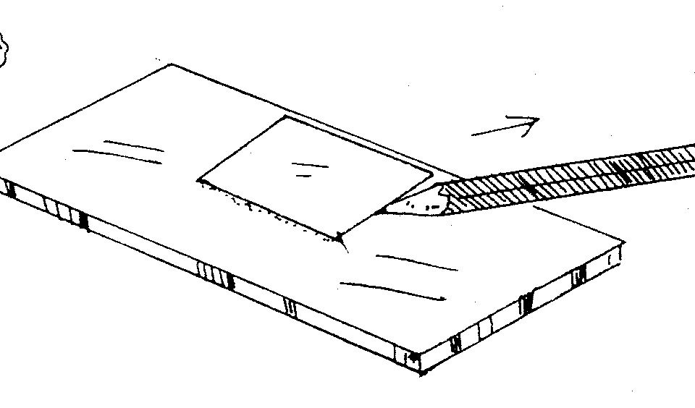
4. When the pencil touches the top of the slide, pull the pencil out from under the cover slip.

Materials: microscope, lens paper, onion skin, tooth pick, methylene blue stain, iodine stain, 2 cover slips, 2 slides

What To Do:
1. Your teacher will go over how to make a wet slide.
2. Obtain and set up the microscope according to the
procedures learned in the last class.
3. Use a clean toothpick and gently scrape the inside of
your cheek. This is your culture of an animal cell.
4. Rub that end of the toothpick on a clean slide.
5. Place a drop of methylene blue stain on the slide and
place a cover slip on top.
6. Observe under low power and draw what you see.
7. Look for the cell membrane and nucleus in the cheek
cells. Label the cell membrane and the nucleus.
8. Get a thin piece of onion skin and place it on a clean
slide.
9. Place a drop of iodine stain and place a cover slip on it.
10. Observe under low power and draw what you see.
11. Look for the cell wall, cell membrane and nucleus.
12. Label the cell wall, cell membrane and nucleus.

Animal Cell Plant Cell

Plant and Animal Cells

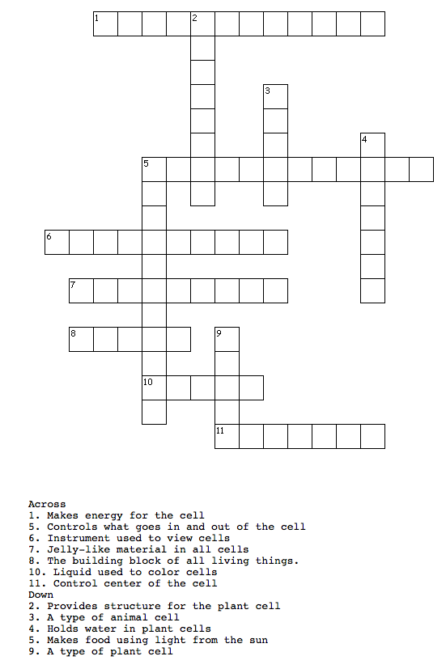
Name _________________ period ______

EXIT TICKET
Observing Plant and Animal Cells

1. What organelles were you able to see in the cheek cell?

A. Cell wall and chloroplast
B. Cell wall and nucleus
C. Cell membrane and nucleus
D. Nucleus and chloroplast

2. What organelles were you able to see in the onion skin?

A. Cell wall and chloroplast
B. Cell wall and nucleus
C. Cell membrane and nucleus
D. Nucleus and chloroplast

3. Why did we stain the cells we looked at?

A. To make it pretty
B. To make it ugly
C. The stain had the cells in it.
D. So we could see them better.

4. What is the total magnification of an eyepiece of 10X and an objective lens of 43X?

A. 43 X
B. 430
C. 430X
D. 53
Name _________________ period ______

EXIT TICKET
Observing Plant and Animal Cells

1. Why did we stain the cells we looked at?

A. To make it pretty
B. To make it ugly
C. The stain had the cells in it.
D. So we could see them better.

2. What is the total magnification of an eyepiece of 10X and an objective lens of 43X?

A. 43 X
B. 430
C. 430X
D. 53X

3. What organelles were you able to see in the cheek cell?

A. Cell wall and chloroplast
B. Cell wall and nucleus
C. Cell membrane and nucleus
D. Nucleus and chloroplast

4. What organelles were you able to see in the onion skin?

A. Cell wall and chloroplast
B. Cell wall and nucleus
C. Cell membrane and nucleus
D. Nucleus and chloroplast

